**For All VUMC >Pain>Pain Site**

New additions to the drop down list include R flank and L flank.  Also please notice that the list has been reorganized to allow options of head to foot while still keeping symmetrical extremities grouped

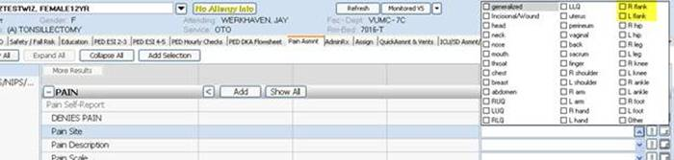

**For ALL VUMC>Pain>Cannot Self-Report Pain>Physiologic Cues**

New addition to the drop down list: “decreased O2 Sat”

