**For VCH to include Peds ED**

**Peds Asmnt/Intervetn and PED ESI 2-3> Renal/Urinary>VOIDS**

**New additions to the dropdown list to include “frequency”, “burning”, “hesitancy”, and “urgency”**

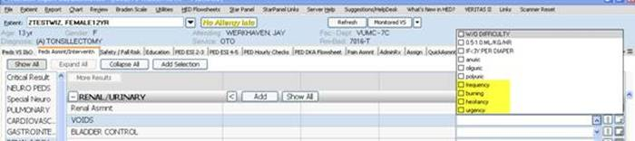

**For Peds ED**

ESI 2-3 and ESI 4-5>Procedure on Unit Added Consult at Bedtime

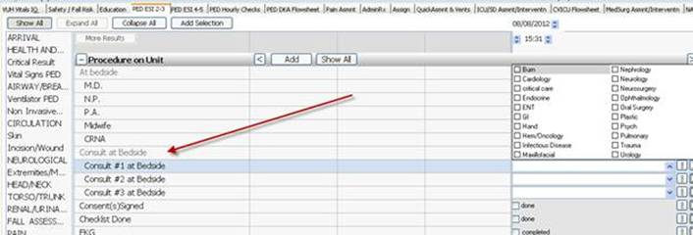

**Sara Winters Turcotte BSN, RN-BC**

Systems Support Specialist II

Vanderbilt Medical Center

Oxford House Suite 1008

Nashville, TN 37232-4740

[sara.m.winters@vanderbilt.edu](mailto:sara.m.winters@vanderbilt.edu)

mobile: 615-429-8171