**NAST** will now be chartable for other units in VCH, so it was separated out from its existing grouping with N-PASS/NIPS.  All scales will continue to be available where they have been; NAST will fall just under N-PASS/NIPS.  Remember to hit **Show All** if necessary:

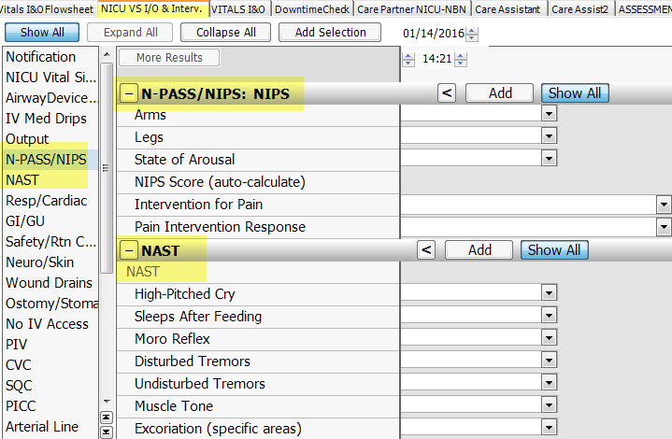

**Implemented units:**

**NAST** is now available to **VCH floors 6, 7 and 8** and will be available on the **Protocols** tab and on **AdminRx**

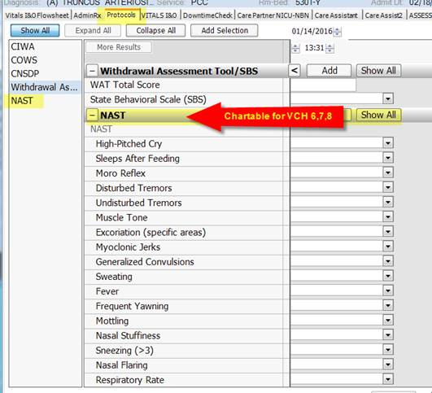

**All Re-Assessment fields** have **Hovers** added that state:

***If unchanged from your most recent prior assessment, click ‘done’***

***If changes are present, click ‘done’ and document the changes***

***‘Prior assessment’ = your initial shift assessment from earlier in your shift***

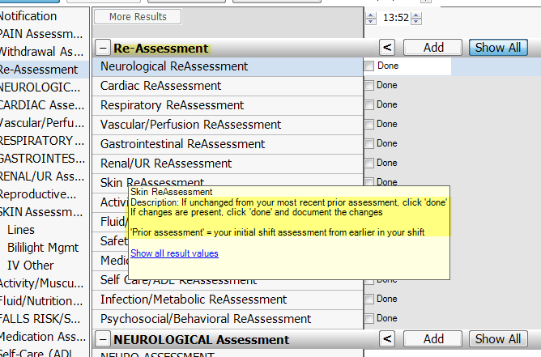

PAIN > **Pain control intervention** > Modified “See notify” to “**See notify/event note**”

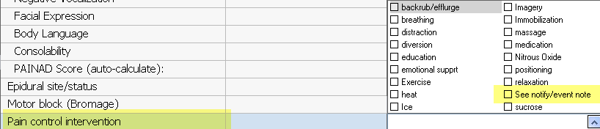

CARDIAC > **Cardiac Intervention** > **Removed all options except “other (annotate)”**

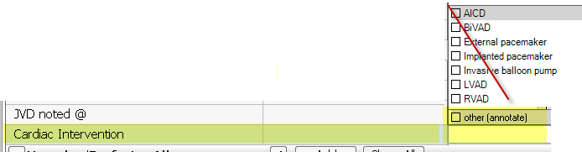

RESPIRATORY Interventions > **Chest Tube Interventions** > Added “**discontinued per Provider**”

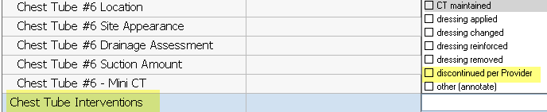

Vascular/Perfusion > Added **Thrombocytopenic Precautions** field

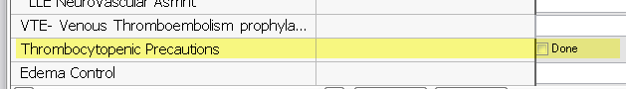

Fluid/Nutrition > **Nutrition Intervention** > **Removed Education** from the dropdown

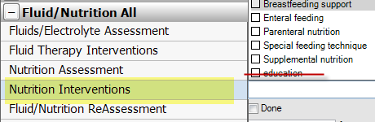

Psychosocial > **Terminal Care/Interventions** > Added **Post-mortem care** options to the dropdown:

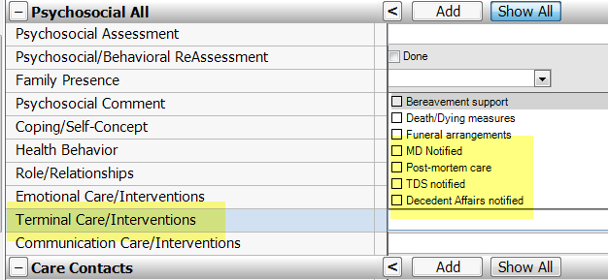

EDUCATION tab > Removed **Interpreter Name and ID field** from units Live with the ReDesign

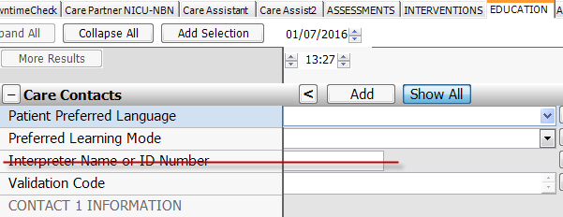

EDUCATION tab > Education & Engagement > **Safety Education** > Added “**Restraint Education**”

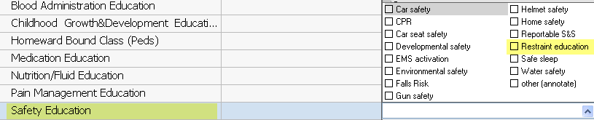

DEVICES > **Sheaths** > Added **Sheaths #4, #5, #6**

