HED: PT EVENT TAB (DRAFT)
The patient event tab organizes shared fields into one tab to facilitate key charting of significant events such as RRT, fall, violence, etc.
- Column times should reflect actual time of VS (before and after) and notification data.
- Notification Outcome should reflect patient status & immediate plan
Rapid Response example:
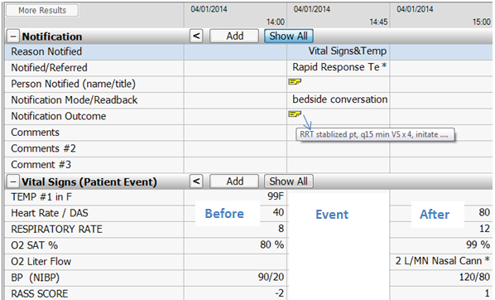

Other Events on this tab: