For all VUMC:
Added Left nare and Right nare to Airway Securement result:
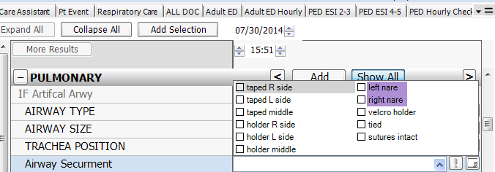

Added new result for “Study Drug” to IV Med Drips section:
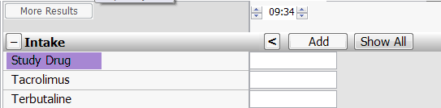

For VUH
Vitals I&O > Intakes – Ketamine has been added
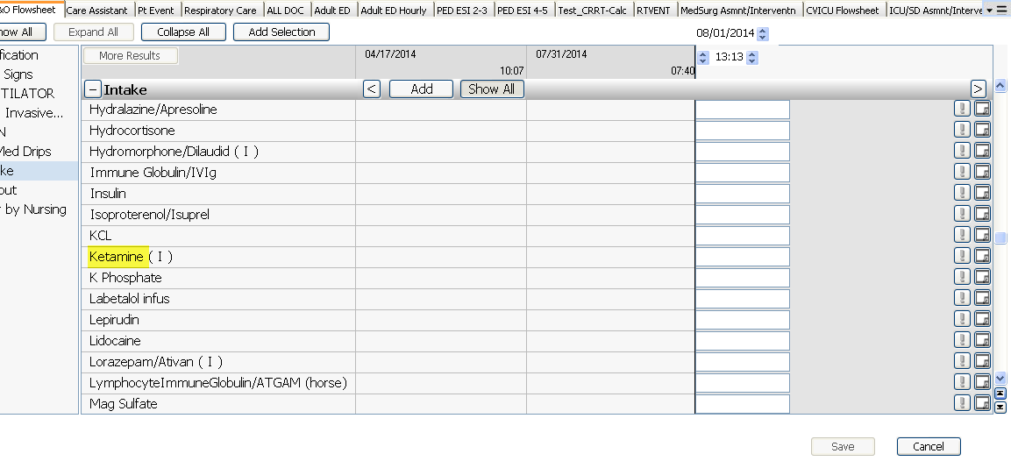
Changes to the Catheter Start details:
Modified the start details section.
All catheters will require documentation in the Catheter Insertion section.
The ED/Inpt insertion section will only be documented if the catheter was started in VUMC ED or Inpatient unit.
Removed fields for “Urine returned”, “Aseptic Technique Used” and “Inserted time”.
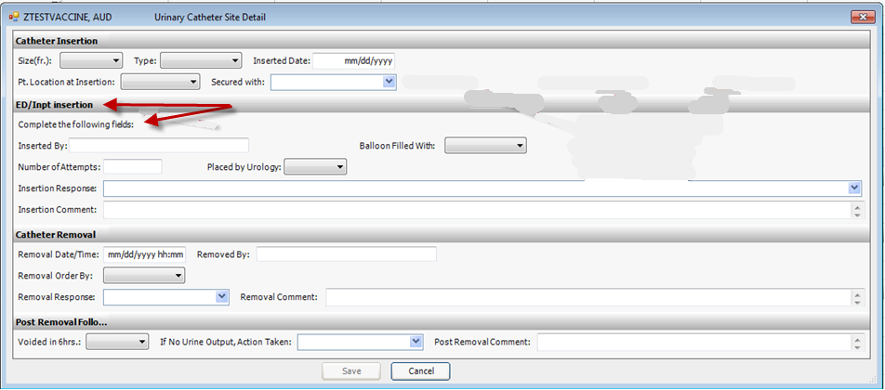

Changes to drop-down list for “Patient Location”:
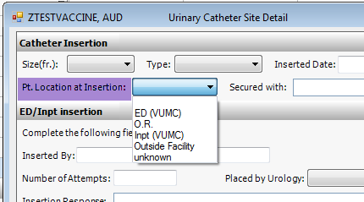

Added “Scan bladder” to drop-down for “If No Urine Output, Action taken”:
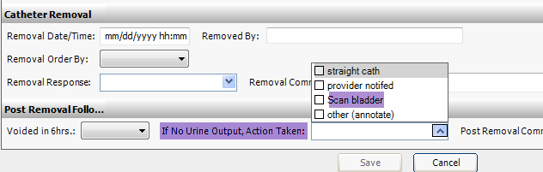
New drop-down list for “Daily Assessment of Need”: