For NICU only:

**July 29, 2014**  
NICU VS I/O & Interv. > GI/GU > Infant Feeds

Liquid Protein has been added to the dropdown. The following formulas are no longer used therefore removed from the dropdown list. Enfamil Premature, Enfamil Gentlease, Portagen, Prosobee, Benefiber, Polycose, and Good Start Protect.  Also, the use of Good Start and Good Start Soy will be discontinued in the near future.  If either of these formulas are used (which should be only on rare occasions), please have the nurses choose other and then annotate.   
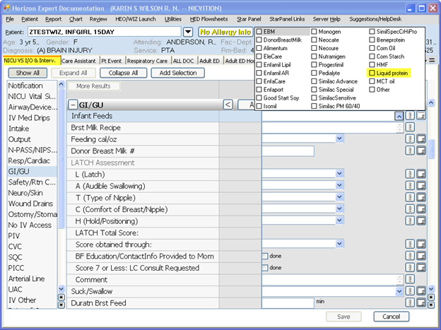

**Saturday, July 26, 7:30pm to Sunday, July 27, 12:30am**, NEW Virtual CWS (VCWS) Sessions may NOT be started. If you initiate a VCWS session prior to 7:30pm, you may continue to use that session BUT should you need to end that session before the end of this maintenance downtime period, you will NOT be able to re-start a VCWS session.

* If you do need to initiate a new CWS session during this 4 hour downtime, you will need to **UNCHECK** the box beside “Logon to VCWS” on *Clinical Desktop Login* box.
* You may swipe your badge during the downtime with the VCWS box unchecked, this will log you into a non-virtual work session.
* After downtime is over you must swipe your badge with the VCWS box checked to return to the virtual work station.

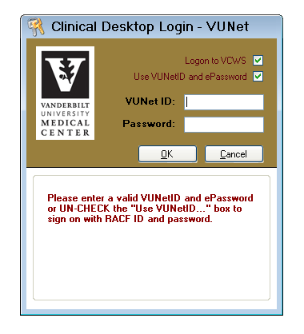

To log on directly to the CWS (by-passing Virtual while it is unavailable), uncheck this box and enter VU Net ID & PW.

For All VUMC:   
These are scheduled to go out **August 5, 2014**

Changes to the Catheter Start details:   
Modified the start details section.  
All catheters will require documentation in the Catheter Insertion section.  
 The ED/Inpt insertion section will only be documented if the catheter was started in VUMC ED or Inpatient unit.  
Removed fields for “Urine returned”, “Aseptic Technique Used” and “Inserted time”.

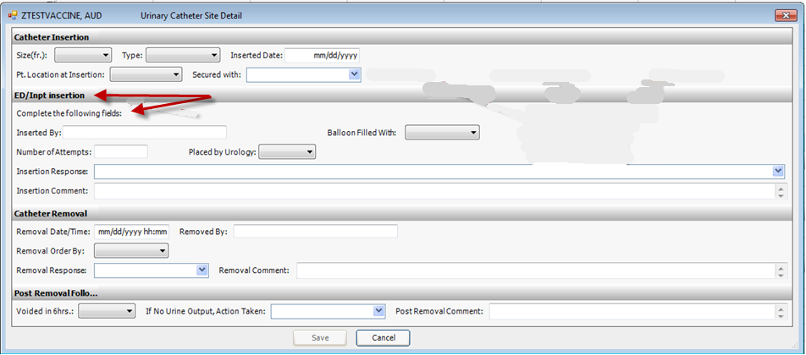

Changes to drop-down list for “Patient Location”:  
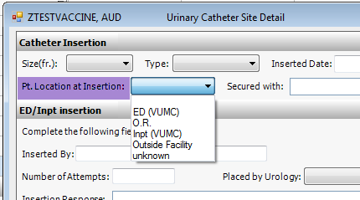

Added “Scan bladder” to drop-down for “If No Urine Output, Action taken”:  
