For All units that do CRRT:
CRRT flowsheet/section has been updated with new calculated result {New Pt. Fluid Removal Rate (Calc)} and a Cosign: CRRT verification result.
The NetCalc fields will autocalculate a result.
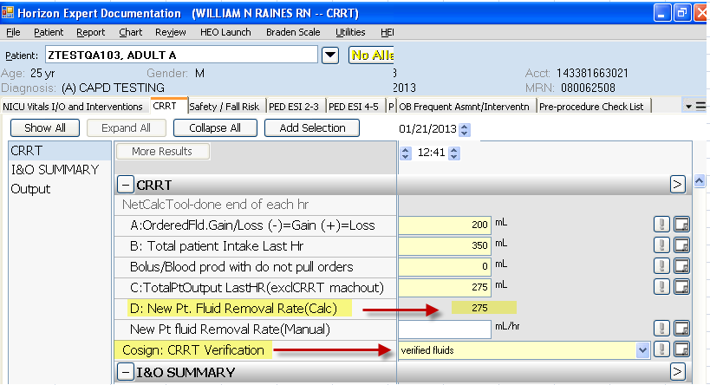
Hover text to describe each new result:
