For all VUMC
“Respiratory Therapy” has been added to the dropdown list of the Notified/Referred charting field available in the Notify/Critical Results section and the Safety Notification/Care Coordination section

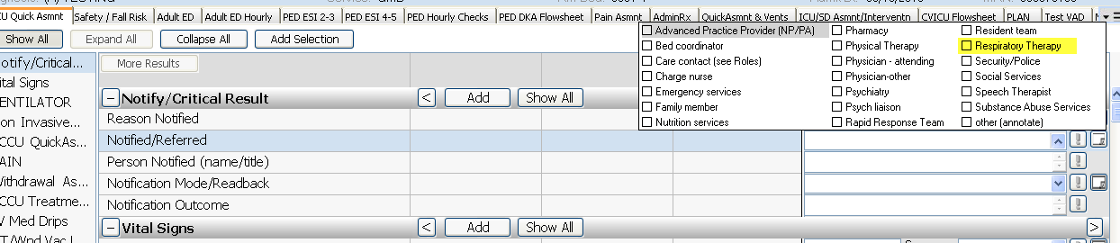

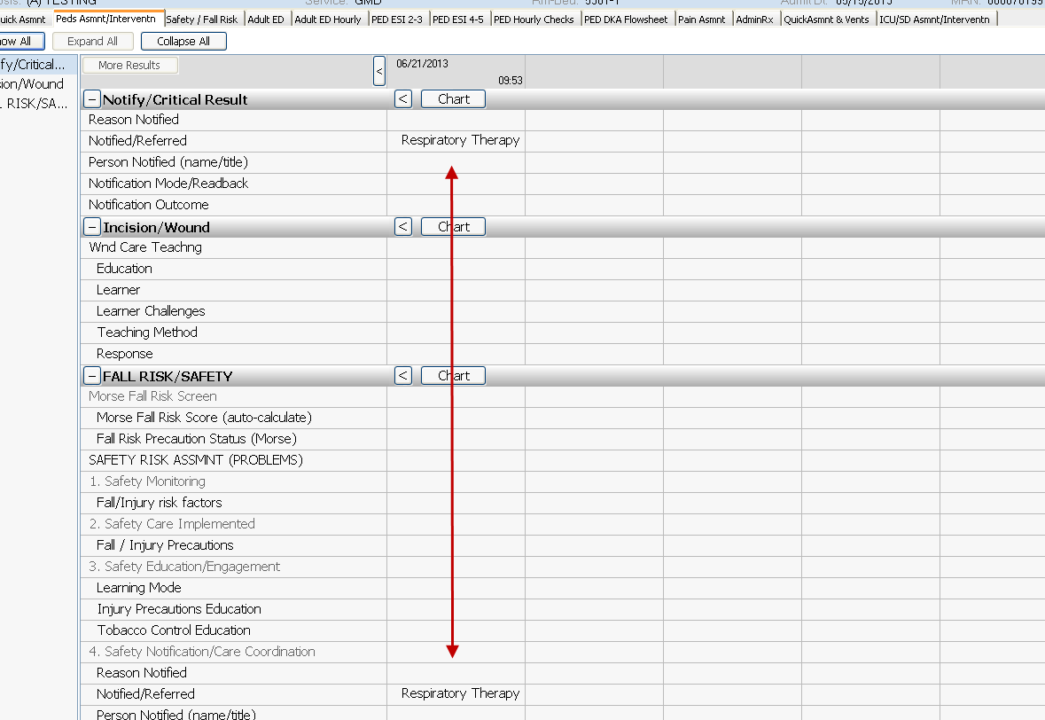

Plan of Care/Dschge tab has display name change for Problems to include the word “Priority”
