For all VUH and VCH (including OB):

Added a column on the Starpanel Nursing flowsheets that captures who documented.  
RACF is shown in the field, hover the mouse over the text and staff name is displayed.  
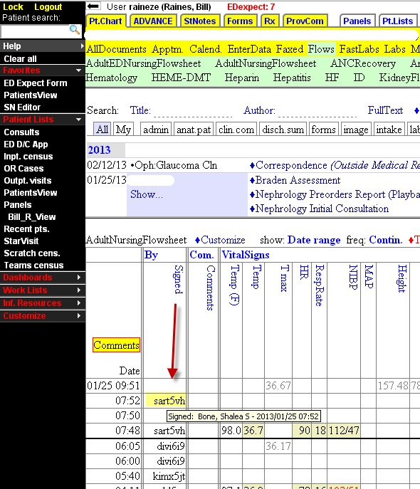

Created new CRRT flowsheet in Starpanel:  
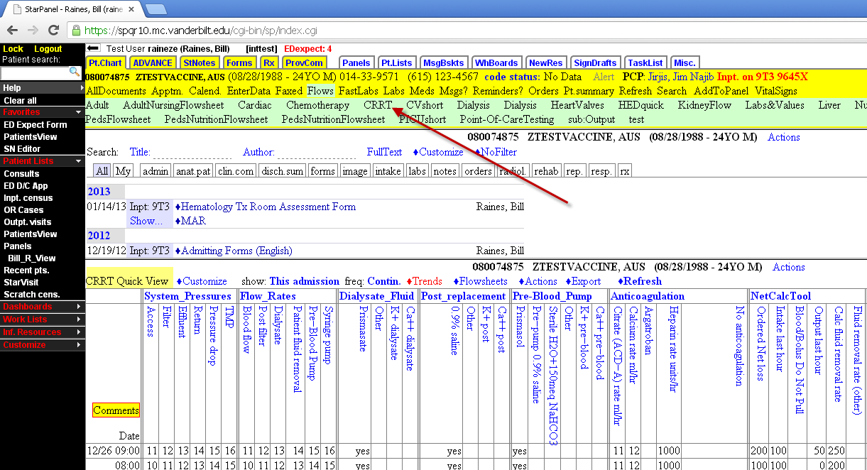

**Starforms Nursing Admission history changes:  
  
All forms**: update instructions when calling Interpreter Services:  
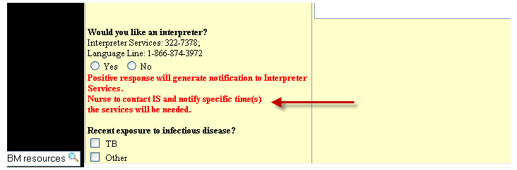

**All forms**: Add text box for facility name if patient lives in SNF, LTC or Assisted Living:  
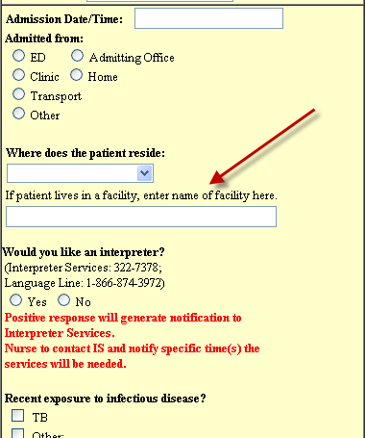

**Adult, OB and Peds**: Moved the existing “Any religious, cultural or ethnic practices that should be considered?” to the Religious/Cultural Needs section.  
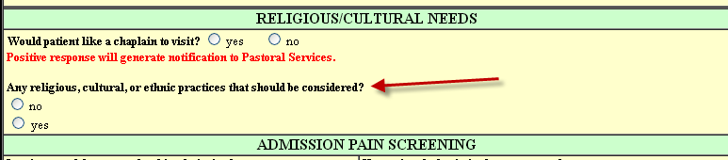

**Adult and Peds**: Remove “Special Diet” question from Nutrition section.   
  
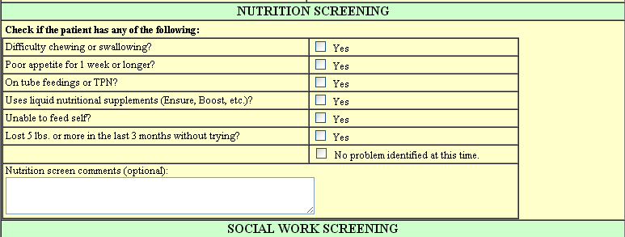

**OB:** removed “Special diet” and Comment text area.   
  
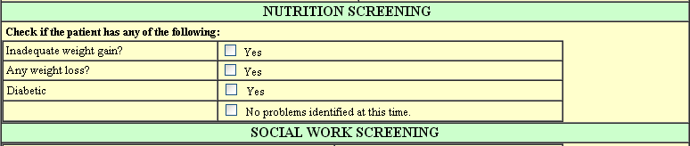

**VCH**: add check boxes for under 5 years and 5 years or older to Nutrition Screen  
Update:  
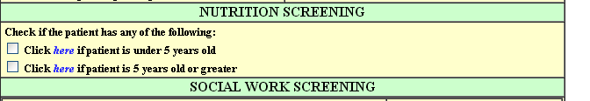

**Adult, OB and Peds**: Change the wording of the instructions for saving a form to  
“Determine you have answered all the questions possible for this visit and save as Complete. Otherwise save as Draft.”  
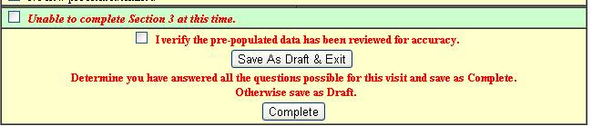

**All of VUH and VCH**  
“VPH Only” restraint documentation removed from the Fall Risk/Safety section.

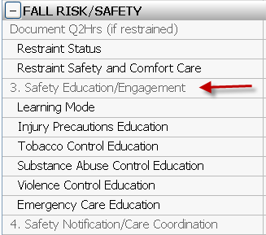

Continues to be available on the Restraint tab:  
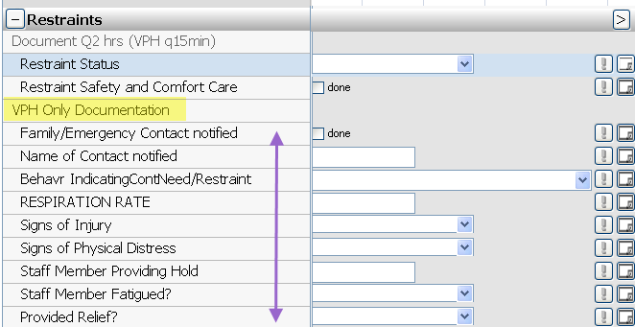

**Education Record**>

The “Tobacco Control Education” charting field is replacing the “Smoking Cessation Counseling” field. Any previous documentation on Smoking Cessation Counseling will be viewable but no longer chartable.

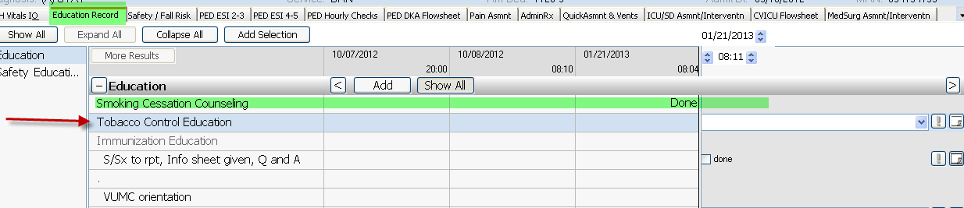

**AdminRx:**

You will see additional fields when administering Warfarin, Opiods and/or Ibuprofen. These fields are not mandatory. Any previous charting will be viewable above the entry boxes.  
  
Example Warfarin administration, the anticoagulant education fields will display and be available for charting.  
Shared results with the Education section.  
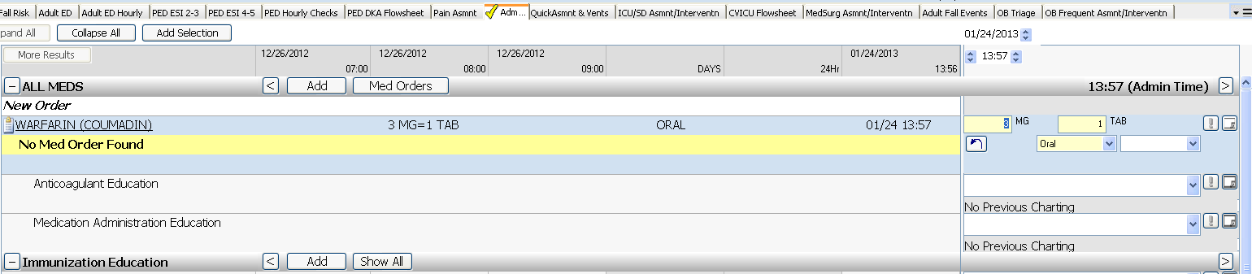

When Opiods and/or Ibuprofen medications are scanned, these results will appear.  
These are shared results with the Pain section.  
Example opiods medication:  
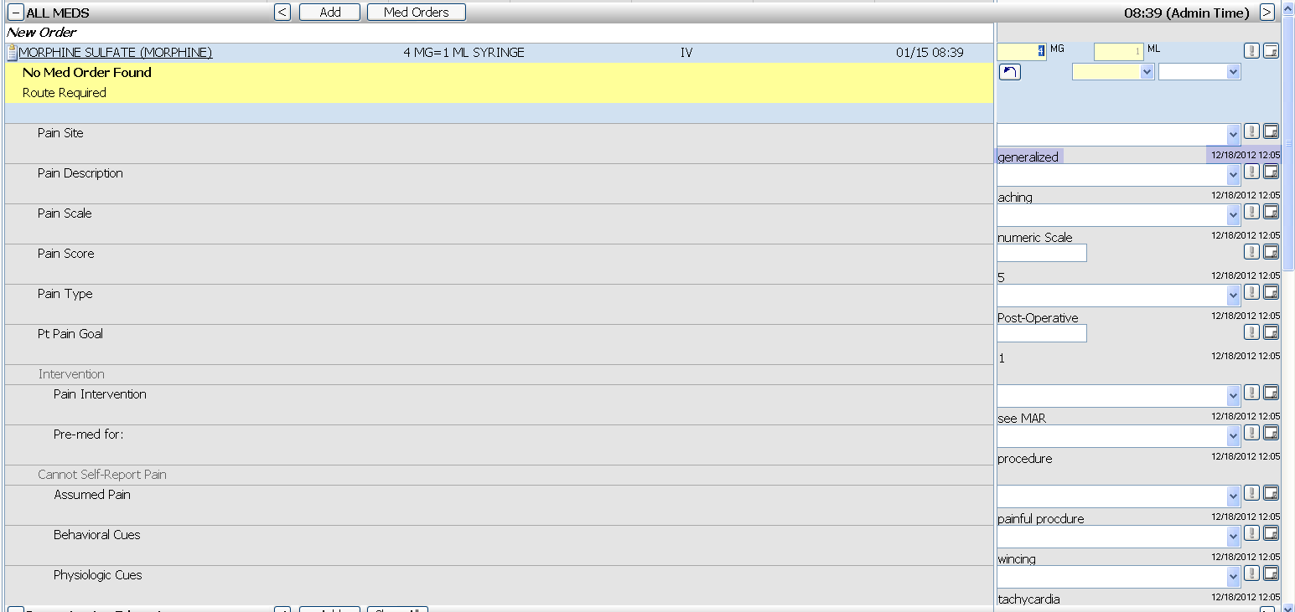

**Vital Signs:**  
RESPIRATIONS Changed to “RESPIRATORY RATE”:  
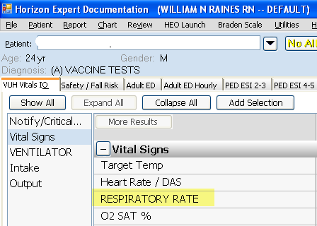

**Pulmonary section:**  
RESPIRATIONS Changed to “RESP PATTERN”.  
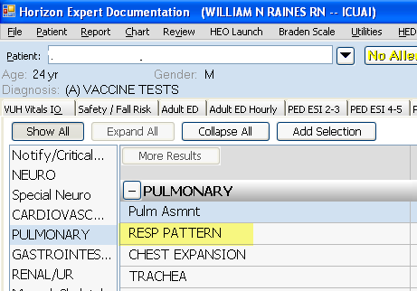

**Intakes and Outputs:**  
Oral and Urine results are now force display:  
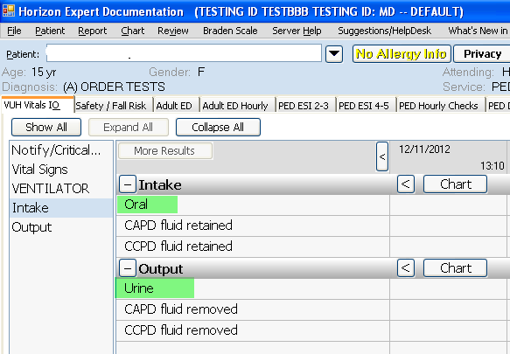

**Turn/Reposition:**

Added selection for “Unassisted side to side movement> 1x/hr”.  
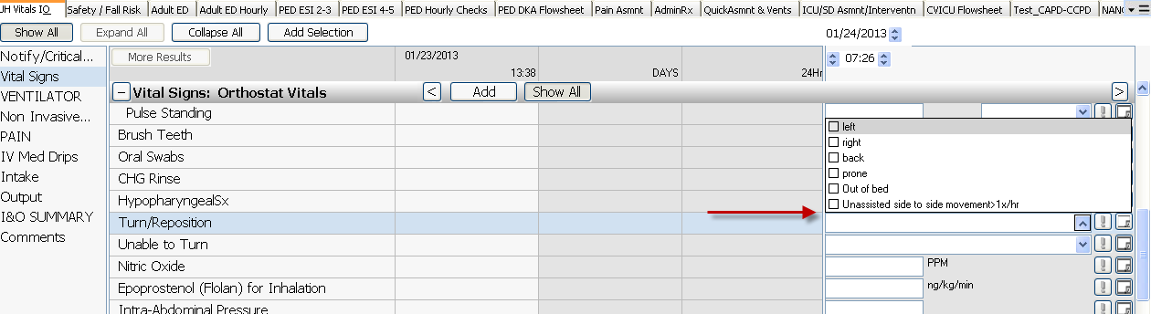

**All VUH**

Adult ED will begin using HED for ALL patients. Once patients arrive on inpatient unit HED charted shared fields will be visible. ED specific documentation will be available on the Adult ED Nursing Flowsheet and the Adult Nursing Flowsheet in StarPanel.

Example of shared fields when HED patient arrives on unit from ED.

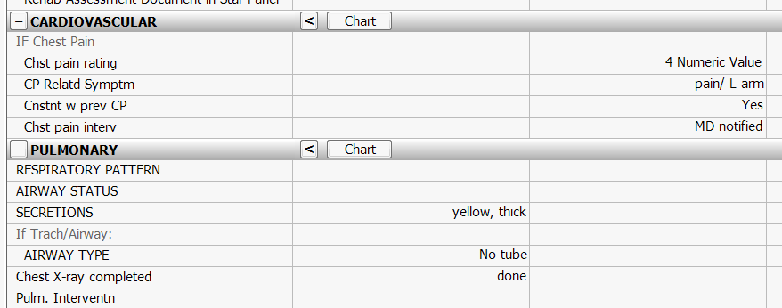

Documentation option added for ED nurses to be able to communicate to inpatient staff the location of pain medication administration in StarPanel

