For all VUH:

Hover text descriptor in “Blood Transfusion Cosign result”:

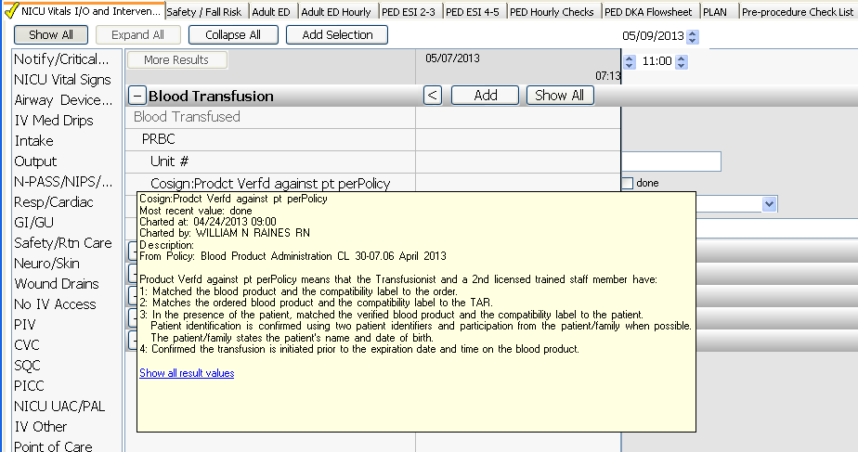

Pulmonary and Respiratory Interventions – Added option “PEP therapy”
