**For all VUH:**Added a message for new IVs to Care Organizer Send Rx Message:  
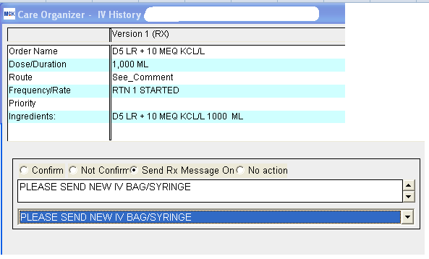

**MedSurg Asmnt/Interventn** - CARDIOVASCULAR - CV site charting fields have been added. These are shared fields with ICU/SD Asmnt/Interventn

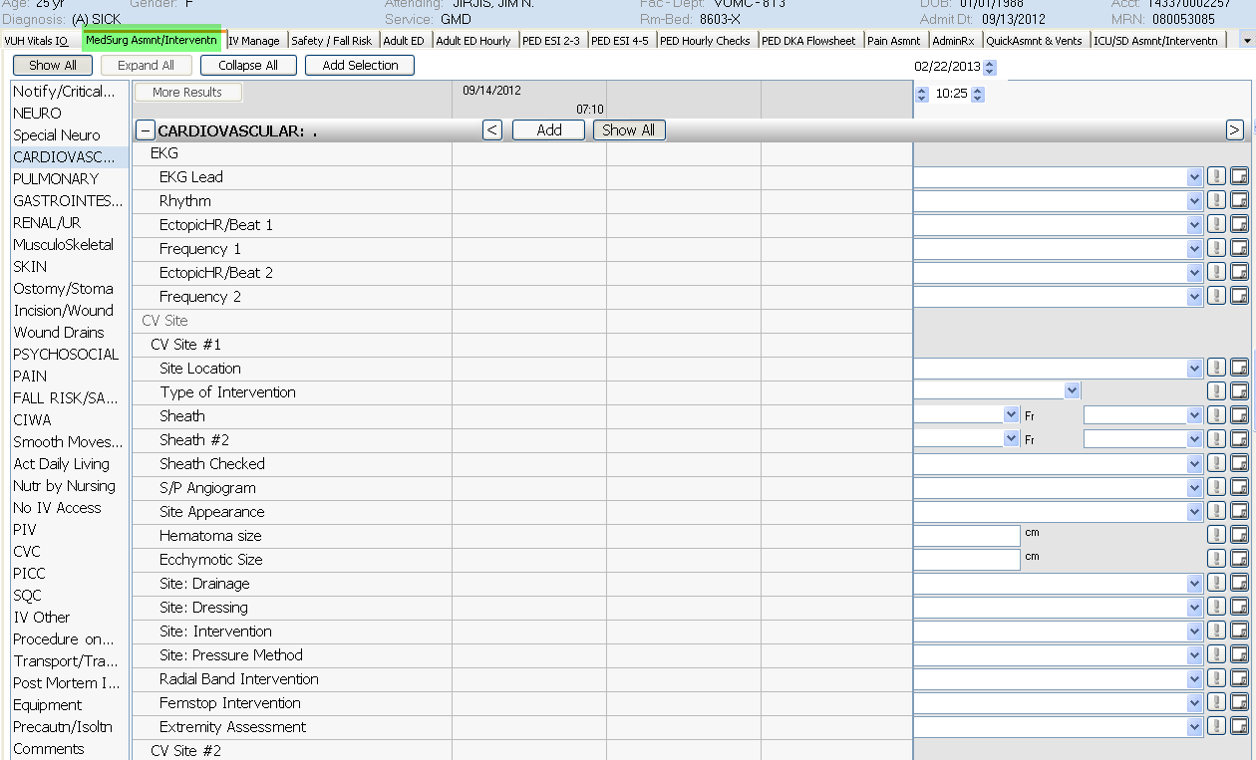

**VUH - MedSurg Asmnt/Intervntn tab** - PULMONARY

IF Trach/Aiway - AIRWAY TYPE:  Added “Oral ETT” to dropdown:

