For VUH and VCH (except NICU and Newborn Nursery):
Assessment tab - Neuro section - Mental Status/LOC will no longer be “No chartable”. Any old documentation will be viewable.
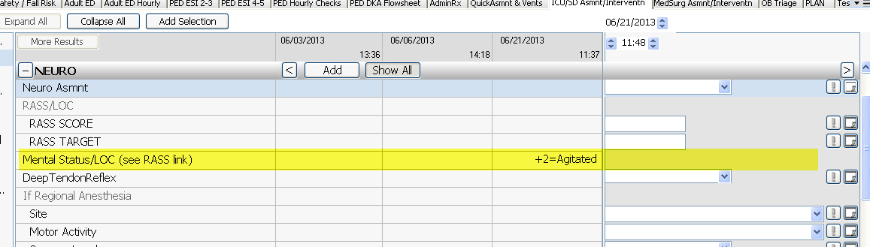
RASS/LOC will be used going forward. Instructions for RASS Scoring will be available in the RASS Score hover, and the RASS Reference link has been updated.
