**For VUH and VCH (except NICU)**

Assessment tabs - Procedure on Unit - Procedure – “Laceration Repair” has been added to the dropdown list

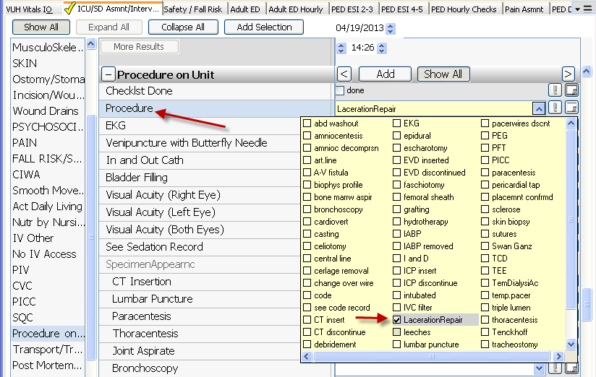

Blood Transfusion tab - Vital Signs – “**O2 SAT%”** has been added just under RESPIRATORY RATE

