For OB:
OB Postpartum tab…Postpartum Assessment…Added “Open to air” to the Dressing drop-down.
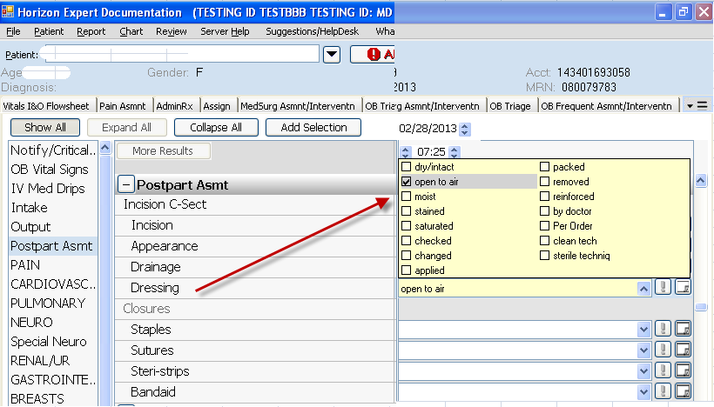
OB Triage tab… Reason for Visit and Dischrg Brochure…
Changed drop-down to include pre-eclampsia and gestational HTN. Removed PIH.
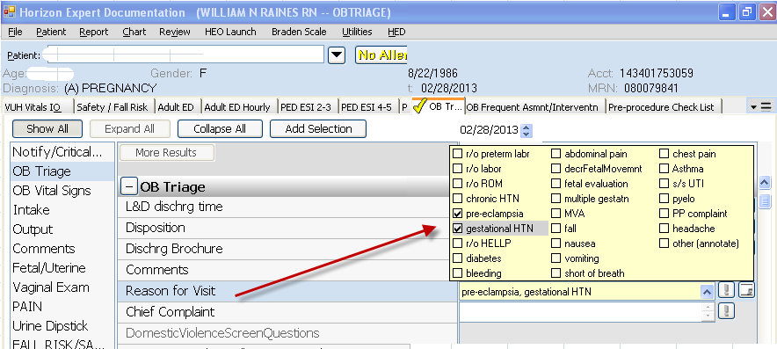
Education Record…
Changed drop-down to include pre-eclampsia and gestational HTN. Removed PIH.