All VUMC:

Vitals I&O - IV Med Drips – Octreotide/Sandostatin – added “mcg/hr” as option:
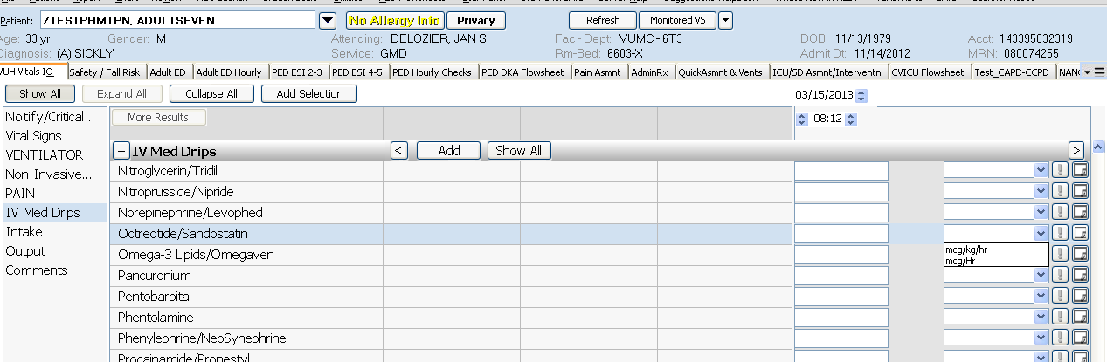

O2 Status is no longer chartable as it was duplicative information. Previously charted information will still be visible:
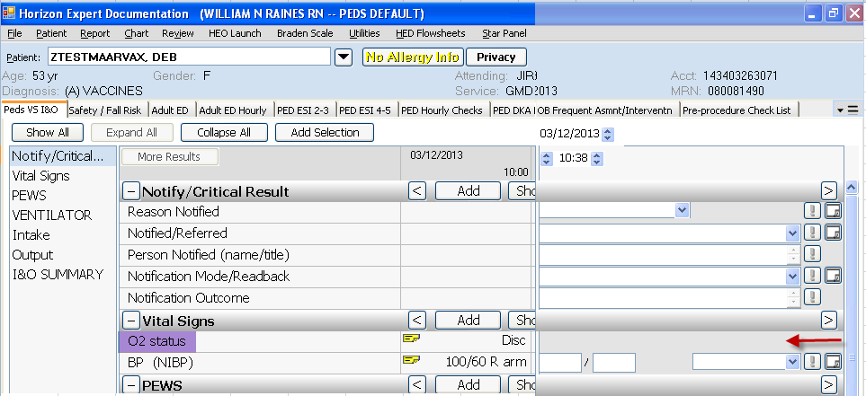
BP (NIBP) has been added as an option to CIWA section: 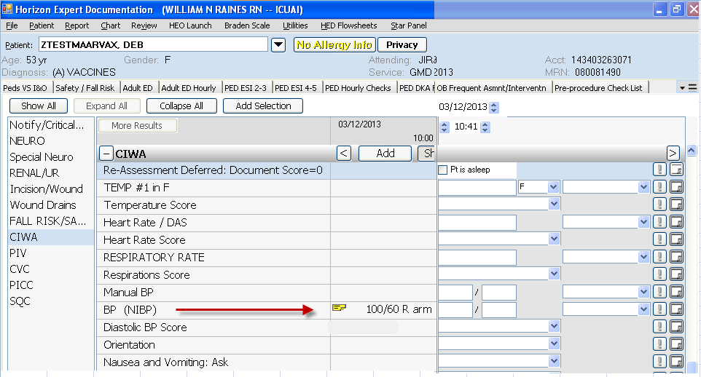

Plan of Care/Dischg Plan - Priority Problems – All Priority Problems: Added hover text “Short Term Goal” and “Short Term Goal Status” with reminder to nursing for appropriate charting frequency:
