For ALL:
Restraint Status and Restraint Safety and Comfort Care will not allow copy any longer:
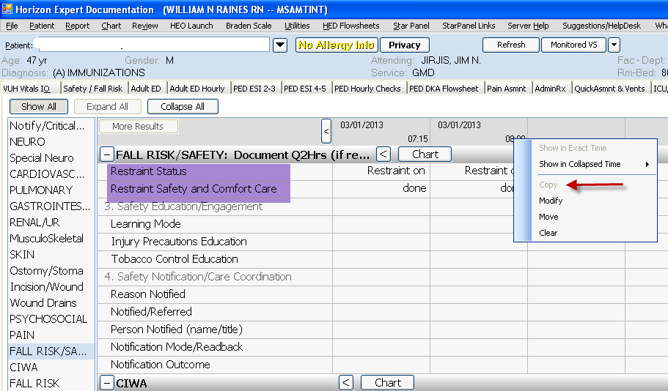
Education Record - Role/Communication – Changed name to “Care Contacts”
