For 5A, 5C, 6A, and 7A the new Peds Fall Assmnt (Graf-Pif) Pilot will begin.
Please note that the “Peds Fall Event” has been added and will be seen by all of VUH and VPH
Assessment tab - Fall Risk/Safety section
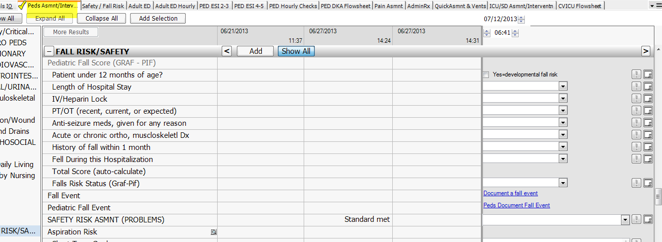
For the Pilot units, the old Pediatric Fall Assessment will be viewable but no longer chartable.
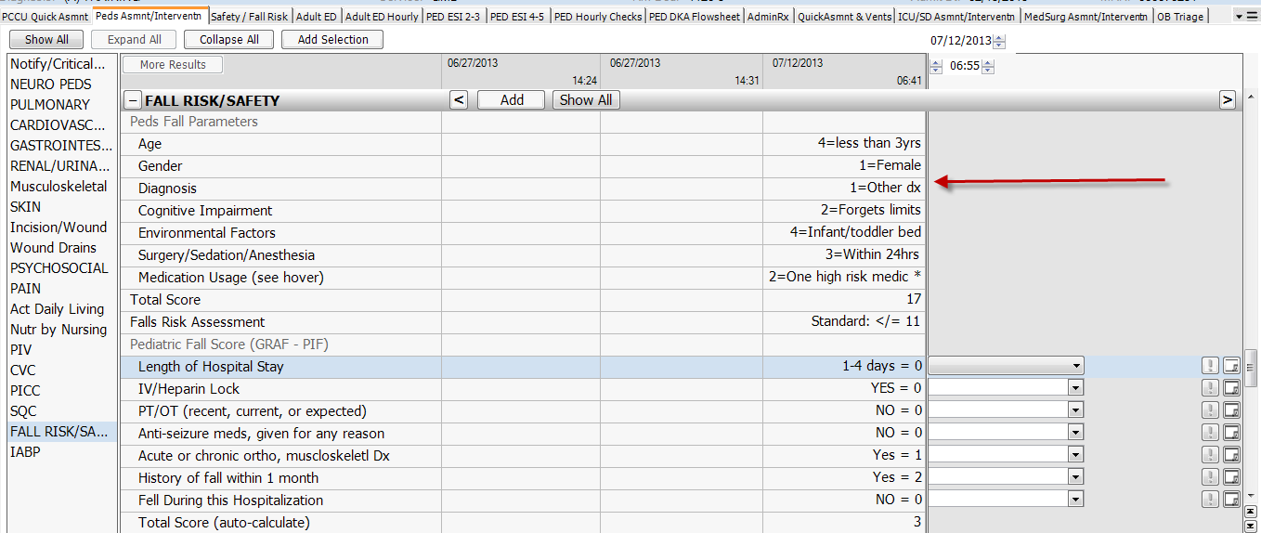
If a patient transfers from one of the Pilot units to another unit, the Graf-Pif documentation will be viewable
but not chartable
