NICU Airway devices - Added new option under Vent Mode “PC-PSV VG”
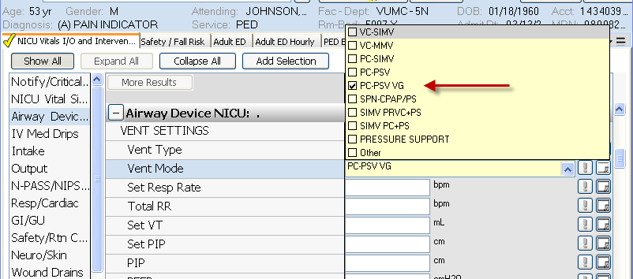

NICU and Newborn Nursery –
Phototherapy additions options under “Bililight Mgmt”
