For 5A and 5C
Any previous charting on SG-PA Catheters and Artline Catheters will remain viewable, but will no longer be chartable. There will be a new section in the Peds Asmnt>Cardiovascular = IntraCardiac Catheter.

In addition, 5A and 5C will now also have access to the UAC charting template that is available to NICU.
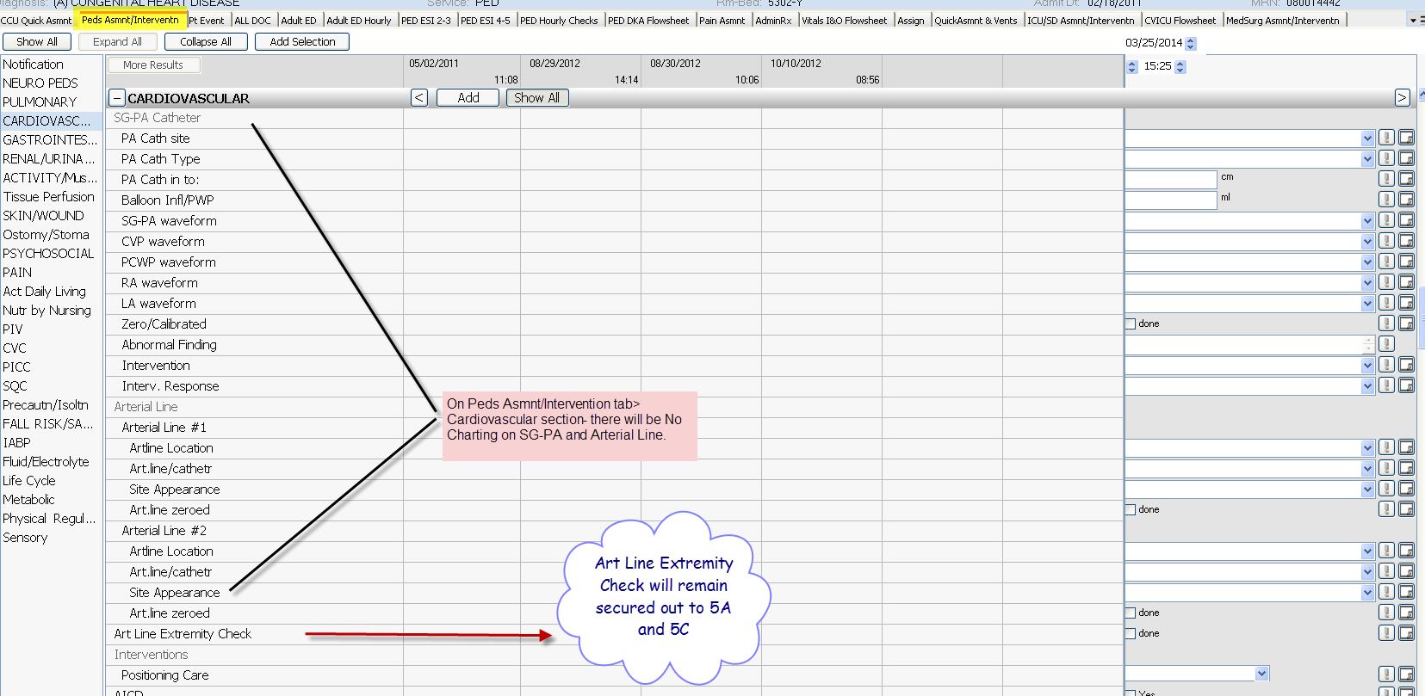
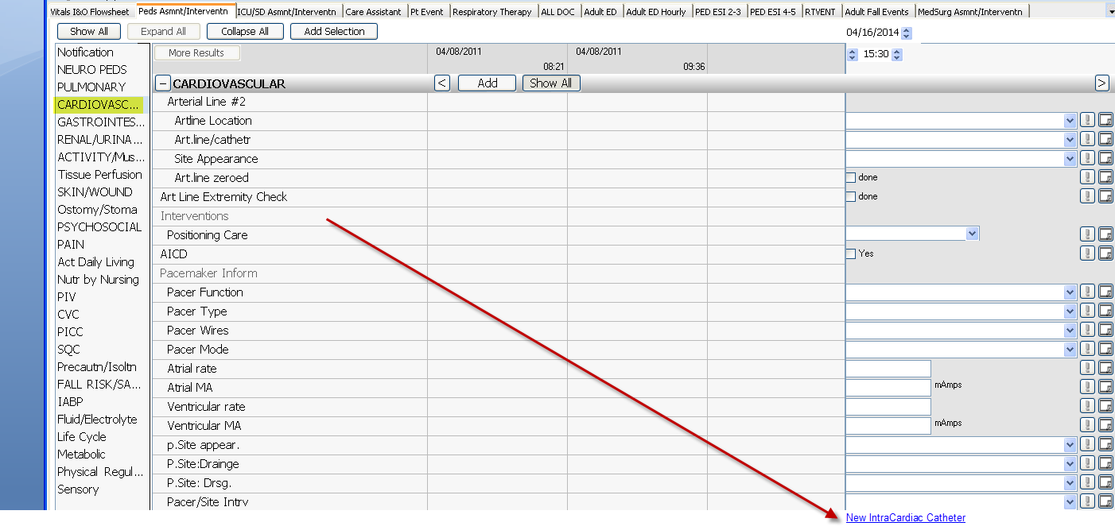

New IntraCardiac Catheter - Mandatory fields for IntraCardiac Catheter, Type, Site, Start Date
