*Due to JCAHO Survey,* ***the enhancements scheduled for July 24 were not done and have been rescheduled for release on Tue., July 31****. They are described again at the bottom of this e-mail. There will be* ***additional enhancements also ready for release July 31*:**

1. For **all of VUMC**, there is an addition to the Links available from HED Tool Bar. New Safety resources are now available:

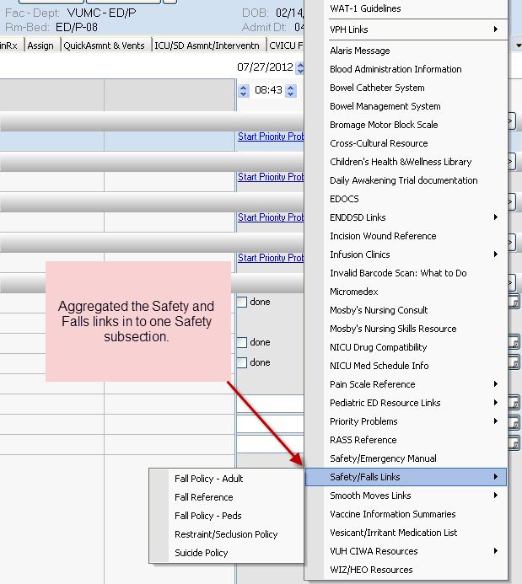

1. **For all of VUMC**, on the Plan of Care Tab, under Safety Problem options, Restraint Injury Risk is now an available option to select so no further need to select “Injury Risk – Other” and annotate “Restraint”.

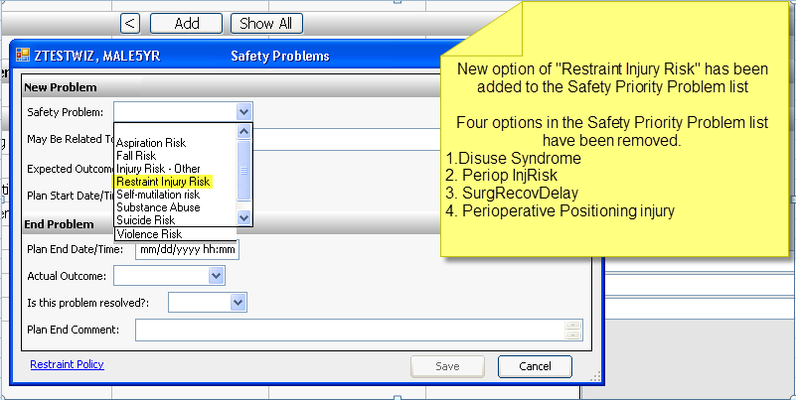

***The following changes were communicated last week but we not done as planned July 24:***

**These changes are all specific to OB and Children’s Hospital.**

1. OB Frequent Assessment tab:  Added “OBET called” to the Interventions drop-down.

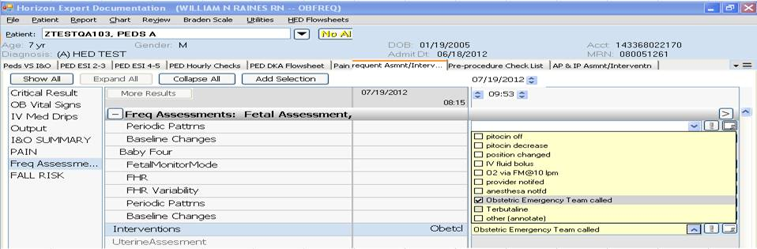

1. Also on the AP&IP tab:

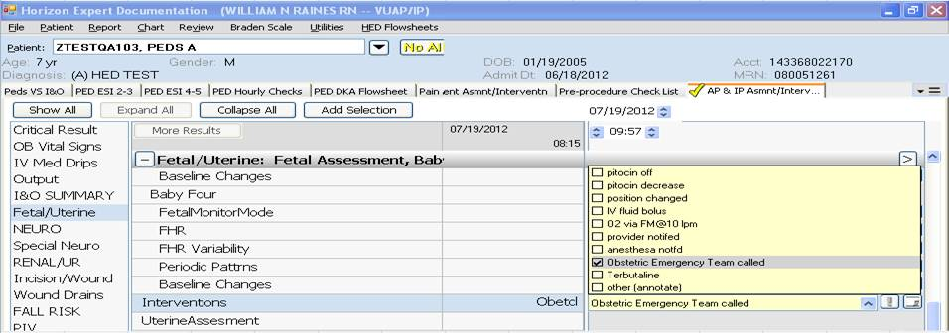

1. Newborn Nursery will now have the Newborn Nursery Flowsheet as their Default tab

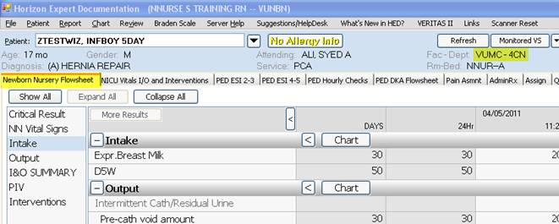

1. New link to the Children’s Hospital Health and Wellness Library on the LINKS menu:

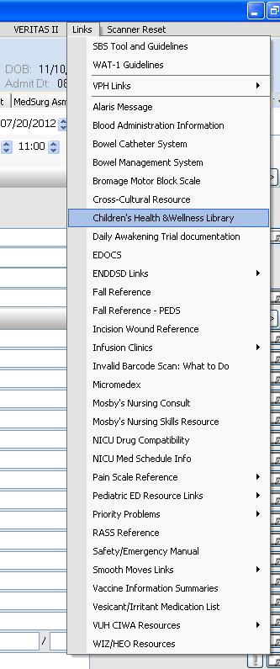

**Karen Hughart, MSN, RN-BC**

Director, Systems Support Services

1009 Oxford House

Vanderbilt University Medical Center

Nashville, TN  37232-4740

(615)936-6779

[karen.l.hughart@Vanderbilt.edu](mailto:karen.l.hughart@Vanderbilt.edu)