Non-Invasive Ventilation changes:

“Vapotherm” would be better charted as an oxygen therapy under Vital Signs; therefore, it is being removed from the NIV section. Instead, please use the “O2 Liter Flow” field by charting “Highflow Nasal Cannula.”

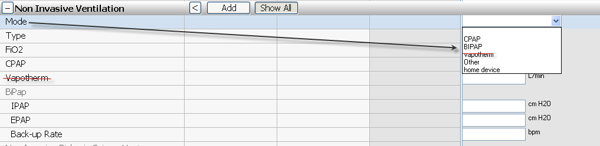

Vital Signs > O2 Liter Flow
Changes to the dropdown list:
- Brand names & redudancies are being removed
- NC-Highflow will be spelled out: Highflow Nasal Cannula
- “T tube” will be more appropriately named to “T-piece”
- The list will be resequenced with most common two on top, rest alphabetical, then Discontinued

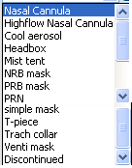
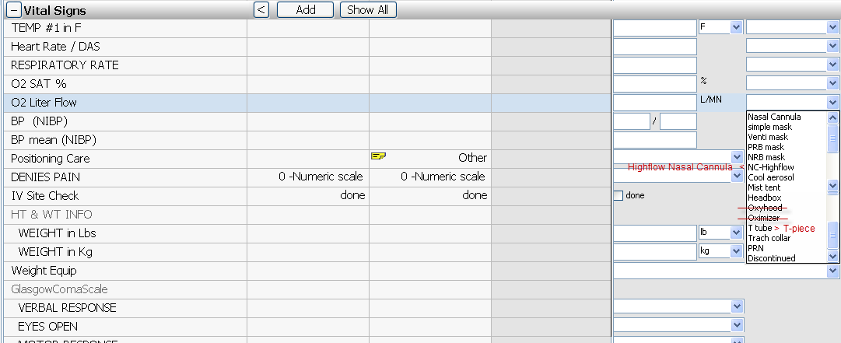

Assessments > Respiratory > IF Artificial Airway:
Changing AIRWAY POSITION to TRACHEA POSITION to more accurately reflect the concept:

