CVICU specific changes to HED
CVICU –
Additions to the CVICU flowsheet
Vital Signs> Added ICP value field
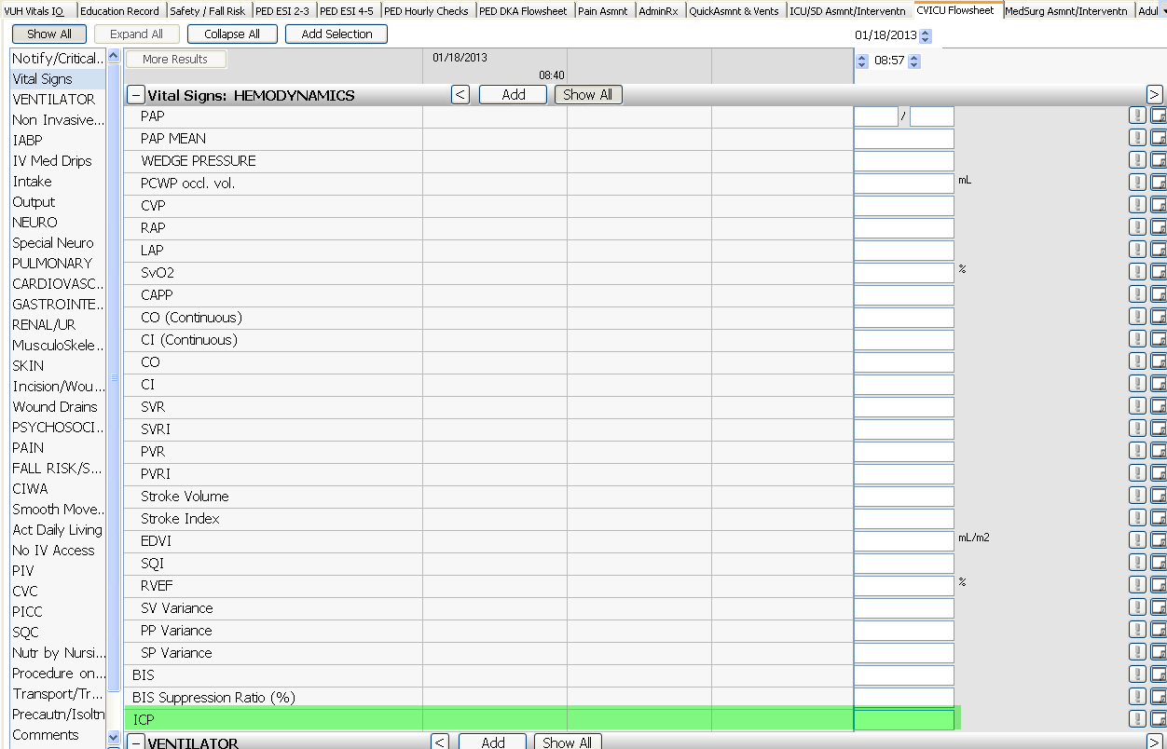

CVICU Special Neuro>Added the Lumbar Drain charting fields and CVICU will also see an additional field of LD Prescribed Pressure
