CRC/S31 is going Live with Priority Problems and Safety build
S31 before changes for Priority Problems
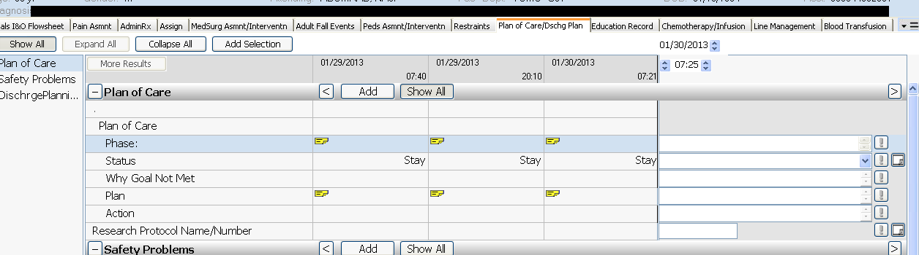

S31 after changes – any old charting will be viewable –
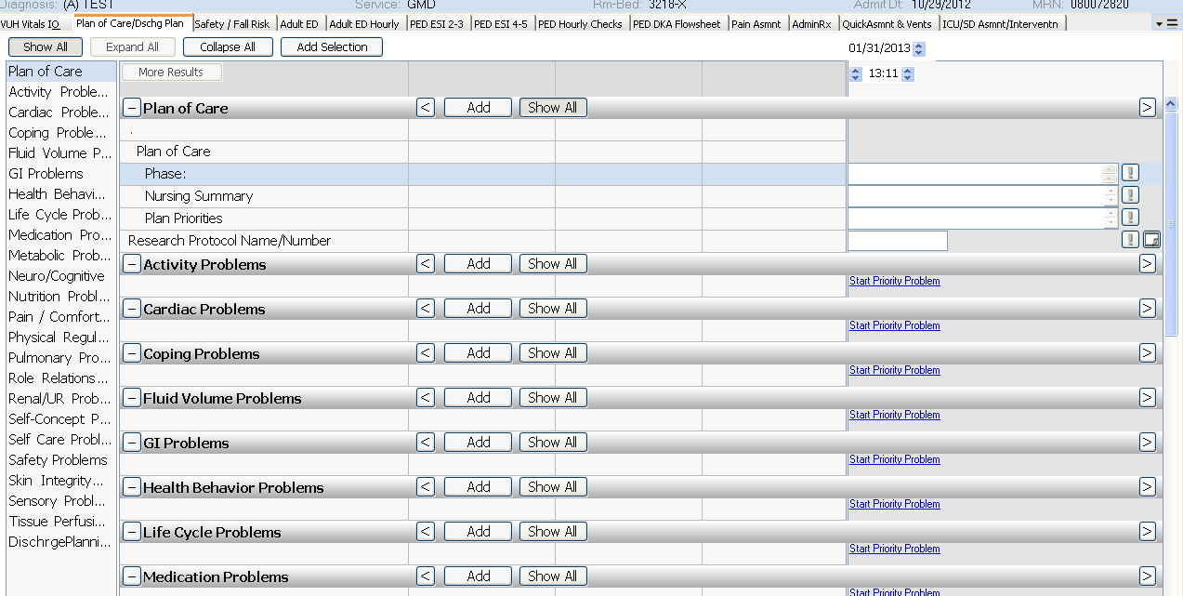

FALL RISK/SAFETY will be available for S31
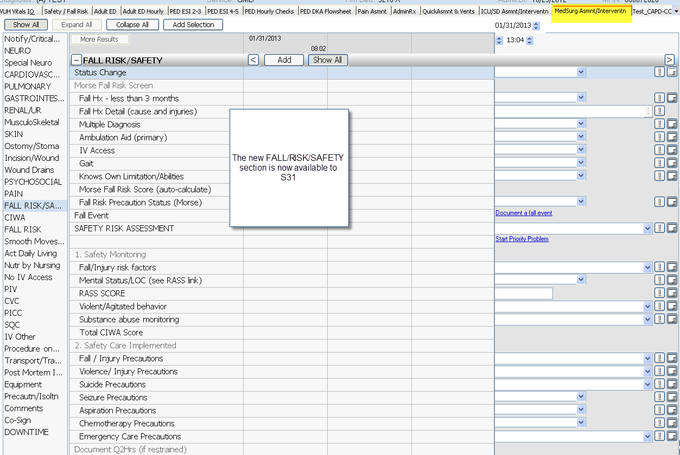

The old Fall Risk section will no longer be chartable. CIWA charting will now be available

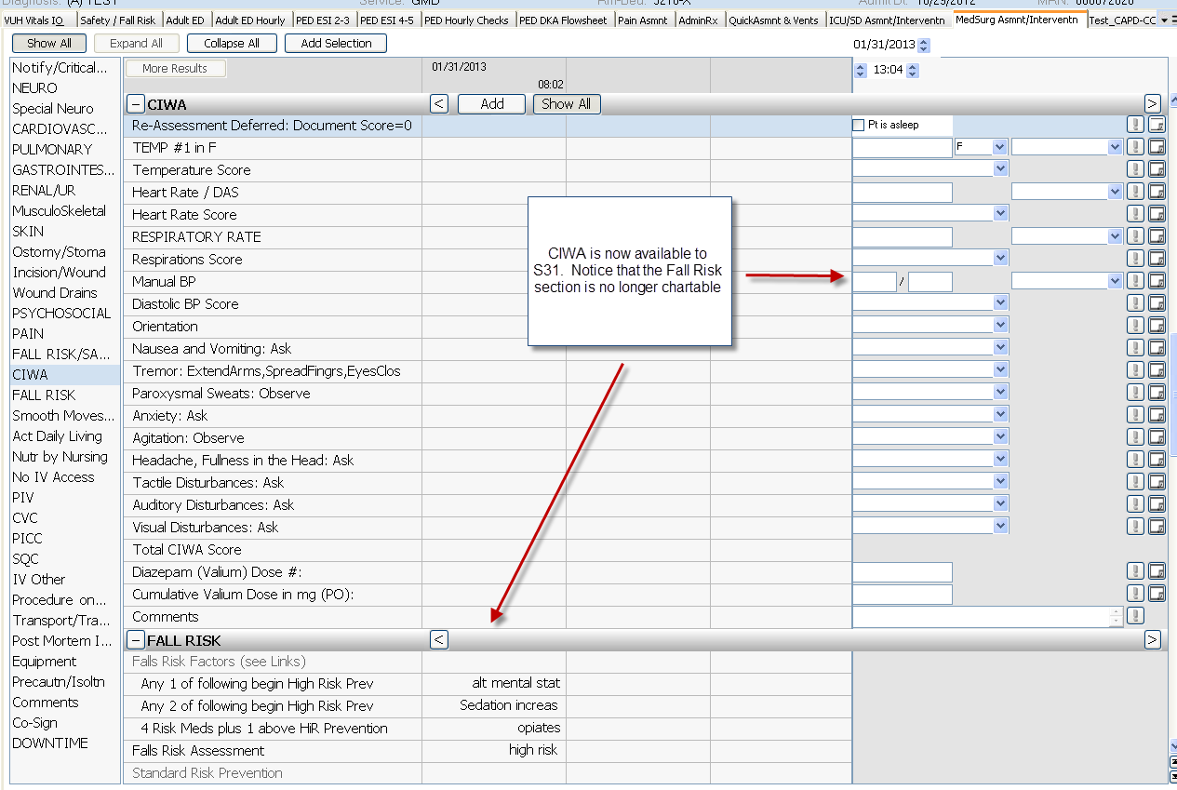

There has been a change in the Precaution/Isoltn section with revised options for “Type”. Any documentation on the old option will be viewable, but nurses will only be able to document on the new options
