For all VUMC units
Critical Results has been renamed Notify/Critical Results.
The current Critical Results are now No Charting allowed. Any prior documentation will still be visible.
The Notification results from Fall Risk/Safety have been added to the Notify/Critical Result documentation.
Notification Mode changed to Notification Mode/Readback.
Drop-down list re-sequenced and Critical value readback added.
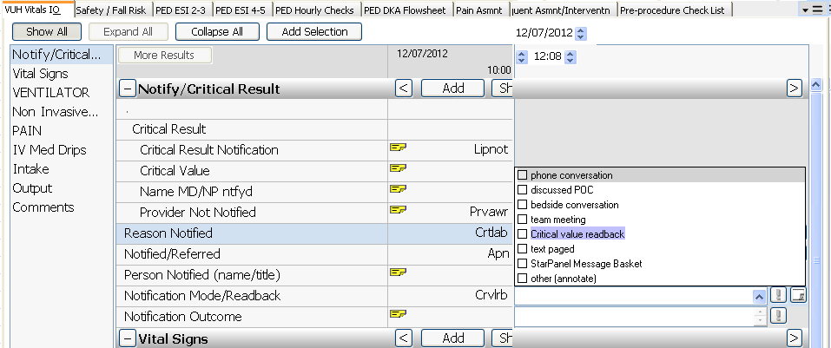

For all units that have the new Fall Risk/Safety
Asmnt Tabs>Fall Risk/Safety>Safety Care Implemented>Fall/Injury Precautions – “Door open” added to the dropdown list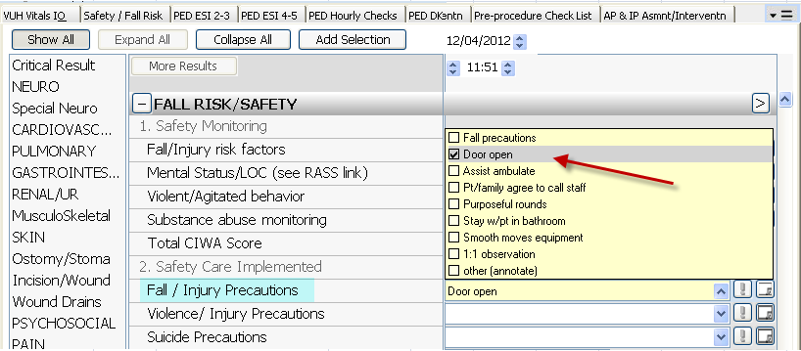

Injury Precautions Education is now forced display
