All VUMC except NICU> Assessment tabs>Fall Risk/Safety>Fall/Injury risk factors – addition to dropdown list of “Thought Process Alteration”.

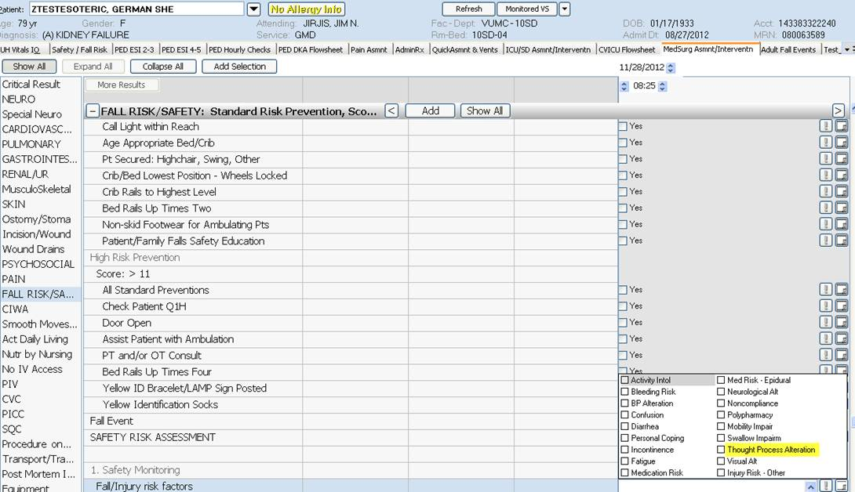

ALL VUMC> Expanded three legends in the Priority Problem for Neuro/Cognitive   
“Cognitive Alt” is now Cognitive Alteration,  
 Thought Process is now Thought Process Alteration, and   
Neurological Alt is now Neurological Alteration

