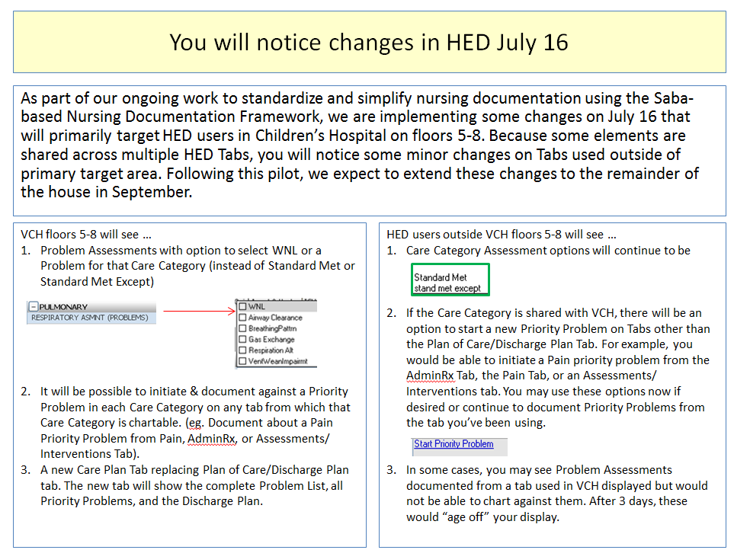

For all VUH:
- Priority Problems can be started from the Assessment tab:
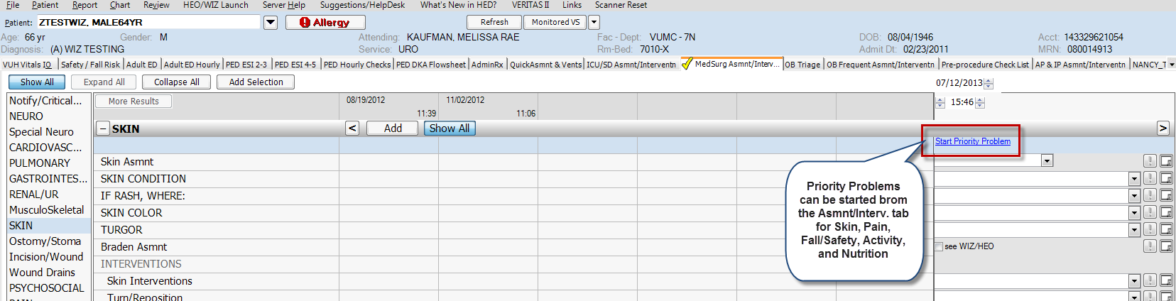
The “Reason Notified” drop-down list has been modified. Vital Signs & Temp are now separate from I&O.