All VUMC
Links menu - Added Krames Patient Education Resources: “Krames Adult” and “Krames Peds”
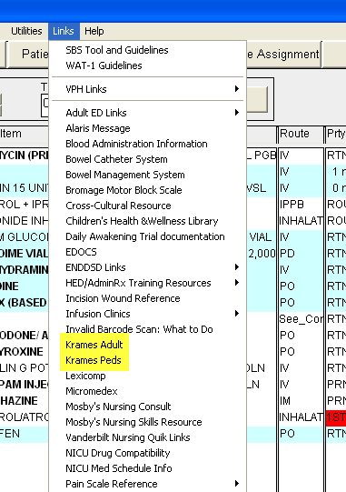

All Assessment/Intervention tabs - Procedure on Unit and Renal or GI/GU sections:
Added “In and Out Cath” field. This single field shares with both sections.
