All VUMC:

PIV Insertion:  Number of Sticks is now a required field for quality and auditing purposes.

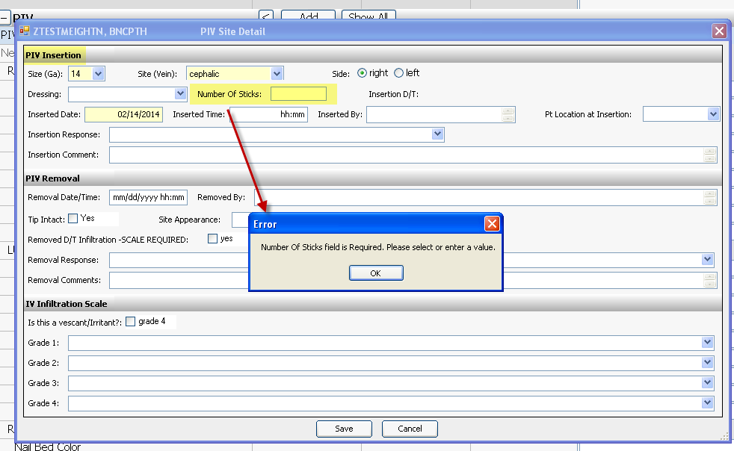  
Asmnt Tab >Skin/Wound > Skin Monitoring > If Rash, Describe – Added two options of “blanchable” and “non-blanchable”  
