**All VUMC** :

Education Record > Pulmonary Education – Adding 4 options:

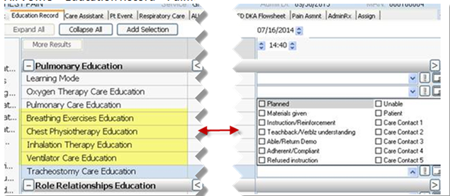

**All VUMC**:

Links Menu > Misc – Adding Mosby’s Nursing Consult

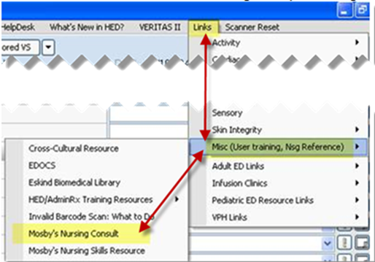

**All VUMC:**

1. Med List Tool (MLT) is embedded in provider  H&P forms.
   * If the nurse initiates the MLT the provider will see the med list created by the nurse to review/ edit and finalize and save to the Patient Summary.
   * If the provider finalizes the MLT before the nurse, the nurse **does NOT** need to edit the MLT unless additional information re: home medications is given by pt/ family.
   * *****If changes are made after the provider has finalized the MLT,  communicate these changes to the provider as needed.

