1. **Effective Mon., July 2:** Patients admitted as inpatient’s through the Admitting Office and ED Registration will have an electronic version of ***the Advance Directive Assessment*** (formerly known as the “Purple Form”) done on a Starform and saved to StarPanel. When doing their admission assessment, nurses should check for presence of this document in StarPanel. (Go to “All Documents” view. See below.)

If there is no an electronic version shown (as would be the case for “Direct Admits” or patients who otherwise by-pass regular registration processes), nurses should complete a paper version (available from E-Docs). Once completed, it should be scanned into StarPanel for access by all team members.

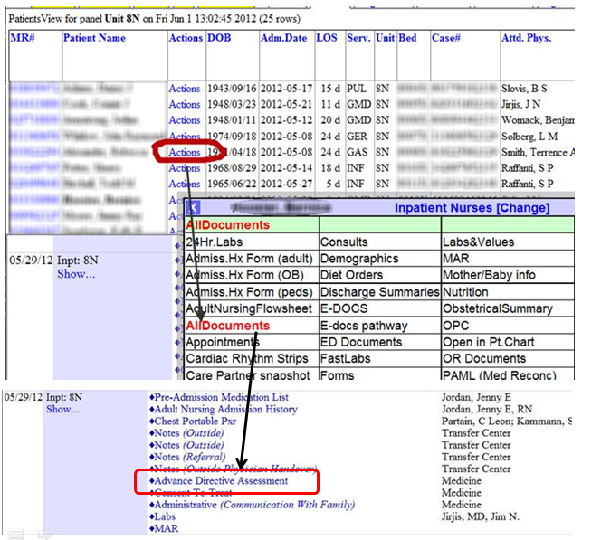

1. **Effecitve Mon., July 9**, we will implement a new ***Vancomycin Advisor in HEO/Wiz*** that will support safer ordering of this drug. At that time, you will see new Messages in Care Organizer with specific date/time instructions to draw Vancomycin trough levels before a specific dose. The attached one page Power Point slide is copied below to show these changes and how to address the prompt in AdminRx. We will include this reminder in the next couple of HED updates as a reminder.

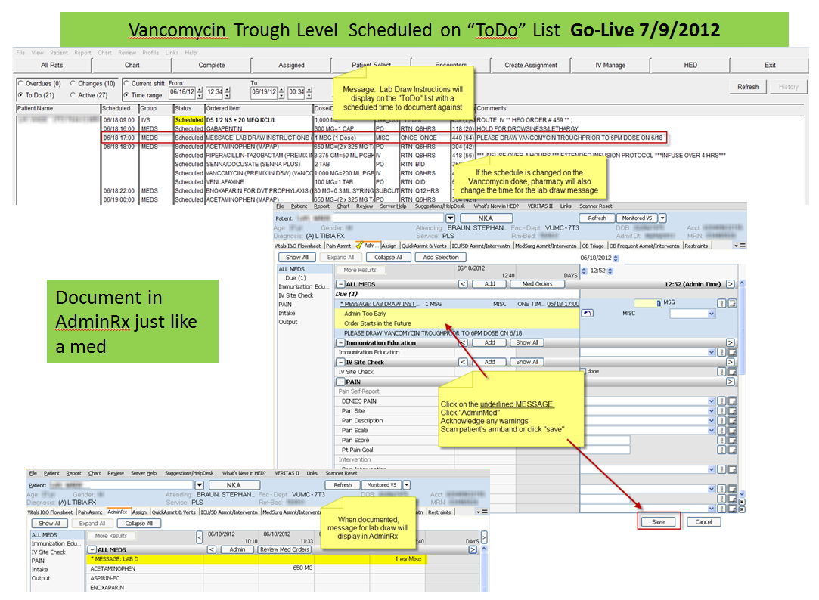

**Karen Hughart, MSN, RN-BC**

Director, Systems Support Services

1009 Oxford House

Vanderbilt University Medical Center

Nashville, TN  37232-4740

(615)936-6779

[karen.l.hughart@Vanderbilt.edu](mailto:karen.l.hughart@Vanderbilt.edu)