Modifications to Adult ED Documentation in HED: 2/12/13
Added “Assessment -Standard Met” fields to ALL CAPS Systems (AIRWAY/BREATHING, CIRCULATION, NEUROLOGICAL, HEAD/NECK, GASTROINTESTINAL, RENAL/UR, PYSCHOSOCIAL). These are borrowed from the Med/Surg tab and will share.
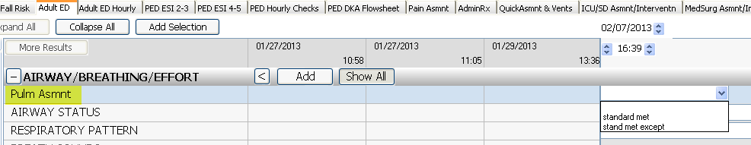
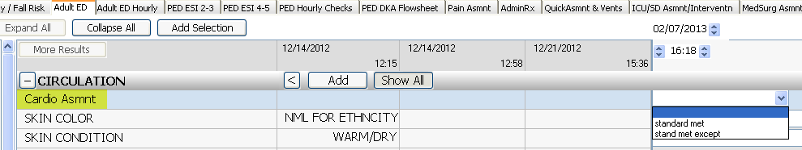
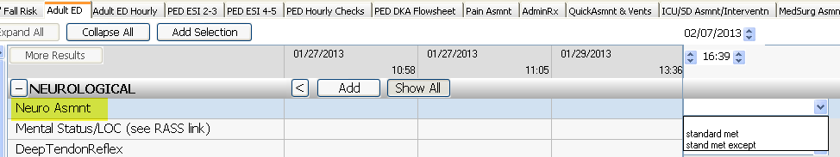
(etc.)

Changed name of ADMIT/DISCHARGE/TRANSFER section to DISPOSITION
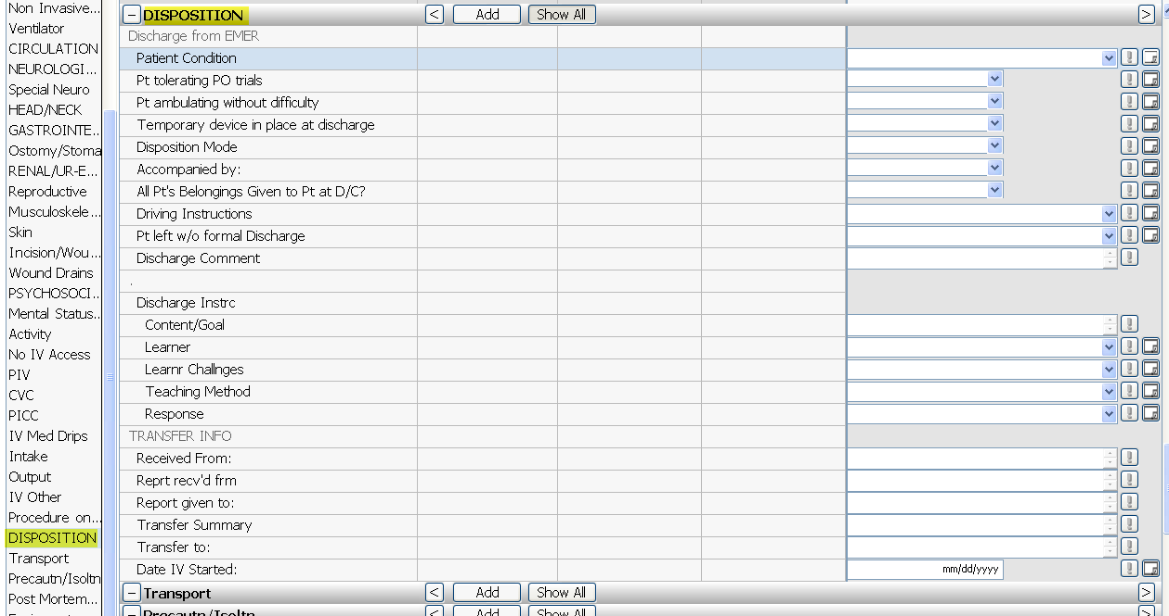
DISPOSITION section:
- Added field for “Pt Tolerating PO Trials”
- Added field for “Pt Ambulating without Difficulty”
- Modified field “Accompanied by:” to include “self” in the dropdown
- Removed separate field for “Pt left without formal D/C Instructions”
- Modified existing field, “Pt left without Formal D/C” to be a dropdown with the following options:
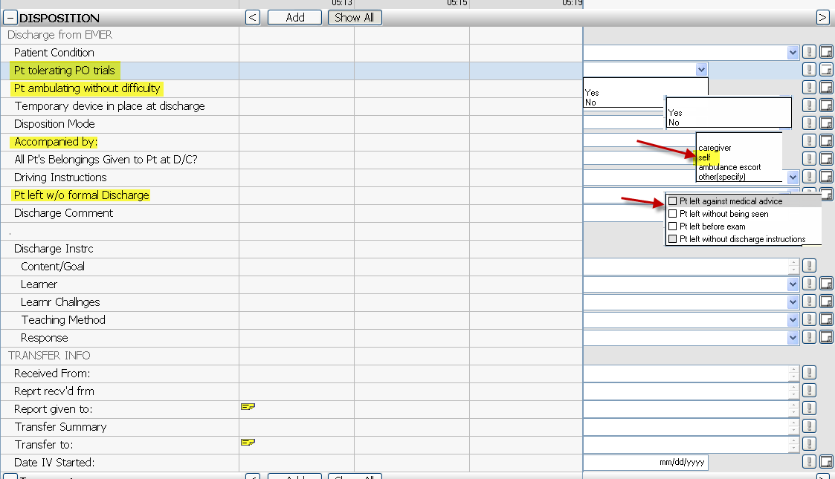

DISPOSITION section: Removed charting capability for “Patient Admitted” fields (any previous charting will display):

Separated out “Transport” Section
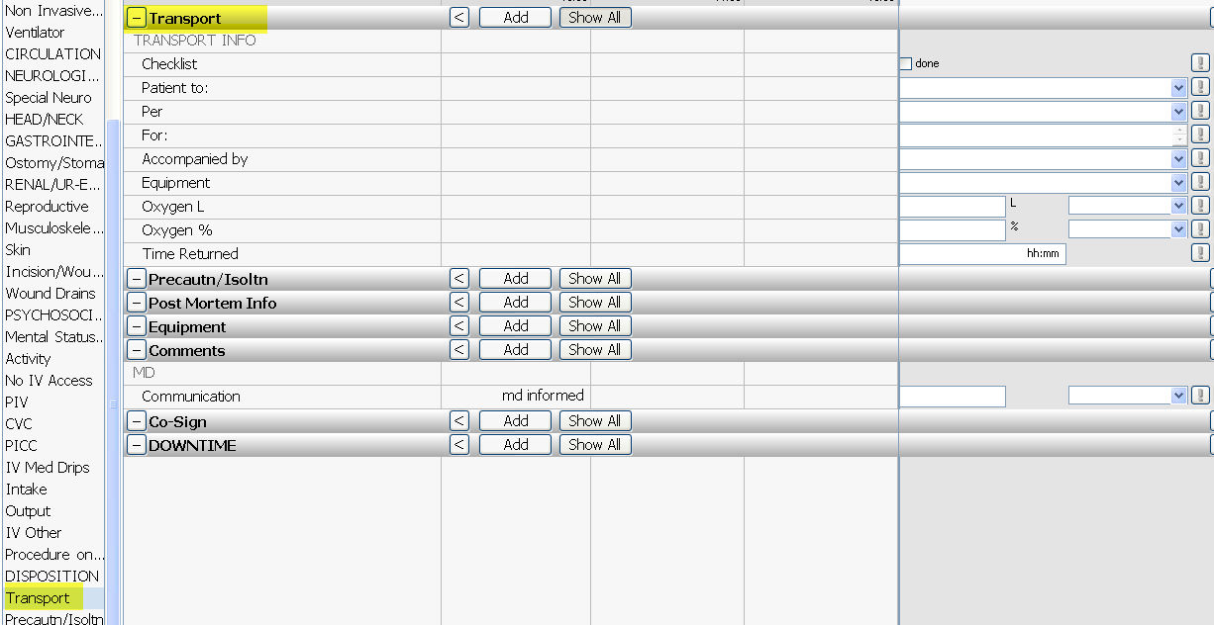

Added “Transport” section to the ED Hourly Tab:
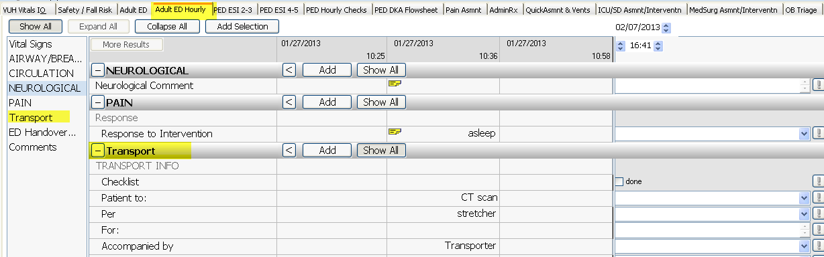

Created new “ED Handover of Care” section on ED Hourly tab. The two fields are pulled from the “Transfer” section and will share. This is intended for “SBAR” handoffs between ED RNs:
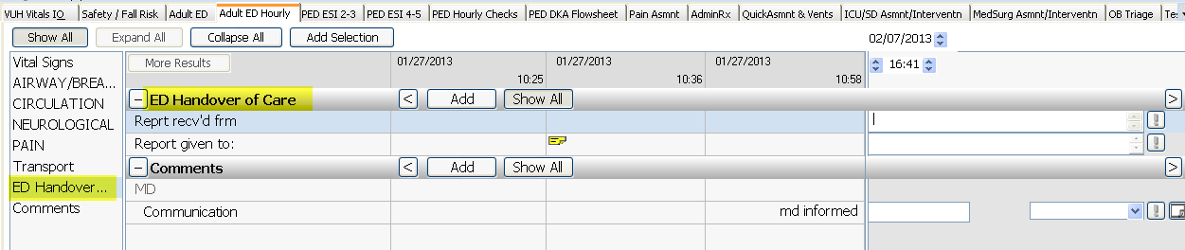

Added “Activity”section to include Ambulation and Turn/Reposition. These share with the Activities of Daily Living section on the Med/Surg tab:
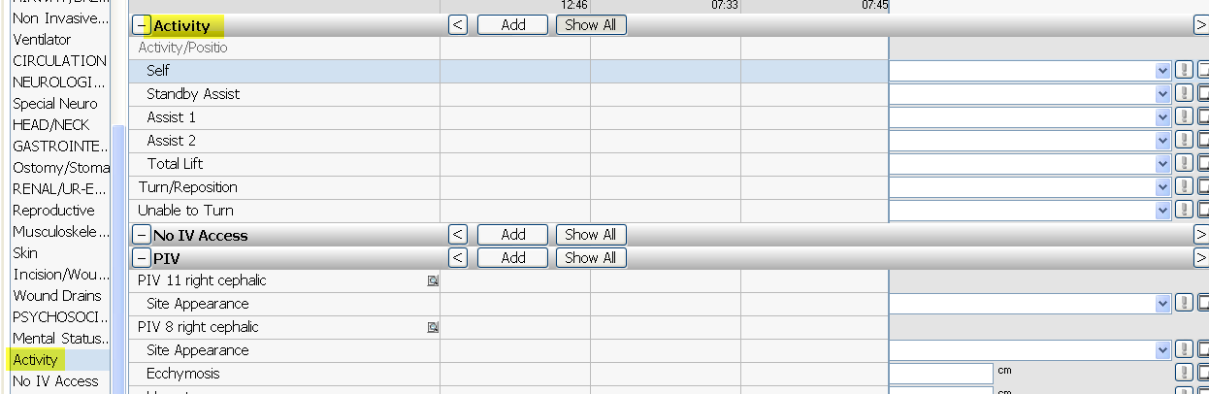

Procedure on Unit > Consult at Bedside fields > Added “Emer General Surgery”
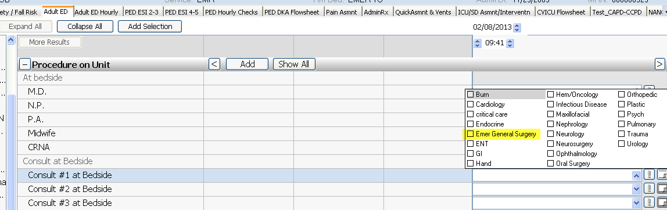

Moved FALL RISK/SAFETY section up on Adult ED tab - under ARRIVAL
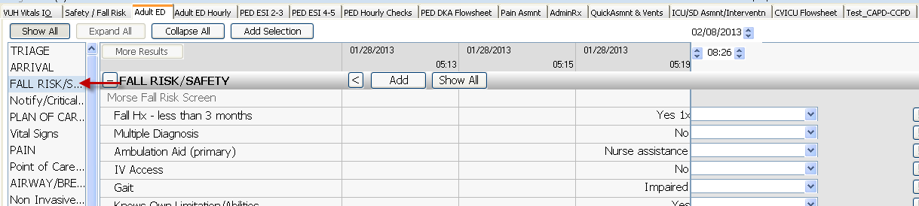

Added Co-Sign section to Adult ED tab
