**VUH - Adult ED - AIRWAY/BREATHING:**

IF Trach/Aiway > AIRWAY TYPE:  Added “Oral ETT” to dropdown:

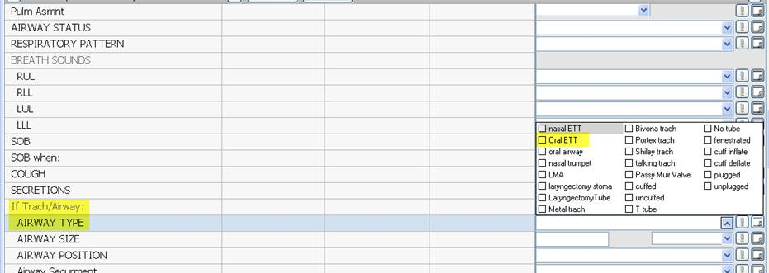

**Adult ED and Peds ED** - HEAD/NECK:

Added options to dropdowns:

