Nursing Admission History status indicator.
- When a patient is admitted to the facility, an indicator is started to monitor documentation completeness.
- The indicator will display a yellow background to show that a nursing admission history needs to be completed.
- If a nursing admission history is started and saved as draft, the indicator will display a yellow background and a capital D to show a draft form is available.
- If the nursing admission form is not started or saved as final within 24 hours of admission, the indicator will display 2 red ?? to show overdue/incomplete documentation.
- When the nursing admission history is saved as final, the indicator will display a green background.
Screenshots with each status on the next page.
If a patient is discharged from the facility with an incomplete nursing admission history (not started or still in draft status) and subsequently readmitted to the facility, the indicator resets to a new admission (does not display status for the prior admission).

Patient admitted to the facility. Indicator shows a yellow background to show nursing admission history needs to be completed.
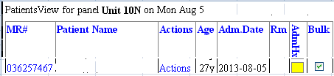
A nursing admission history form has been started and saved as Draft. Indicator displays a yellow background with a capital D to show that draft form started.
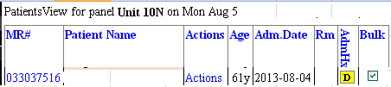

Nursing admission history not saved as final within 24 hours of admission time. Indicator displays a clear background and 2 red ?? to show overdue documentation.
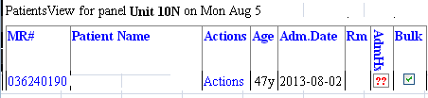

Nursing admission history has been saved as Final. Indicator displays a green background.
