New charting fields added to the Admission Hx forms for Febrile Traveler Screening. If the first question is answered “No”, no further screening is required
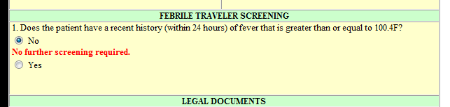
If the answer to question #1 is “Yes”, questions #2 and #3 need to be answered
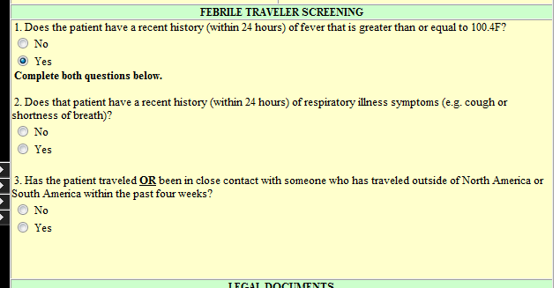
In question #2, if either “Yes” or “No” are answered, question # 3 needs to be answered.
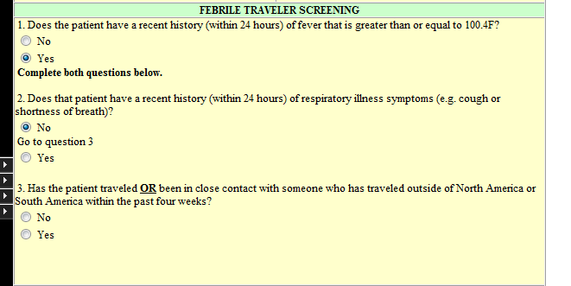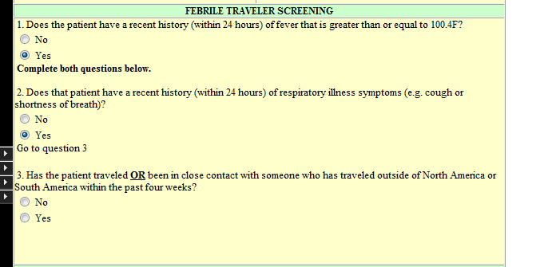

If the answer to question #3 is “No”, no further screening is required
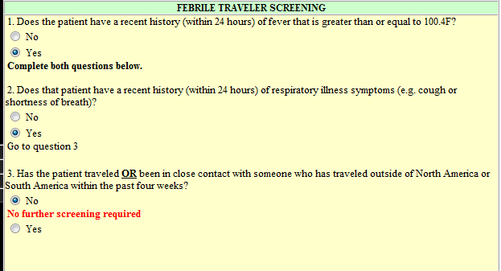

If the answer to question #3 is “Yes”, instruction are provided on nurse actions
