**Attention!**

**Admission History Changes to be released 9/24/12. *Please Print, Post and Share!***

**Influenza Screening returns to the Adult, OB and VPH Nursing Admission history.**

**If the patient does not have a documented flu shot this flu season, you will see this:**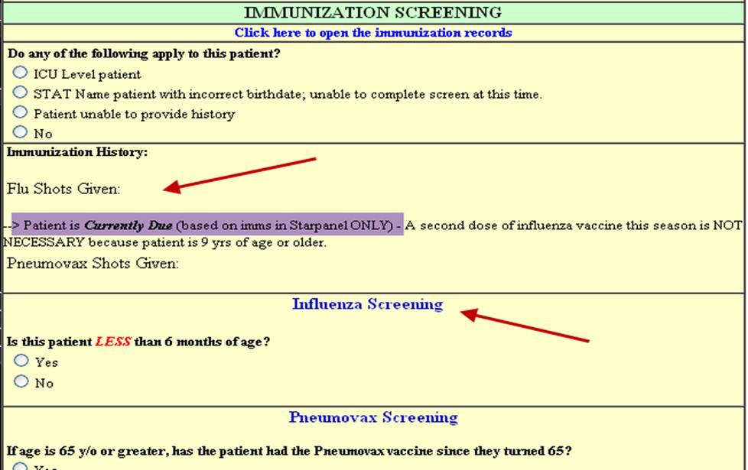

**Screening questions remain the same as last year’s.**

**If the patient is up to date on immunizations, you will see this:**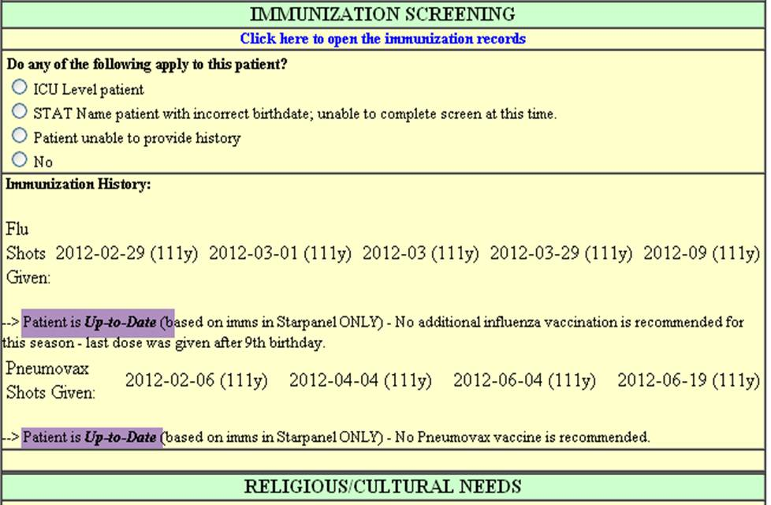

**The screening sections are not displayed if the patient is up to date per Starpanel records**.  
  
**If the patient has received a flu shot, but it is not documented in Starpanel, you will be able to enter the date received here:  
if the exact date is unknown, month/year only is allowed:**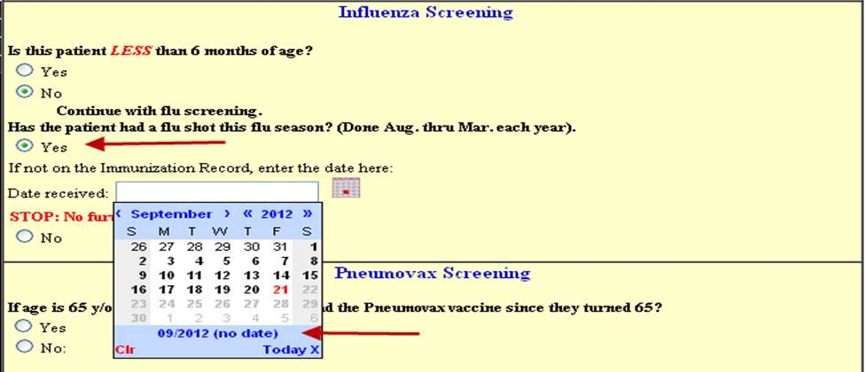  
**If the patient has not received a vaccination this flu season, does not decline the flu shot, and has none of the listed exclusion criteria, a protocol order will be sent from the admission history when this selection is clicked:**  
