VANDERBILT UNIVERSITY
DEPARTMENT OF ANESTHESIOLOGY

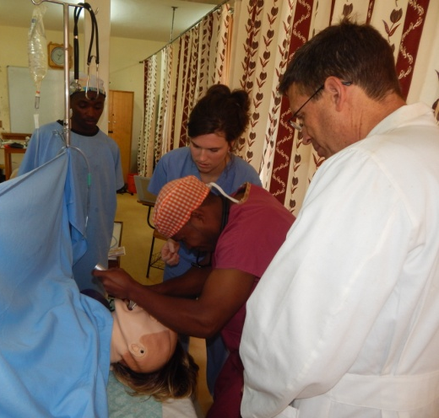 | 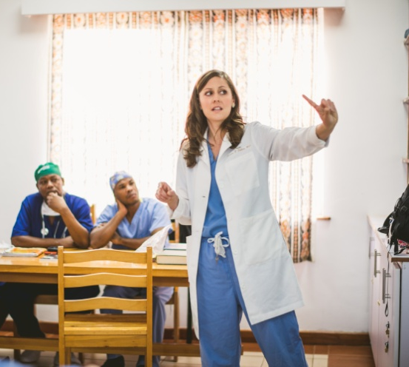 | 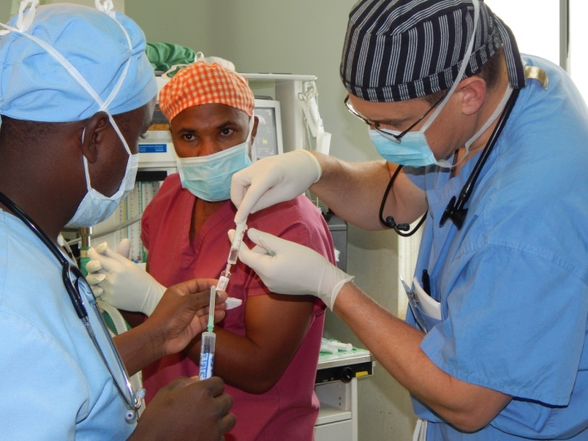

Vanderbilt International Anesthesiology
Kenya Elective Rotation Handbook
(Updated May 2016)



Vanderbilt University School of Medicine
Department of Anesthesiology
Office of Educational Affairs
2301 Vanderbilt University Hospital
Nashville, TN 37232-7237
p. 615-936-3415
f. 615-936-3412
Improving International Anesthesia Care
Through Education and Research

TABLE OF CONTENTS
PROGRAM CONTACTS 4
ONE PERSON CAN MAKE A DIFFERENCE 5
ABOUT THE ROTATION 6
ELIGIBILITY 6
VOLUNTEER OPPORTUNITIES 7
PREPARING FOR YOUR TRIP 8
Pre-Departure Planning 8
Suggested Reading 10
Smart Traveler Enrollment Program (STEP) 10
Passport 10
Medical Insurance 11
Travel Exam and Medicine 11
Medical Licensure 12
Other Required Documentation 13
Air Travel 14
Emergency Travel Assistance 14
Kenyan Visa 15
Finances 16
Laptops 16
Host Gift 16
What to Bring 17
WHEN YOU ARRIVE 18
Customs Declarations & Visa 18
Luggage Collection 18
Money 19
Transport & Lodging 19
Shopping (applicable for self catering accomodation at Kijabe) 19
ON THE GROUND 21
About Kijabe 21
Health Issues 23
Transportation and Travel 23
Door-to-Door Vendors (applicable in Kijabe) 23
Cultural Sensitivities 24
BEFORE YOU LEAVE 26
Settling Accounts 26
Donations 26
Transport 26
WHEN YOU RETURN 26
Case Log & Trip Report 26
Expenses and Reimbursement 26
ATTACHMENTS 27

PROGRAM CONTACTS

 | Mark Newton, MD  mark.w.newton@Vanderbilt.Edu  Dr. Newton is an Associate Professor of Clinical Anesthesiology and serves as Director of Vanderbilt International Anesthesia (VIA) and Chief of Anesthesiology at Kijabe Hospital in Kenya. Dr. Newton and his family moved to Kenya in 1997 and at this time he developed a nurse anesthesia program in East Africa based at Kijabe Hospital. He has been instrumental in the establishment of Kijabe Hospital as one of the premier surgical educational hospitals for rural Africa.
 | Matt McEvoy, MD  matthew.d.mcevoy@vanderbilt.edu  Dr. McEvoy is an Associate Professor of Anesthesiology and serves as Vice-Chair for Educational Affairs and Program Director within the Department of Anesthesiology. With a longstanding interest in international health, Dr. McEvoy serves as the stateside advocate for the VIA program which he desires to grow by increasing resident participation.
 | Jenny Venecek  jennifer.venecek@vanderbilt.edu  Jenny Venecek is the Program Manager for ImPACT Africa and serves as Program Coordinator for the VIA Kenya Rotation at Kijabe Hospital and Jaramogi Odinga Oginga Referral and Teaching Hospital.
Dr. Lisa Mudola
mudola.manyano@cphdev.org

Dr. Mudola serves as the Director of the Anesthesia Training program based at Jaramogi Odinga Oginga Teaching and Referral Hospital implemented through the Kenya Medical Training College. This program trains both Clinical Officers and Nurse Anesthetists.

ONE PERSON CAN MAKE A DIFFERENCE
Congratulations on your decision to take advantage of the Vanderbilt International Anesthesiology (VIA) elective rotation in Kenya. You are preparing to complete an exciting and challenging rotation at our partner sites; Kijabe Hospital and/or Jaramogi Odinga Oginga Teaching and Referral Hospital (JOOTRH) that will enhance your professional and personal growth.

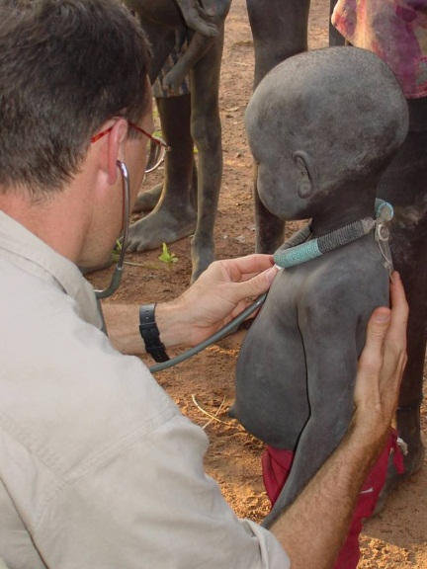
The overriding objective of VIA is to benefit the lives of others by sharing the Department’s institutional strengths and resources, the most valued of which is you. Through your service, significant benefit will be immediately provided to the underserved through relief of their pain and suffering. As this is an educational experience for you, we hope that your experience caring for patients with significant co-morbidities in a busy, under-equipped facility will be as rewarding as it is challenging An additional benefit to you will be the positive relationships you will build with those you serve and your colleagues working within the international community.


People in developing countries are dying for shortage of trained professionals and equipment for the provision of safe anesthesia. With your decision to share your professional medical knowledge and develop the skills of others you have dramatically affected the healthcare of a continent.

Thank you for your investment in global health!
ABOUT THE ROTATION
The block structure of this 4-week rotation is as follows with your choice of chronology:
- Three (3) consecutive weeks of work in Kenya
- One (1) week of vacation

You may choose to stay in Africa for your vacation or return to the United States. As an alternative to your vacation week, you may also elect to return to work at Vanderbilt.

As a VIA resident you will be teaching knowledge and clinical skills to local anesthesia practitioners and perioperative nurses. You will also have extensive opportunities to develop regional anesthesia skills that may be underutilized in contemporary western practice. You will be expected to be part of the anesthesia team in the Operating Room (theatre) including clinical care and teaching. The theatre starts at 8 am. An exception to this applies in Kijabe where it starts later on Wednesday due to weekly hospital-wide chapel service. Each anesthesia resident will take ICU call only with back-up by Dr. Newton/Dr. Mudola, if needed.

A minimum of two (2), 30-45 minute educational lectures will be prepared and presented by each resident at a Kenya nurse/clinical officer anesthesia student level. The presentations can be given on the topic of your choice (unless Dr. Newton/Dr. Mudola gives you an assignment) and should consist of 20-30 slides. You will need to leave a copy of each presentation in the lecture library for future classes.

See Attachment 1. VIA Clinical Curriculum for a more detailed description of work goals, guidelines and responsibilities.

ELIGIBILITY
CA-3 resident physicians and fellows are eligible to participate in this program. Exceptions to this policy will be made on a case by case basis by Dr. Newton and Dr. McEvoy. Priority will be given to senior residents, those who choose to contribute vacation time to the program, and those who have not taken a previous trip with VIA. Only individuals who are in good standing in the program are eligible. In addition, residents must hold a valid and active Tennessee medical license.

Residents interested in participating must notify Dr. Matt McEvoy, Program Director, and complete the rotation request form sent out by the chief residents. This must be done in late March/early April prior to the completion of the annual master rotation schedule.

Following approval by Dr. McEvoy, the request will be submitted to Dr. Mark Newton, VIA Program Director, in order to coordinate the rotation with the Kijabe Hospital/JOOTRH. The final schedule will be approved by Dr. McEvoy.

VOLUNTEER OPPORTUNITIES

If you are interested in bringing your spouse, there are dozens of ways they can make a significant and much appreciated contribution to Kijabe Hospital.

Needs vary, but possibilities include:
- Chaplaincy
  - Bedside evangelism
  - Play with children (puzzles, simple board games, crafts), Bible Stories.
  - Sewing, cooking, or visiting Somali patients
- Operating room
  - Sterilizing and folding packets
- Central medical store
  - Organizing and arranging donations
- Library
  - Arranging books, coding, cataloguing, classification, internet services
- Kijabe school of nursing
  - Filing, photocopying, word processing, preparing paperwork
- Engineering & Maintenance Work
  - Painting, carpentry, auto-mechanics, welding, engineering, plumbing, biomedical engineering, electrical work
- Gardening

Dr. Newton’s wife, Sue Newton (mama.newtontano@gmail.com), is a great contact for discussing these opportunities as is the Chaplain Director, Pastor Ndivo (chaplaindir.kh@kijabe.net).
See also Welcome Pack APPENDIX VII: FAMILY VOLUNTEER OPPORTUNITIES AT KIJABE

PREPARING FOR YOUR TRIP

Pre-Departure Planning

One Year Ahead
- Notify Resident Program Director of intent to rotate to Kijabe.
- Submit rotation request form to Chief Residents (late March/early April).
- Apply for Tennessee Medical License if necessary (will need in hand at least 4 months prior to rotation).

Six months ahead
- Apply or renew passport if necessary (must be valid for at least 6 months AFTER your return).
- Enroll in U.S. Department of State’s Smart Traveler Enrollment Program (STEP) to receive information and travel warnings. Create account at: https://step.state.gov/step.

Four months ahead
- Complete Application for Temporary Kenyan Medical License, Personal Information Form, Kijabe Hospital Code of Conduct (where applicable), and Budget Form (where applicable) and submit to the VIA Program Coordinator.

Two months ahead
- Book airfare – Regarding your airline travel to Kenya, Dr. Newton recommends that all visitors use British Airways and connect Chicago to London to Nairobi, or KLM through Amsterdam. British is not a provider through the Concur site so you will need to call Corporate Travel Management (who partners with Concur) to make these arrangements (1-866-303-1019). Even if you decide to use KLM via Amsterdam, please call Corporate Travel Management for their assistance in making your flight arrangements. This insures you are automatically registered for International SOS (ISOS). We typically book flights for Saturday departure from Nashville arriving in Nairobi on Sunday evening.

Return flight information if you are vacationing in another country: When you speak with Corporate Travel Management and make your reservations through Concur, CTM will need to give you the flight costs from both Kenya and from your vacation destination for the day you are leaving. If the flight from your vacation destination is more expensive than flying home from Kenya, you will need to pay the difference. (Please make sure to give the VIA Program Coordinator both figures.)

- Set up pre-travel consultation with VU Occupational Health Clinic (615-936-0955), receive immunizations. (NOTE: If you need hepatitis A or B vaccinations, you will need to get started at least 6 months prior to departure.)
- Visit VU Travel Clinic if required to receive yellow fever vaccine.
- Prepare two (2), 30-45 minute educational lectures to be delivered to the Kenya nurse/clinical officer anesthesia students.

One month ahead
- Apply online for your Kenyan visa (See page 15 for instructions).
- Arrange for payment of your rent, utilities, loans, insurance, and other bills.
- Finalize any shift swaps or clinic changes necessary to clear your clinical schedule.
- Check your insurance plan for international coverage. Purchase supplemental insurance if needed.
- Vanderbilt has contracted with International SOS to provide emergency travel assistance and evacuation services for all students, faculty and staff members traveling internationally on Vanderbilt related business. Read a summary of services here. Prior to embarking on an international trip, all VU travelers should complete the Personal Traveler Locator on the portal which is located on the International Travel and Safety website at http://www.vanderbilt.edu/gss/travel/International-travel-registration.php. This ensures coverage and provides the contact information needed by ISOS and Vanderbilt to locate the traveler in the event of a crisis or emergency. After you have completed the ISOS information, you may either print a card to carry with you or get one from the VIA Program Coordinator.
- Notify your bank and credit card company of your travel so a hold is not placed on your account.

A few days ahead
- Submit copy of health insurance card and Emergency Contact Form to VIA Program Coordinator.
- Pick up supplies and donation letter for transport in luggage from VIA Program Coordinator.
- Make copies of first 2 pages of passport – place in each item of luggage along with address of Kijabe Hospital (recommended).
- Re-read “When You Arrive” section of Handbook.

Suggested Reading
This manual is a supplement to the documents provided by Kijabe Hospital which includes:
- AIC Kijabe Mission Hospital Welcome Pack (Attachment 2)
- Medical Orient - Doctors and Trainees (Attachment 3)

Please read and review all documents carefully. The purpose of these is not only to prepare you for your journey and return to Vanderbilt, but also to help you make the most of your international experience. If at any time you have questions, comments, or suggestions, please contact Jenny Venecek, Dr. Newton, or Dr. McEvoy.

Dr. Newton also suggests reading the following articles on global health ethics:

Crump JA, Sugarman J; Working Group on Ethics Guidelines for Global Health Training (WEIGHT). Ethics and best practice guidelines for training experiences in global health. Am J Trop Med Hyg. 2010 Dec;83(6):1178-82. (Attachment 4)

White M, Evert J. Developing ethical awareness in global health: four cases for medical educators. Dev World Bioeth. 2014 Dec;14(3):111-6. (Attachment 5)

Smart Traveler Enrollment Program (STEP)
All trainees are encouraged to sign up for the Smart Traveler Enrollment Program (STEP), a free service that allows U.S. citizens and nationals traveling abroad to enroll their trip with the nearest U.S. Embassy or Consulate. STEP enrollment gives you the latest security updates, and makes it easier for the U.S. embassy or nearest U.S. consulate to contact you in an emergency.
Visit step.state.gov to enroll so that you are connected when you arrive.

Passport
Participants need a passport that is valid for at least 6 months after your return date. Start this process as soon as possible if you do not have a passport or if it will expire too soon.

Passports are at high risk for theft and should be carried and stored securely. It is recommended to make copies of the first two pages and place a copy in each item of hand-carried and checked luggage. If your passport is lost these copies should speed replacement along.

Visit passports.state.gov for information regarding passport application and renewal.

Medical Insurance
Before you travel, it is important to know how your medical insurance coverage works and that your medical insurance needs are covered. Please check with your medical insurance carrier before departure to see how your health insurance applies out-of-the-country and if they offer specific out-of-the-country insurance. You may want to purchase supplemental travel insurance, especially if you will be out of the country for a long period of time.

Travel Exam and Medicine
All Vanderbilt faculty and staff who will be conducting business which requires international travel need a pre-travel consultation with the Occupational Health Clinic. During this consultation, a customized healthcare plan for your business travel will be prepared. This includes:
- Destination specific vaccinations and prescription medication
- Medical travel kit
- Travel health and safety advice

A clinic team member will assist you in determining the immunizations that you will need for your trip. In addition to routine vaccines being up-to-date recommendations for travel to Kenya include:
- Hepatitis A
- Typhoid
- Polio

The yellow fever vaccine is required. You will need to set up a separate appointment with the Vanderbilt Travel Clinic. They are the ONLY Vanderbilt clinic authorized to dispense the yellow fever vaccination.

Malaria prophylaxis is required. Although not always practiced in Kijabe, it is a necessity for short-term visitors especially those going to JOOTRH. You may need to take prescription medicine before, during, and after your trip. This will be prescribed at the OHC and may require an additional fee which is reimbursable.

Schedule your pre-travel consultation by calling 936-0955. The OHC will send you a pre-travel survey to complete prior to your appointment. Visits for pre-travel consultation and vaccines last about an hour, so plan accordingly.

See also Welcome Pack 2.4 TRAVEL MEDICINE SUGGESTIONS

Medical Licensure
After rotation dates are confirmed, you will need to obtain a Kenyan Medical License. Licensing requirements must be met and the Kenya Medical License application form with photo must be submitted a minimum of four (4) months ahead of travel.

All physicians must send the following in order to obtain a Kenya medical license that allows one to practice medicine legally in AIC Kijabe hospital:

- Completed Medical Practitioners and Dentists’ board “license to render” application.
Please fill out section 9 as follows:

 | KIJABE HOSPITAL | JOOTRH
Name of employer: | AIC Kijabe Hospital | Jaramogi Odinga Oginga Teaching and Referral Hospital
Address | P.O. Box 20, Kijabe, Kenya | P.O. Box 1818
Code: | 00220 | 40100
Email: | medstaffcoord.kh@kijabe.net
Tel No.: | 020.324.6216

- Copy of medical school diploma and all professional certificates
- Copy of current/last medical license
- Copy of registration certificate from respective medical board/council/state
- Letter of good standing issued within the past six months by your state or other official licensing board. (Requested by VIA Program Manager)
  - https://apps.health.tn.gov/licensure/
  - Tennessee Medical Examiner’s Board
227 French Landing, Suite 300, Nashville, TN 37243
(615) 532-3202
- Introduction letter/job offer from AIC Kijabe Hospital/JOOTRH (Requested by KH Medical Staff Coordinator)
- Copy of the front page of your passport
- Colored passport size photo (attached to application)
- Curriculum vitae

The VIA Program Manager will contact you with the application when it is time to start the paperwork process.

Once you have completed your application and made copies of necessary documents, please send it back to VIA Program Manager for review prior to submission to the KH Medical Staff Coordinator.

There is a license fee of 20,000 Kenya shillings (approximately $250 US Dollars) as well as KES 15,000 for special pass and KES 2,000 processing fee. Normally, these fees will be paid before you arrive. Confirm if this has been done with the local program staff-Gatwiri and/or Miriam. If not paid for, this will be invoiced to you in your final housing invoice at the Kijabe Hospital. These fees are reimbursable through the department.

Other Required Documentation

All documents can be retrieved from the VIA Program Coordinator. You will be asked to read, sign, and return the following forms to the VIA Program Manager:

- Standard of Conduct
AIC Kijabe Hospital is a church hospital belonging to the Africa Inland Church of Kenya. As such it is an evangelical Christian institution. Please carefully read and sign the Kijabe Hospital Code of Conduct.

It is vital to remember that you will be representing not only yourself but also Vanderbilt University. Your actions, positive or negative, intentional or unintentional, have implications for the entire program.

- Budget Form
By signing this form you acknowledge that you are responsible for covering the costs associated with your visit, including your malpractice, and housing.

Check “reimburse the hospital” for each item listed. You will be invoiced for all charges and settle your account before leaving the hospital. All of these expenses are reimbursable by the Department. Make sure to retain the invoice and payment receipt.

- Personal Information Form
There is a work permit required by Kenyan immigration known as a “Special Pass”. The Personal Information Form is used to fill out the permit application which will be applied for by the Medical Staff Coordinator in advance of your visit. The cost is about 200 USD.

Air Travel
As with all Vanderbilt travel, you will need to purchase the tickets with a personal credit card using Concur. If you don’t have a Concur profile set up, you will need to do this prior to making travel arrangements. This will include linking your bank account for reimbursement and adding credit card information for purchase.

Please contact Corporate Travel Management (1-866-303-1019) to assist you in booking your travel arrangements through Concur. The payment for your reservation will be processed with the card you have in your Concur profile. Please forward your itinerary confirmation to the VIA Program Coordinator once you have done so. NOTE: You do not have to wait until after your trip to get reimbursed. You can submit a Concur expense report directly after booking.

Dr. Newton recommends that all visitors use British Airways and connect Chicago to London to Nairobi. A typical itinerary would be:

Saturday  ~14:00  Nashville  (operated by American Airlines) | Saturday  ~16:00  Chicago
Saturday  ~17:00  Chicago | Sunday  ~07:00  London
Sunday  ~10:00  London | Sunday  ~22:00  Nairobi

British is not a provider through the Concur site so you will need to call Corporate Travel Management (who partners with Concur) to make these arrangements. KLM through Amsterdam is also an option.

Dedicated Vanderbilt Line: 1-866-303-1019

Emergency Travel Assistance
The Vanderbilt University Travel Registration Program provides university and medical center students, faculty, staff, and housestaff with emergency medical, security and travel assistance while abroad, managed and administered by International SOS.
Faculty and staff traveling abroad for work-related activities AND who go through the Vanderbilt Travel Office (using CTM or Concur to book travel) will be automatically registered in ISOS coverage. Your flight information will automatically be added to the ISOS system, and you will be enrolled to receive the appropriate travel advisories.
See Attachment 6. ISOS Summary of Coverage.

Kenyan Visa
Apply online for the Kenya visa (You don’t want to apply too early since Kenyan visas are usually valid for three months, but it would be preferable to apply a month prior to your visit just in case you face any problems.)
Please have the following documents ready for download:
Travel Itinerary
Digital Passport Photo (maximum size 500px by 500px)
A copy of the first two main pages of your passport

Here is process from the Kijabe Medical Coordinator:
- Visit the eCitizen electronic visa page at www.ecitizen.go.ke
- Select the red “Register” icon in the top right corner and then “Create an Account” under the “Visitors” option in blue.
- Complete the registration form.
- You will receive a confirmation email where you will need to click on a link to verify and confirm your registration
- You will be asked to upload a digital passport photo (maximum size 500px by 500px)
- Once you have been logged in, select “Department of Immigration Services”
- Select “Submit Application”
- Select “Kenyan Visa”
- Select the type of visa (i.e., Single Entry) you want, read instructions carefully, and click “Apply Now”.
- Complete the application form. Please note that incomplete applications will be rejected and you will lose your processing fees
- You will need a scan of the main page of your passport (with your name, date of birth, and other relevant information)
- You will need to re-upload your passport photo
- Pay using your Visa card, MasterCard, or other debit card
- Your approval will be sent to you via email and can take up to 7 days.
- Once you have received the email to say that your visa has been approved, you can log into your eCitizen account and download your visa. If you don’t receive the email, log in to your account to see if your visa is ready.
- Print a copy of your visa to present to the immigration officer at your point of entry into Kenya

Luggage/ Kijabe Supplies
You are allowed two (2) pieces weighing 50 lbs. each. If you are willing, we hope that one piece of luggage can be used for Kijabe/JOOTRH supplies that has been donated and needs to be transported. You will be informed of the items so you know what you are carrying and will not be asked to transport controlled substances. You can refuse any items that you do not want to transport.
The VIA Program Manager will provide you with a “donated supplies” letter signed by Dr. McEvoy to be shown at airport (if questioned.) Recently, the Kenyan government has started taxing items carried into the country. Pay the fees and you will be reimbursed.

Good luggage tags are important. Make sure address of Kijabe Hospital can be found inside all bags.

Finances
Inform your bank you will be travelling to Africa so that your card is not “flagged” when they see a withdrawal from Kenya.
Bring at least 200 USD. All bills should be 2006 or later. If you will be carrying in donated supplies, plan to bring additional cash as you will be taxed for the items and expected to pay USD.
Bring a few personal checks. For a fee, you can write a check to the hospital cashier at Kijabe Hospital in exchange for shillings. You can also pay your final bill with check if so desired.

See also Welcome Pack 2.3 FINANCIAL MATTERS and 2.9 BUDGET WORKSHEET

Laptops
Due to U.S. regulations and Vanderbilt policies, only vetted Vanderbilt-owned laptops can be taken out of the U.S. Personal laptops are taken at your discretion, and all patient information or other sensitive data must be removed. Dr. Newton has a laptop with internet services available for your use.

Host Gift
Remember that you are a guest in Kenya and as such it is a nice gesture to bring a gift. If you choose to bring a gift to your host, chocolate chips are always the right size. Kool-aid is nice for families with children. The hospital chaplain can always use crayons, stickers, and construction paper. Candy is not allowed for children in the hospital.

What to Bring

When on safari or participating in other non-medial activities, clothing can be more casual. While on hospital grounds we recommend a smart casual look. The local community particularly in Kijabe is very conservative so chose modest clothing. Vanderbilt residents and faculty are asked to respect and follow the following rules:
- Jeans are NOT permitted while on duty.
- Shirts without sleeves are NOT permitted while on duty.
- Women are NOT permitted to wear above the knee garments on or off hospital grounds. The showing of knees is considered immodest.
- Men are permitted to wear shorts only off hospital grounds.

The above does not apply at JOOTRH but you should maintain a smart casual appearance during your stay there.

What to bring:
- All:
  - OR shoes (clogs, crocs, or the like)
  - Scrubs
  - Cloth head covers
  - White coat(s)
  - Fleece or jacket
  - Sweats for warmth at night (especially if you are cold natured)
  - Sturdy shoes for gravel roads
  - Flip flops or house shoes for walking within accommodations
  - Layering clothes - if visiting in July or August it can get quite cool
  - Swimsuit for day trips
  - Flashlight and extra batteries for going out at night to the hospital
- Men:
  - Cotton slacks
  - Jeans
  - Casual shirts, some with collar
  - One dress shirt and tie in case of visit to University of Nairobi for grand rounds//JOOTRH administration, etc.
- Women
  - Below-the-knee skirts and shorts
  - One ankle length skirt in case of opportunity visit a Kenyan’s home or a more rural area.
  - Blouses or shirts with sleeves (long and short)
  - Jeans
  - Nice slacks

What Not to Bring:
- Fine jewelry (target for theft)See also Welcome Pack 2.5 CLOTHING & WEATHER CONDITIONS

WHEN YOU ARRIVE

Customs Declarations & Visa
- Customs declaration forms are distributed on the airplane. Fill it out before landing to have ready to present when you approach the passport/visa desk. Have your Visa easily accessible to present to the Immigration officials.

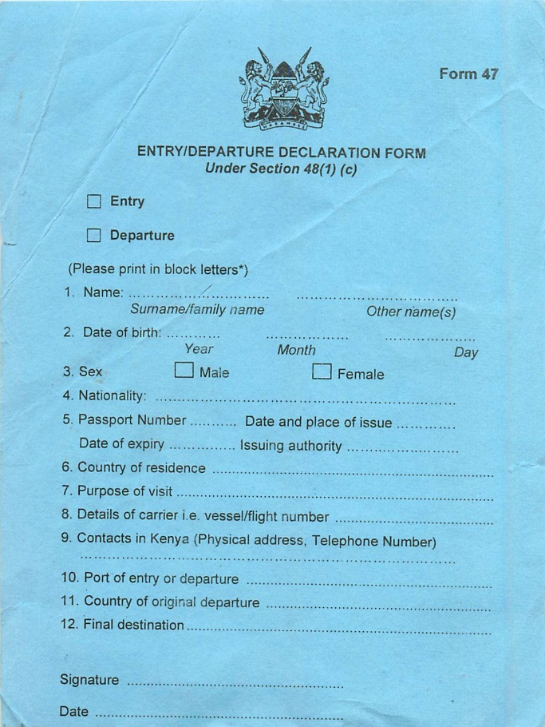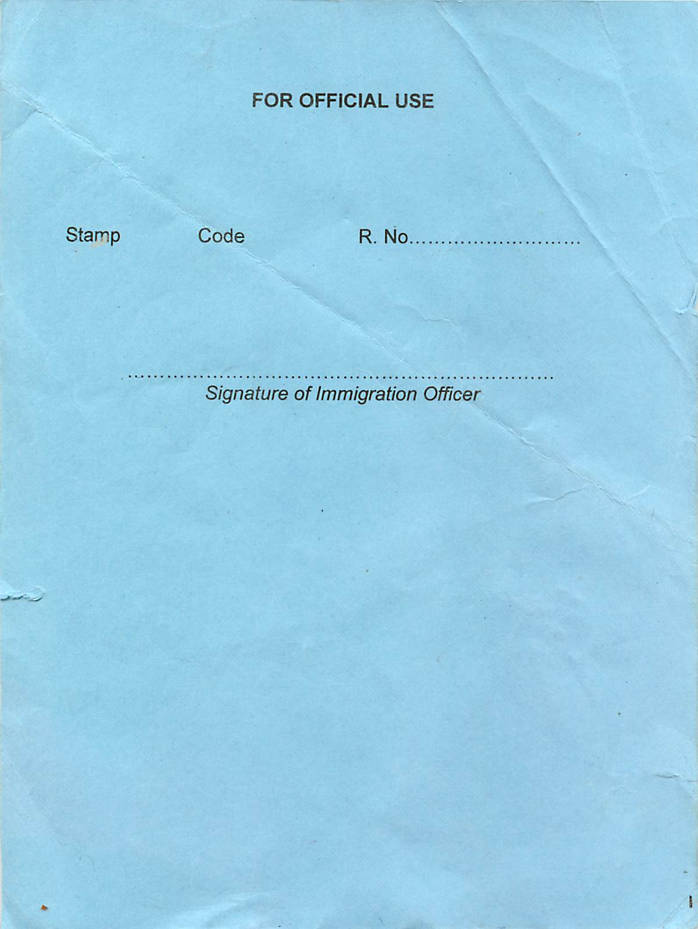

- Reasons for entry: volunteer medical doctor/tourist
- Full Names and addresses of Friends, Firms of Relatives to be Visited:
Dr. Mark Newton, Consultant, Kijabe Hospital, phone #: +254 739 262 557
Kijabe Hospital P.O. Box, Kijabe, Kenya 00220

Luggage Collection
Collect and go through the “Nothing to Declare” line
- Just say no to baggage attendant. They don’t work for the airport and will expect a tip.
- If you are asked about your luggage say “I am going to Kijabe Hospital”. They are very familiar with Kijabe and will likely let you proceed without further questioning.
- If they open your luggage and ask questions say “Everything is a donation to be used for the people of Kenya” and show Donated Supplies Letter. They may still tax it.

Money
There are ATMs (Barclays is the best) in the Arrivals Hall at NBO which are safe and used by Dr. Newton. Before leaving the airport, stop at one and withdrawal at least 20,000 Kenya Shillings (~230 USD).

There is an ATM in Kijabe, but it frequently runs out of money and the exchange rate is not as good. If you do any activities on the weekend, the driver will ask if you want to stop at an ATM while you are out. Kisumu has more ATM options that you can easily access.

Transport & Lodging
Look for a professional driver meeting you in Arrival Hall with a sign with your name or “Kijabe” and wait until met. Naomi Cabs is the taxi service always used to pick guests and the cars usually have the cab company name on the driver’s door. They know Dr. Newton and take great care of all our visitors.

Typically, you will arrive in the late evening and will be transported to one of two guest houses. Rooms at these facilities shall be booked for you and you will be sent a confirmation email prior to your departure. The chosen guest houses are secure and commonly used by visitors to Kijabe.
- Amani Gardens Inn +254 0723-161935
- Mayfield Guest House (0)20-2723233; mobile (0)733-518217—Also useful for emergency if you aren’t met
Your driver will transport you from the airport to the guest house your first night in Nairobi. The same driver will pick you up the next day and transport you to Kijabe. Estimated cost will be KES 7,000 (80 USD). Make sure to ask for a receipt in order to submit for reimbursement. Otherwise, you will have to submit a missing receipt affidavit.

Shopping (applicable for self catering accomodation at Kijabe)
Before departing for Kijabe you will be taken to a large grocery story to stock up for your time in Kijabe. If you would like convenience items such as spaghetti sauce, Bisquick, American brands of cereal, or macaroni & cheese, then you should have your driver take you to Chandarana at ABC Center. ABC Center also has a produce store called Zucchini that will have apples, oranges, bagged lettuce, grapes and strawberries (these are not available in Kijabe). Gilani is a good butcher in ABC Center.

Also recommended by previous visitors is Nakumatt in Nairobi. It is a huge grocery store, but they also have a phone store inside. It is a great place to get a SIM card for your phone and a USB modem if desired. The program will provide these items should you need them. You will be shown where to buy airtime for minutes and internet bundles for the phone and modem.

Before arriving at Kijabe, you will want to purchase some of the following items in Nairobi, either at the Uchumi or Nakumatt supermarkets. The driver will take you to one of these full-service supermarkets. Basic supplies, including some of these, are available in Kijabe.

Milk sugar
Flour lunch-meat
Napkin chicken
Toilet paper cheese
Salt juice
Pepper eggs
Yeast cookies
Baking powder mincemeat (ground meat)
Baking soda laundry detergent
Tea dish detergent
Coffee jam
Cereal peanut butter
Bread butter
Rice pasta
Cornmeal cooking oil
Vinegar bath soap
Sterilizing solution (for vegetables)

OPTIONAL:
Ketchup mustard spaghetti sauce
Ice cream salsa long-life or powdered milk

AVAILABLE LOCALLY (in Kijabe)
Bananas pineapples potatoes
Tomatoes zucchini strawberries
Apples pears cabbage
Onions carrots cauliflower
Green beans peas spinach
Avocadoes lettuce broccoli
Passion fruit Tortillas English muffins
Diet Coke Cheese Frozen meat
Sterilizing solution (for vegetables)
These are purchased at a local market in Kijabe

(Revised August 2011)

ON THE GROUND
**DO NOT DRINK ANY WATER FROM TAPS ANYWHERE IN EAST AFRICA**

About Kijabe
AIC Kijabe Hospital is located in a small village about 1 ½ hours northwest of Nairobi on the Rift Valley escarpment at about 7200’ elevation. The AIC (Africa Inland Church) community consists of the hospital, Rift Valley Academy, a 1-12 American-curriculum missionary school, and Moffet Bible College.
The temperature at Kijabe is mild 60F – 80F (15-25C) most of the year. It can get quite chilly when it rains. The heavy rainy season is March through May. June through August are cold months (as low as 40F (5C) during the day. October and November are light rains.

About JOOTRH
The Hospital is the major referral hospital in Western Kenya, Serving a population in excess of 5million; average annual outpatient visits are 197, 200 and inpatient admissions of about 21,000. It has 467 bed capacities. The bed occupancy is about 94.8%. The highest bed capacity is in surgical wards and gynecology. There are also six operating rooms with 4 fully operational rooms.

The hospital is located in Kisumu and is next to the Lake Victoria. The region enjoys a hot humid climate.

Accommodation

Kijabe
The hospital provides furnished housing with meal-preparations facilities for visiting physicians, but with the large number of visitors, Vanderbilt residents may not all be housed in the same facility. Accommodations are based on availability at the time of arrival, with some housing having shared common areas, kitchen and bath facilities.
Water, electricity and modems for internet access (wifi for the campus is in the works) are quite reliable with occasional brief outages.
Effective January 1, 2014, the following rates apply:
- Shared dorm-style accommodation (Heron / Hammerkop/Roller Anesthesia House etc) 800 Sh pp/pn
- Self-contained housing (Sitaplex, Turner, etc)
  - 1 person alone - 1000 Sh pn
  - 2 people (married couple or friends) - 1600 Sh pn
  - 3-5 people (couple with 1-3 children) - 2500 Sh pn
  - 6+ people - 3000 Sh pn
Most residents traveling in pairs will be placed in 2 person self-contained housing making the room charge approximately 20 USD/day. It includes a twice weekly laundry service.

See also Welcome Pack 4.2 HOUSING

JOOTRH
In Kisumu, our guests stay at the Victoria Comfort Inn. The program has an agreement with this facility to provide accomodation at a subsidized rate. They will provide bed and breakfast to our guests at a negotiated rate of KES 4,000 for 9 days or less and KES 2,500 for more than nine days stay.
In addition to this, they will provide laundry services for KES 1,500 per week.
The hotel also provides WiFi services which are somewhat reliable given the service provider.
Food, Dining & Local Shopping

Kijabe
A substantial lunch is served without charge in the OR every day. The hospital has a small cafeteria where you can buy basic Kenyan food, as well as fries, chapatis, soft drinks, and other items for very reasonable prices.
Local persons will deliver tortillas, samosas, spring rolls, pizza crusts & English muffins to your residence. Hiring a local person to cook for you several times a week is an affordable option if desired. This service is called Hellen’s Kitchen and is highly recommended. The food is cheap and delicious. Contact the Medical Housing Coordinator to get connected (visitingdocshost.kh@kijabe.net).
If you are one who really depends on peanut butter it is recommended that you bring your own from the US as it is quite different in Kenya. Other items to bring are trail mix, peanut butter crackers, power bars or tuna (packets or cans).

Within a 5-10 minute walk from the hospital housing is the “Supa Duka” (small grocery), a smaller shop, and a fresh fruits and vegetables market with a small but nice selection of Kenyan souvenirs. Fresh vegetables that are eaten raw should be soaked in a bleach (Jik is a common brand) and water solution of ½ capful of bleach in a large bowl of water for about 10 minutes.

The Supa Duka and small shops have nearly all of the basics needed to survive: rice, spaghetti, jams, peanut butter, eggs, brown & white sliced bread, cooking oil, frozen hamburger, frozen chicken, diet Coke (Coke light), soft drinks, tea, coffee, sugar, salt, some spices, cookies, a small number of canned vegetables and sometimes tuna and cheese, napkins, dishwashing liquid, face soap, shampoo, some feminine hygiene products, disposable diapers, writing materials, and other items.

See also Welcome Pack 4.3 MEALS

JOOTRH
The hotel you are booked in provides an a la carte menu with a price range from KES 800-1500. The program Coordinator, Miriam W will guide you if you want other options on where to get meals.

Health Issues
Cases of personal illness or incident in the hospital should be reported to Dr. Newton/Dr. Mudola immediately. AIC Kijabe Hospital and JOOTRH both have ART and HIV testing available. If a needle stick occurs, the appropriate action can be taken on location.

Transportation and Travel
The greatest threat to your health and safety is a road traffic crash. All transportation must be provided by approved drivers. Vanderbilt residents may not drive vehicles or ride on or drive motorcycles or motor scooters while in Kenya. Vanderbilt residents should never travel by road after dark and should not use the public vans (matatus).
Cars can easily be hired for any recreational travel including day trips or for game parks. Check with Sue Newton/Gatwiri/Miriam W for information. Estimate $75-100 per day for a driver for the entire day.

DayTrips/Safari
Day trips to Lake Navaisha, Lake Nakuru, Nairobi, and Mt. Longonot (national park volcano)[for Kijabe] and Kiboko Bay, Rongo, Kakamega Forest and Rusinga Island [for JOOTRH] are easily managed during weekends off. Your phone will be loaded with phone numbers for our trusted taxi drivers who are available for hire for the day (approximately $50-100/day.)
Day trips to some parks such as Nakuru would have an addition $50 park fee. A 3-day, 2-night visit to Masai Mara Game Park would run about $500/person all inclusive of lodging and food & game drives (higher in peak season of July and August).

Although expensive, you are in KENYA… do these things!

Door-to-Door Vendors (applicable in Kijabe)
Please note that, per long-standing Kijabe Station policy, door-to-door vendors are not permitted on the private property that constitutes Kijabe Station (e.g. all of the hospital compound and surrounding houses.)
There are numerous vendors who honestly abide by Station policy and sell their fruit, vegetables and curios in the easily accessible Madukani (shops) area. The vendors who come door-to-door are well aware of the station policy and choose deliberately to disregard it. Newcomers and short-term volunteers are frequently targeted by such door-to-door vendors.

PLEASE DO NOT BUY CURIOS OR FOODSTUFFS FROM DOOR-TO-DOOR VENDORS. If you are approached by such, please call and notify KSM security personnel on this number 0738 328139.

Cultural Sensitivities
Show respect for everyone in the hospital, from the cleaners through the administrators, as well as patients and families. It is never wrong to ask questions if you are uncertain about actions or appropriate words or situations. Always greet your co-workers before getting down to business, no matter how urgent (e.g., good morning, good evening, how are you, how is your family, etc.)
Please do not make critical remarks or any comments about the way things are done differently than in the U.S. Don’t complain about the accommodations, the food, the roads, or the infrastructure. Don’t offer advice on how to improve medical care, the hospital, or the housing. Remember you are a visitor/guest and do not have a full understanding of the situation. Always display a good attitude—about your accommodations, the food, the hospital, and the personnel.
Be low maintenance.
At Kijabe, there is a weekly hospital-wide chapel service is held every Wednesday at 8 a.m. Attendance is not mandatory but is encouraged as it is an important aspect of this faith-based hospital’s mission to an underserved population, as well as a cultural experience. However, the religious aspects of the hospital might be a sensitive topic, therefore it is best not to discuss these when you are reporting on your experiences.

Useful Contact Information

DESIGNATION | NAME | CONTACT DETAILS
Medical Director | Dr. Mardi Steere | meddir.kh@gmail.com
Medical Staff Coordinator | Miriam Gitau | medstaffcoord.kh@kijabe.net medstaffcoord@gmail.com  0723 638332
Medical Housing Coordinator | Hellen Chemaraba | 0734 042630/  visitingdocshost.kh@kijabe.net
ImPACT Africa W Kenya Director/Consultant Anesthesiologist | Dr. Lisa Mudola | mudola.manyano@cphdev.org  0722 749167
Program Manager for ImPACT Africa | Gatwiri Murithi | hsogatwiri@gmail.com  0737 858850
Program Officer for ImPACT Africa W Kenya | Miriam W | hsomiriam@gmail.com  0737 505030
Long-term missionary family representative  (Mark Newton’s Wife) | Sue Newton | mama.newtontano@gmail.com  0738 086359 (Kenya mobile)
Director, VIA  Chief of Anesthesiology, Kijabe Hospital | Dr. Mark Newton | Mobile: 0739 262557  mark.w.newton@vanderbilt.edu
Kijabe Hospital Anesthesiology Department | Mary Mungai, KRNA  Anesthesia Phone | 0724 777370  0739 262531
Kijabe Security Office |  | 0738 328 139
Former Medical Director & Friend of the Newtons | Dr. Steve Letchford | 0733 918537
AIM Mayfield guest house | Nancy | Mobile: +254 733-518217  +254 723-083296  +254 733-621868  E-mail: mayfieldbookings.is@aimint.net
Amani Gardens Inn (formerly the Mennonite Guest House) | Daniel/Joseph | E-mail: reservations@amanigardensinn.com  Phone: +254 0723-161935  PO Box 14646-00800, Nairobi, Kenya
Nairobi Taxi Company (recommended) | Naomi Cabs (John Githii) | Naomi cabs Ltd.  Jethro chambers, 2nd Flr P.O.Box 16310-00100, Nbi, Kenya. Email: naomicabs@yahoo.com 020.2143378/0722.815662/0734.968649
American Embassy, Nairobi |  | (0)20-3636622
Kijabe Hospital |  | P.O. Box 20  Kijabe, 00220, Kenya  (0)20-324650  +254 737 370690
Jomo Kenyatta International Airport |  | Embakasi, Nairobi, Kenya  (0)20-6611000

BEFORE YOU LEAVE

Settling Accounts
Several days before your departure, please see the Victoria Comfort Inn Front Office/Medical Staff Coordinator for a copy of your expense bill and settle your accounts. DO NOT wait until the last moment to request your bill!

Donations
If you have clothing or other items you wish to give away, leave them with the hospital chaplain or the missionaries rather than giving them directly to individuals.

Transport
Gatwiri/Miriam W. will help you make your arrangements for transport to return to the airport in order to arrive before dark. The airport is pleasant and safe with snacks available.

WHEN YOU RETURN

Case Log & Trip Report
During your rotation a Case Report must be completed for all patients. Additionally, after you return to Nashville, a Trip Report must be completed. You will NOT be reimbursed until all forms are submitted.

See Attachment 7. Case Log and Attachment 8. Trip Report. Attached forms are for reference. If not sent to you, contact VIA Program Manager to receive copy of fillable Word document.

Expenses and Reimbursement
You must retain all approved travel receipts prior to and during your trip to be eligible for reimbursement. VIA will reimburse the following expenses.
- Immunization and medication related expenses (not provided by OHC)
- Kenyan Visa
- Transportation from Nairobi airport to guesthouse to Kijabe
- Lodging in Nairobi guesthouse
- Kenya Medical License (if not paid yet)
- Lodging in Kijabe/VCI
- Meal service in Kijabe/Kisumu
- Malpractice Insurance
- Transportation from Kijabe to Nairobi upon completion of rotation

All reimbursements will be processed through Concur.

ATTACHMENTS

- VIA Clinical Curriculum

- ISOS Summary of Coverage

- Case Log

- Trip Report

Vanderbilt International Anesthesia Clinical Curriculum
The Vanderbilt International Anesthesia (VIA) clinical experience provides an excellent opportunity for residents to learn about the practice of anesthesiology in an international medical environment. Residents travel outside of the United States to a VIA site, where they enjoy a rich cultural experience while continuing anesthesiology education and training. They learn about perioperative patient care and the management of general anesthesia, regional anesthesia, and sedation in a resource poor environment, caring for patients who often present with advanced pathology and disease uncommonly encountered in typical western medical training.
OUTLINE
- Educational Goals
- Procedural Guidelines
- Resident Responsibilities
- Recommended Reading
- Evaluations

- Educational Goals: The Vanderbilt International Anesthesia experience trains residents in a cross-cultural environment, enabling them to develop knowledge, skills attitudes and behaviors essential for effective anesthesia practice in less developed, international healthcare settings. Teaching and transfer of knowledge and clinical skills to local anesthesia practitioners and perioperative nurses is a key element of the VIA program. Residents will also have extensive opportunities to develop regional anesthesia skills that may be underutilized in contemporary western practice. Working and teaching in international settings is an eye-opening experience that broadens residents' awareness of cultural diversity and international healthcare delivery systems, influencing professional attitudes and behaviors after returning to training and practice in the U.S.

A. Medical Knowledge:
1. Acquire knowledge of surgical pathologies, medical illnesses, and anesthesia techniques that are not commonly encountered in the US.
2. Learn about anesthetic techniques and medical problems that are common at the VIA site but uncommon in the US: halothane, malaria, etc.
3. Develop and practice teaching skills through lecture preparation and delivery, case-based discussions, and clinical supervision.
4. Identify instructional topics for international students and prepare appropriate teaching materials and techniques, e.g., presentations, lectures, seminars, learning resources, etc. Determine what teaching and learning resources available and adapt teaching plan and style accordingly.
5. Appreciate that effective teaching must be practical, culturally sensitive, non-judgmental, and consistent with the needs of students and the hospital.

- Patient Care
1. Observe routine delivery of anesthesia and perioperative care in a developing country.
2. Provide anesthesia and perioperative care that is safe, effective, and sustainable, adapting knowledge and clinical skills to local systems and limited resources.
3. Model behaviors that will assist students in providing effective and safe care: critical thinking, careful planning, altruism, vigilance.
4. Appreciate cultural differences in expectations surrounding medical care.
5. Appreciate ways in which the fundamentals of anesthesia practice can be resource-independent (“airway, breathing, circulation”) and that scarce external resources make the anesthesiologist’s intellectual and clinical skills more essential.
6. Accurately and effectively perform preoperative evaluations in healthcare settings with limited laboratory, diagnostic, and pharmaceutical resources.
7. Utilize clinical skills to diagnose and manage problems without utilizing high tech interventions commonly available in home institutions.
8. Develop anesthesia plans for general or regional anesthesia, as appropriate for the patient’s disease and surgical procedure. Recognize the commonly advanced state of patients’ disease processes and appropriately and safely adjust anesthesia plans.
9. Safely and effectively use available equipment, supplies, anesthetic agents and drugs, which may not be commonly used in the U.S., e.g., halothane.
10. Develop proficiency in performing the following blocks: spinal, epidural, Bier, axillary, ankle, wrist, digital, penile, and femoral.
11. Supervise, with the assistance of the faculty instructor, national anesthesia care providers, who may be at the level of registered nurses.
12. Appropriately communicate with primary care physicians and the ICU physicians regarding perioperative issues, such as pain management, laboratory and pharmaceutical management, as well as disease state.
13. Demonstrate the clinical skills necessary to manage the postoperative ICU patient in a resource poor setting, which may not have ventilators and invasive monitoring.
14. Manage patients in a PACU setting, including supervising PACU nurses as they care for postoperative patients.

- Professionalism
- Demonstrate commitment to carrying out general professional responsibilities, as well as those that are institutionally specific, based upon the VIA site.
- Fulfill all requirements for international travel and participation in the VIA program in a timely manner.
- Adhere to ethical principles and demonstrate appropriate sensitivity and respect for local culture, beliefs, and customs when interacting with patients, families and all healthcare colleagues. Recognize that local standards of professional and personal behavior may differ substantially from U.S. norms.

D. Communication and Interpersonal Skills
1. Communicate in a timely manner with supervising Vanderbilt faculty responsible for coordination and supervision of international training.
2. Effectively communicate with patients, families and healthcare staff, utilizing a translator when required. Identify ways in which cultural differences may impede effective communication. Strive to overcome impediments and adapt to the cultural setting. Demonstrate cultural sensitivity and respect in all interactions.
3. As a cross-cultural educator in the host country, develop interpersonal skills necessary to effectively communicate medical knowledge and clinical skills to local healthcare providers. Speak clearly and slowly when teaching to improve comprehension. Realize that change comes slowly and that unwelcome criticism can be counterproductive.
4. Communicate with the surgical team regarding preoperative assessment, general or regional anesthesia, and postoperative care plans.
E. Practice-Based Learning and Improvement
1. Discuss with the supervising faculty significant differences in international anesthesia practice and adjust skill set and methods of practice to provide care in the international setting.
2. Discuss preoperative assessment, anesthetic plans, case outcomes and complications.
3. Review pertinent literature and books that provide guidelines on the practice of international anesthesia.
4. Be open to learning from anesthesia care providers who have trained in other regions of the world and practice in the international venue.
5. Reflect upon teaching, self-assess, self-educate, and adjust teaching techniques in response to feedback from students.
F. Systems-Based Practice
1. Develop awareness of and interest in the way optimal care of patients fits into the larger context of the health care system of the host country, including an awareness of the country’s major health care issues.
2. Become knowledgeable about hospital resources available for anesthesia care and constraints on obtaining additional resources.
3. Share experiences with U.S. colleagues upon return.
III. Procedural Guidelines
- Verify appropriateness for general or regional anesthesia with the faculty supervisor and the surgical team.
- Perform essential resident anesthesia skills required by an advanced level resident physician.
- Prepare the anesthesia machine, monitors, essential supplies, operating room table, room temperature, drugs, and suction apparatus necessary to perform a safe anesthetic.
- Prepare the regional anesthesia tools necessary to perform the appropriate regional block for the cases.
- Prepare for administration of fluid and blood products required during the case.
- Adapt management of patients in the ICU setting as required, utilizing the outdated ventilators and monitoring equipment normally available in the international medical environment.
- Perform anesthesia with available drugs, which may be limited and different from the vast array of pharmaceutical options available in the U.S.
- Utilize spinal anesthesia, a major element of international anesthesia care, developing and refining skills necessary to utilize this block without intravenous anesthesia drugs.
- Provide safe and effective pediatric anesthesia care, which will be a major element of clinical experience in this rotation.

IV. Resident Responsibilities
- Coordinate in a timely manner the necessary visas, travel documents, and immunizations, (MUST BE COMPLETED 6 WEEKS PRIOR TO TRAVEL) needed for a trip to an international VIA destination.
- Communicate directly with the faculty supervisor for the VIA resident rotation to receive guidelines and information regarding the rotation and the country dynamics.
- Lectures will be prepared by each resident prior to arrival at the VIA site. Topics will be assigned based upon the level of students, e.g., Kenya Registered Nurse Anesthetist (KRNA) students. These lectures (typically 3-5) will be presented in Power Point format and will be supplemented with handouts for students. Presentations and handouts should be recorded on a “flash drive” to enable presentation and reproduction.
- Complete the rotation report and evaluation within one month of completing the rotation and return to the VIA coordinator and residency program director.
- Residents are encouraged to participate in ongoing VIA research projects, as well as preparation of case reports and other manuscripts for presentation and publication.

V. Recommended Reading List
A. Reference Books:
1. Hadzic, A, et al. Textbook of Regional Anesthesia and Acute Pain Management, 2007.
2. Brown, DL, et al. Atlas of Regional Anesthesia, 3rd edition, 2006.
3. Hadzic, A, Vloka,JD. Peripheral Nerve Blocks, 2004.
4. Barash, PG et al. Clinical Anesthesia, 5th Edition, 2006.

B. Web searches:
1. Research the country including the climate, culture, government, and current events of the country where the VIA rotation will be accomplished.
2. Research basic medical issues including tropical diseases, HIV/AIDS, tuberculosis and any other perceived medical education needs related to the country of the rotation.
3. Research the specific hospital where the rotation will be held with information located on the internet, if available.
- Evaluations:
A. Resident evaluations will be completed by the VIA faculty supervisor(s) and returned to the residency program director.
D. Each resident will maintain a standard case and procedure log and submit this data to the ACGME. In addition, a copy will be submitted to the Director of the VIA Program at the end of the rotation.
E. Each resident will submit evaluations of VIA faculty and the VIA clinical rotation per normal residency program evaluation processes. In addition, residents are encouraged to provide direct feedback, regarding benefits of the rotation, achievement of academic and personal goals, and recommendations for improvement, to the faculty supervisor and Director of the VIA Program. Any questions or concerns about the rotation can be directed to the Director of VIA Program and/or residency program director.

ISOS Overseas Emergency Procedures
Travel Registration
Vanderbilt University works with International SOS (ISOS) to provide travel assistance and evacuation services for all faculty, staff, and students traveling internationally on Vanderbilt authorized trips or business. The services provided by ISOS range from telephone advice and referrals to vaccination requirements to full-scale evacuation by private air ambulance.
A portal has been linked to the Vanderbilt International Office website to permit Vanderbilt users to access these services. The portal can be accessed at http://www.vanderbilt.edu/vio/isos
Vanderbilt travelers can use this portal by logging on using the Vanderbilt ISOS member number (11SGM000066). First time users will be asked to establish a user name and password. This should NOT be a VUNet ID and password. A screenshot guide to ISOS registration is available at http://www.vanderbilt.edu/vio/isos
Prior to embarking on an international trip, travelers should complete the Personal Traveler Locator on the portal. This provides the contact information needed by ISOS and Vanderbilt to locate the traveler in the event of a crisis or emergency. Travelers also have the option of storing their personal health, vaccination and travel information securely online. Please note Vanderbilt personnel will NOT have access to a traveler’s personal health information stored on the ISOS site.
ISOS wallet cards with contact information can be downloaded from the ISOS website. Travelers should keep this card with them at all times so they have ready access to the ISOS emergency call center contact information.

Emergency Protocol

In the event of a medical or security emergency, the traveler should call ISOS to notify them of the situation. In the event that the traveler is unable to make the call, someone other than the traveler can initiate the process. When a Vanderbilt traveler contacts the ISOS alarm center, they are asked the following questions:

Q1. Are you traveling on behalf of the Medical Center or Medical School?
If the answer is "no:"
- Are you a Student; Faculty Member; or Staff Member?
- If Student: What program or department are you affiliated with?
- If Staff or Faculty: What department or school authorized your travel?
If the answer is “yes:”
- Are you a medical/nursing student, resident or housestaff, faculty or staff?
- If housestaff: What program or department are you affiliated with?
- If Faculty or Staff: What department or school authorized your travel?

.
The following situations result in a phone call and email from ISOS to Vanderbilt:
- Evacuation/Repatriation/Repatriation of Mortal Remains
- Inpatient services for students, faculty, or staff
- Security Emergency

In cases where travelers receive outpatient medical treatment, Vanderbilt contacts are notified via email only. In cases where travelers receive advice or referrals, Vanderbilt is not contacted.

In cases where contact is necessary, ISOS will contact the “authorized persons” listed on the Vanderbilt operating procedures. These are people who can authorize payment for ISOS services (see Appendix A).

In University Central, the authorized persons are:

- Joel Harrington, Associate Provost for Global Strategy
- Tim McNamara, Vice Provost for Faculty
- Melissa Smith, Vanderbilt International Office

In VUMC, the authorized persons are:

- Cathryn Rolfe, Director, International Clinical and Administrative Initiatives
- John Manning, Associate Vice Chancellor for Health Affairs and Chief Administrative Officer
- Douglas Heimburger, Associate Director, Institute for Global Health

The “authorized persons” will be contacted in the order they are listed. In all cases, ISOS will call down the list until they speak to someone. See attached list for contact information.

In the event of a medical emergency, or other situation that requires continuous updates, the first point of contact or designated point of contact will be sent updates via email and phone until the situation is resolved. The nature of the update will vary based upon the point of contact. Per HIPPA privacy rules, in emergency situations, patient information will only be shared as necessary to provide treatment. This includes sharing information with other providers, referring patients for treatment, and coordinating patient care with others (http://www.hhs.gov/ocr/privacy/hipaa/faq/disclosures_in_emergency_situations/960.html).

After authorizing payment/treatment, the Vanderbilt “authorized person” will contact appropriate colleagues to inform them of the situation. Vanderbilt will also be responsible for contacting the family member or emergency contact of the traveler to inform them of the situation and put them in touch with ISOS as needed.
In addition to the “authorized persons”, there are also VU personnel listed for University Central and VUMC who are authorized to obtain information about a case from ISOS. These people are:

- Mark Bandas, Associate Provost and Dean of Students
- Sandy Bledsoe, Executive Director, Risk and Insurance Management
- Jim Crowe, Director, Vanderbilt Vaccine Center
- Carol Etherington, Associate Director, Institute for Global Health
- Louise Hanson, Medical Director, Student Health Services
- Shelley Jewell, Program Coordinator, Global Education Office
- Pat Kinman, Occupational Health Clinic
- Julie Lankford, Country Desk Officer, Institute for Global Health
- Catherine Lem, Program Manager, Institute for Global Health
- Melanie Swift, Medical Director, Occupational Health
- Dawn Turton, Assistant Provost for Faculty
- Alfredo Vergara, Associate Director, Institute for Global Health
- Sten Vermund, Director, Institute for Global Health
- Seth Wright, Director, Division of International Health, Emergency Medicine

Resources to Locate Vanderbilt Travelers Overseas

In the event of an emergency situation overseas such as a natural disaster or political unrest, it is important that Vanderbilt is able to locate all its travelers. There are two means of doing this:

- Travel Tracker: Designed by ISOS, this system provides travel tracker users with access to the “Personal Travel Locator” (PTL) records of all travelers who have registered their travel in the system. All students studying abroad are required to enter their travel details and emergency contacts into this system. Faculty and staff members are strongly encouraged to enter their information. Only authorized personnel in the Vanderbilt International Office, Office of Active Citizenship, Vice Chancellor for Health Affairs Office, and Institute for Global Health have access to Travel Tracker.

- StudioRisk: StudioRisk is a data management system used by the Global Education Office (GEO). Students enrolling in study abroad programs through GEO are automatically entered into StudioRisk. They are also required to enter their information into ISOS through the Personal Travel Locator. Students who participate in Vanderbilt affiliated programs outside of GEO are also asked to enter their information in StudioRisk and ISOS. (GEO is currently working with StudioRisk and ISOS so the information can be streamed directly from StudioRisk to ISOS).

Both these systems have been used successfully to locate Vanderbilt travelers after earthquakes in Haiti and Chile.
Summary of Services Provided by ISOS

Medical Assistance
- 24-Hour Worldwide Medical Information & Assistance
- Medical & Dental Referrals
- Dispatch of Medication & Medical Supplies
- Medical Monitoring
- Insured Medical Evacuation
- Medically Supervised Repatriation
- Repatriation of Mortal Remains

Personal Assistance
- Legal Referrals
- Lost Document Advice & Assistance
- Emergency Message Transmission
- Emergency Personal Cash
- Medical Expense Guarantee
- Emergency Translation & Interpreter Services
- Claims Assistance

Travel Assistance
- Transportation to Join Hospitalized Member
- Accommodation While Visiting Hospitalized Member
- Transportation of Minor Children
- Return of Traveling Companion
- Travel Arrangements After Medical Evacuation
- Emergency Family Travel Arrangements

Online Services & Information
- SOS Global Traveler Portal
- Travel Health Information
- Emergency Record
- Email Health Alerts

Security and Safety Assistance
    - Insured Security Evacuation
    - Online Travel Security Information
    - Security Crisis Center
    - Security Surveys and Emergency Response Planning
    - Travel Safety Information
    - Personal Locator
    - Email Safety Alerts
    - Personal Safety Assistance

Among the assistance services included in the program, the following benefits are insured through Intl. SOS and are per traveler per incident:
- Emergency Medical Evacuation - $1,000,000
- Medically supervised repatriation - $1,000,000
- Repatriation of mortal remains - $1,000,000
- Security Evacuation - $100,000

Combined Benefit of $10,000.00 for the four below listed services:
- Transportation to join a hospitalized member - $2,500
- Accommodation while visiting hospitalized member - $2,500
- Return of Minor Children - $2,500
- Return of Traveling Companion - $2,500

Important Facts about coverage:
- In all cases ISOS makes a determination as far as what constitutes an emergency.
- In the case of political evacuation, ISOS bills Vanderbilt for those expenses and Vanderbilt pays them through a different insurance policy.
- ISOS is not medical insurance so medical expenses are Not covered. ISOS will initially pay expenses if the situation demands , but Vanderbilt will be billed for those costs and will then will work with the traveler to determine whether the charges would be applied to Vanderbilt’s worker’s comp carrier or to the traveler’s health insurance.
- ISOS does not cover a Vanderbilt traveler’s family members or friends unless they too are traveling on behalf of Vanderbilt university (traveler may purchase coverage for family members through ISOS).
- ISOS does not cover certain costs for travelers who are in their country of citizenship at the time medical or emergency evacuation is necessary.
- ISOS does not cover expenses related to injury sustained while engaging in dangerous recreational activity.

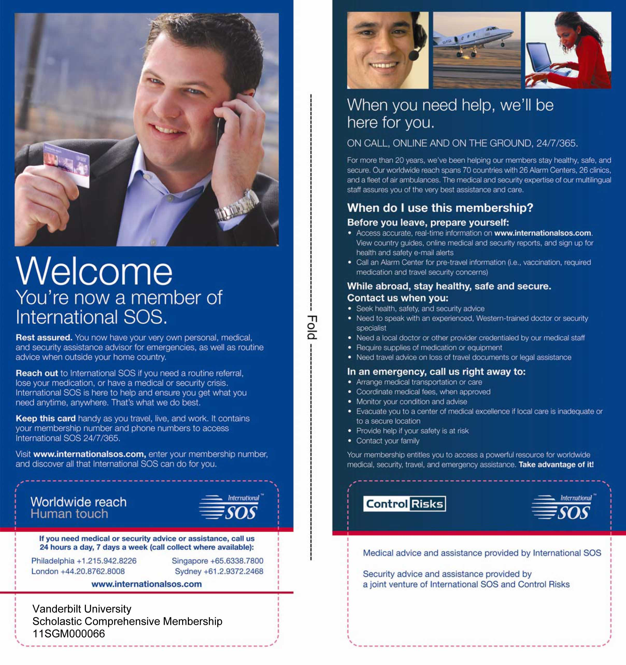

Vanderbilt International Anesthesia Patient Case Report
Patient ID Number
Date |  | M | DOB:

Anesthesia provider

Diagnosis

Surgery performed

Anesthesia provided (i.e., general, spinal, epidural, peripheral nerve block)

Complications

Learning Points

Patient ID Number
Date |  | F | DOB:

Anesthesia provider

Diagnosis

Surgery performed

Anesthesia provided (i.e., general, spinal, epidural, peripheral nerve block)

Complications

Learning Points
Patient ID Number
Date |  | M | DOB: | adult

Anesthesia provider

Diagnosis

Surgery performed

Anesthesia provided (i.e., general, spinal, epidural, peripheral nerve block)

Complications

Learning Points

VIA Trip Report

TO: Warren Sandberg, MD, PhD, Mark Newton, MD, Suzette Laws, Jill Clendening
FROM: Attendees’ name(s) & title(s)
LOCATION: Country, city, hospital/clinic name
DATE(S): Departure & return dates (month, day, year)

The purpose of this report is to compile critical data from VIA participants. It is important that this report be completed, in detail, within two weeks of return from an international service trip. The information provided will assist in developing a more accurate, global perspective on anesthesia provision; will provide practical information for future participants; and will add validity to our international efforts.

Participants should provide information regarding the overall anesthesia services available in the country visited, including number of anesthesia care providers (physicians, nurses, clinical officers) for the country; available drugs; available mortality/morbidity figures; anesthesia deaths/complications statistics; any anesthesia CME in the hospital and in the country; available anesthesia educational books in the hospital/clinic; anesthetic equipment available in the hospital/clinic (i.e., number of anesthesia machines, pulse oximeters, capnographs, ventilators); anesthesiologist to CRNA/clinical officer ratio in ORs; anesthesia obstetrical services in the hospital and country; any ongoing anesthesia research information available for the country and/or hospital; and any anesthesia training programs for physicians and nurses in the country, including when the programs were established.
Please also obtain a copy of the OR list, complete with case detail, for a year’s timeframe (if possible).

This will require some investigational work, but will greatly assist us in building an invaluable data base on international anesthesia development. We appreciate your involvement with VIA.
Please answer all questions on this fillable form. Text fields are unlimited. Email completed form and additional supporting information to the contacts at top of form.

- Provide trip highlights, including pre-trip planning, transportation details, immunization and other health issues, and trip cost summary.

- Reason for the trip

- Other partnering organizations/individuals

- Place(s) visited

- Contacts made

- Overall usefulness of the trip

- Lessons learned (both clinical and social)

- Issues/concerns (if any)

- Quality of travel, accommodations, meals, teaching program, clinical experience, clinical setting & equipment

- What you would have liked to have known before you went?

- What would you change on your next trip?

- What are your recommendations for future trips?

- If this is a return trip for you, what improvements did you see?

- Additional comments?

Attendee signature

