Vanderbilt University Medical Center

2016 - 2017
Rehabilitation Providers
Career Advancement Program

Preface

The Career Advancement Program (CAP) was developed in 1999 by Vanderbilt Rehabilitation Services providers. This manual serves as written documentation of the components of the program that educate and direct Vanderbilt employees in the CAP process. It is a reference for those who seek advancement or those who will maintain at Levels III and IV. This manual is protected by copyright and no part may be reproduced without written permission from the CAP Steering Committee.

Revision Date: 08/2011; 10/2012; 12/2013; 12/2016
Table of Contents
CAP Level III’s 5
CAP Level IV’s and Clinical Coordinators, Management 6
Steering Committee Members 7
CAP Timeline 8
CAP Background and Charter; Values; Goals 9
Steering Committee Guidelines 10
Level I Practitioner 11
Level II Practitioner 12
Level III Practitioner 13
Process of Advancement to a Level III 14
Level IV Practitioner 16
Process of Advancement to a Level IV 19
CQI: Continuous Quality Improvement 20
CAP and Clinical Coordinator Position 21

APPENDIX 1: Policies 22
Policy: Declaration of Intent to Advance 23
Policy: Advancement Review Board Quorum 23
Policy: CAP Mentors 24
Policy: Clarification for Prior Work Related Experience 24
Policy: Prorating and Deferment 25
Policy: Failure to Successfully Advance 25
Policy: CAP Maintenance 26
Policy: Appeal Process 27
Policy: CAP Activities and Reimbursement 28
Policy: Declaration of Advancement for Former Level III or IV Employees 29
Policy: Participation in Interview while on FMLA 30

APPENDIX 2: CAP Portfolio and Interview Instructions 31
CAP Portfolio Instructions 32
Curriculum Vitae Resume Instructions 34
Advancing Level III Interview Guidelines 35
Advancing Level IV Interview Guidelines 35

APPENDIX 3: Advancement Review Board Tools 36
Advancement Review Board (ARB) Portfolio Assessment 37
Advancement Review Board Interview Assessment 39
Table of Contents Continued

APPENDIX 4: Printable Forms (including activities list instructions) 42
Activities List and Instructions 43
CAP Declaration of Intent 50
CAP Advancing Affirmation Statement 51
Bibliography Log 52
In-service Log 53
Continuing Education Log 54
CAP College Course/Audit Log 55
Mentoring Form 56
CAP Mentor Agreement 57
CAP Mentor Log 58
Advocacy Form 59
Community Service Log 60
Journal Club Log 61
Committee Participant Assessment Form Clarification 62
VUMC Rehabilitation Services Committee Facilitator Assessment Form 63
VUMC Rehabilitation Services Committee Participant Assessment Form 64
CAP Project Description Form 66
CQI Project Proposal 67
CQI Project Summary 68
 Other Form 69
Maintenance Affirmation Statement 70
Glossary 71
2016-17 Career Advancement Program Participants
Level III Practitioners

Acute Adult: Andrea Antone, PT Judy Booker, PT Katie Crouch, OT Lisa Jones, PTA Jim Lassiter, OT Lynette O’Brien, OT Sandy Shelton, PT Shane Wood, OT Caleb Templeton, OT Emily Sutinis, PT Scott Hawes, PT Brooke Gentry, OT

Acute Pediatrics: Caryn Givens, PT Sarah Wilson, OT Ashley Allen, PT
Heather Winters, OT Charlotte French, OT

Belmont: Jonathan DeMarie, ATC

Bill Wilkerson Center: Lori Buck, OT Rebecca Jones, OT

Dayani Center: Jadi Franjic, PT Allison Jagoda, CES
Jeremy McNatt, CES Katie O’Hara, PT

Osher Center: Cynthia Allen, PT

Outpatient – Cool Springs: Amy Aston, PT Tabitha Harder, PT Julie Kay Holt, PTA Jill Porter, PT
Meg Stockman, ATC Brad Hammer, PT Renee Simpson, OT Mary Jackson, PT Elaine Weisberger, PT

Outpatient – Pediatrics: Amanda Gillian, PT Shirley Gogliotti, PT Lindsey Ham, OT Laura Gish, PT
Kelley Newman, PT Deborah Powers, OT Donna Trotter, PT
Jennifer Hutton, PT

Outpatient – VOI: Hung Do, PT Jennifer Emery, PT Nicole Motzny, PT Jennifer Farrar, OT Stacey Humel, PT Tom John, PT Jamie Bergner, OT Haley Brochu, ATC
Brenda Robinson, PTA Emily Preston, PT Eric Williams, ATC
Indu Padmanbhan, PT Shantel Phillips, PT Tiffany Priest, PT

Pi Beta Phi Rehabilitation: Valery Hanks, OT Christy Horner, OT Andrea Ondera, PT
Christina Barfield, OT Christina Durrough, PT

VOI – Outreach: Micah Holland, ATC Teresa Pritchett, ATC Austin Williams, ATC
Brittany Klaus, ATC

Vanderbilt Bone and Joint: Keely Burnham, ATC Seth Woodard, ATC Lyndsay Sullivan, ATC
Alexis Boorde, ATC Eric Owens, ATC LeighAnne Schlichte, ATC

Vanderbilt HomeCare: Katherine Brown, PT Tim Brown, PT

Vanderbilt Athletics
– Training Room (TR): Tracy Campbell, ATC Kerry Wilbar, ATC

Vanderbilt University: Miya Sullivan, ATC
2016-17 Career Advancement Program Participants
Level IV Practitioners
Amy Darrow, PT – Acute Pediatrics Peggy Haase, OT – Outpatient VOI
Pat Flemming, PT – Pi Beta Phi Rehabilitation Institute Laura Flynn, PT – Outpatient Pediatrics
Penny Powers, PT – PBP Rehabilitation Institute Lisa Perrone, OT – Outpatient VOI
John Purdy, ATC – Outpatient VOI Vicki Scala, OT – Acute Pediatrics
Jake Landes, PT – Outpatient VOI Paula Donahue, PT – Dayani Center
Brittany Work, OT – Acute Adult Andrea Donald, PT – PBP Rehabilitation Institute
Valery Hanks, OT – PBP Rehabilitation Institute Shirley Gigliotti, PT – Outpatient Pediatrics
Kelley Newman, PT – Acute & Outpatient Pediatrics

Clinical Coordinators

Kim Anderson, ATC – Belmont Athletics, TR Missy Bryan, OT – Outpatient Pediatrics
Rebecca Dickinson, PT – Outpatient VOI Melinda Sandy, PT – Outpatient VOI
Flavio Silva, PT – Outpatient Cool Springs Justin Wenzel, ATC – Vandy Athletics, TR
Sara Melby, AT – Vandy Athletics , TR Julia Jones, OT – Acute Adult
Mark Johnson, PT – Acute Adult

Management

Heather Skaar – Administrative Director: Outpatient Cool Springs, Vanderbilt Orthopedic Institute, Adult Acute Care, & Dayani
Ellen Argo – Pediatrics
Heidi Kessler – Pediatrics
Jennifer Pearson - Pediatrics
Jeff Palmucci – Pediatrics
Kelly Floyd – Acute Rehabilitation
Kim Walter – Outreach ATC
Jennifer Cook – Vanderbilt Orthopedic Institute
Brian Richardson – Vanderbilt Orthopedic Institute
Pam Harrell – Outpatient Cool Springs
Mike de Riesthal – Pi Beta Phi Rehabilitation Institute, Bill Wilkerson
Barb Jacobson – Bill Wilkerson
Jane Wcislo – Dayani
Macy Sipes – Bill Wilkerson
Carey Tomlinson – Dayani
Tim Hoskins – Outreach (Vanderbilt Bone and Joint)
Robert Knight – Acute Adult
Julie Hobson – Acute Adult
Scott McLaurin – Acute Adult

2016-2017 Career Advancement Program Steering Committee

Management Representation:
Jennifer Pearson, OT - Pediatrics
Brian Richardson, PT – Outpatient, Vanderbilt Orthopedic Institute
Facilitators:
Julia Jones, OTR/L – Acute Adult Rehabilitation, Vanderbilt Medical Center (VMC)
Valery Hanks, OTR/L – Pi Beta Phi Rehabilitation Institute
Members:
Ashley Allen, PT – Acute Pediatrics
Alexis Boorde, ATC -
Lori Buck, OT – Bill Wilkerson Center
Lisa Gelfand, OT - Pediatrics
Amanda Gillian, PT – Outpatient Pediatric Rehabilitation, Vanderbilt Children’s Hospital (VCH)
Elise Huehner, COTA – Adult Acute
Brittany Klaus, ATC - Outreach
Sara Melby, ATC – Vanderbilt Training Room
Nicole Motzny, PT – Outpatient VOI
Flavio Silva, PT – Outpatient, Cool Springs
Tim Brown, PT – Vanderbilt Home Care
Katie O’Hara, PT – Outpatient Rehabilitation Dayani Center
Brittany Klaus, ATC – Outreach
Brittany Work, OT – Adult Acute

 | CAP TIMELINE 2016-2017
Wednesday, August 31, 2016 | Declaration of Intent forms due to manager
Friday, September 23, 2016 | Mentors assigned, candidates begin working on CQI proposals
Friday, October 14, 2016 | Meet with mentor and establish regular follow-ups
Friday, October 28, 2016 | CQI proposals due to CTL/manager, begin working on CV resume and introduction
Monday, November 21, 2016 | Submit introduction and CV resume to mentor for review and begin working on activity forms with supporting documentation
Monday, December 19, 2016 | Mentor returns introduction and CV resume with suggested edits
Monday, January 04, 2017 | Submit activity forms with supporting documentation to mentor for review and begin working on section summaries
Monday, January 23, 2017 | Mentor returns activity forms with supporting documentation with suggested edits
Monday, February 13, 2017 | Submit section summaries to mentor for review
Monday, March 27, 2017 | Mentor returns section summaries with suggested edits
Monday, April 11, 2017 | Submit rough copy of ENTIRE portfolio in approved order and binder to mentor for review
Monday, May 08, 2017 | Mentor returns rough copy of portfolio with suggested edits
Monday, May 29, 2017 | Submit ENTIRE portfolio to manager/CTL for review
Monday, June 19, 2017 | Manager/CTL returns portfolio to candidate with suggested edits
Thursday, June 29, 2017 | All activities, including CQI projects, must be completed
Thursday, July 20, 2017 | Entire portfolio to CAP committee for review
Thursday, August 17, 2017 | FINAL submission to CAP committee (4 copies in approved binders) Portfolios will be sorted and delivered to the ARB this date
Tuesday, September 12, 2017 | Feedback due from ARB to CAP Steering Committee facilitators
Tuesday, September 19, 2017 | CAP Interview Day
Tues.-Fri. Sept. 19-22, 2017 | Notification of advancement via letters

CAP Background and Charter
In January 1998, the charter for CAP (Career Advancement Program) was created. This committee was to form a model of career advancement for Rehabilitation Professionals to supplement the annual performance appraisal. The Charter based the program on the Nursing Professional Practice Model of 1998, literature review, and benchmarks with other facilities and professional organizations. This committee’s purpose was: to analyze and develop a Model for Rehabilitation Professionals comparable to the Nursing Model for recognition of the clinician’s performance; to determine job responsibilities for the levels of clinicians; to develop an implementation plan with timeline, coasts and benefits; to educate staff and management in the benefits and use of the model and plan and to then advocate with Administration and Human Resources for the implementation. They included staff in the development of the program as it is the staff’s program. The program was revised in 2010 to meet the needs of clinical staff. In 2011-12, the program was expanded to include Physical Therapists Assistants (PTAs), Certified Occupational Therapists Assistants (COTAs), and Exercise Specialists (ES).
CAP Values

We Believe:
- Patient outcomes are improved by the delivery of superior care
- Beginning clinicians develop clinical competences before pursuing specializations and other career interest
- Clinicians are empowered to take ownership of their professional practice
- Expert practitioners who mentor and promote team development will be retained
- Compensation is commensurate with level of clinical practice

CAP Goals
- Recruit and retain expert clinicians
- Support VUMC’s mission and vision
- Encourage ongoing learning and skill refinement
- Encourage clinician involvement with research and outcomes
- Standardize expectations across clinics

CAP Promotes
- Professionalism
- Leadership and Facilitation
- Superior Clinical Practice
- Expertise and Teaching
- Advocacy
- Outcomes and Evidence Based Practice
- Vanderbilt’s visibility in the community
Steering Committee Guidelines
The Steering Committee was created to oversee the CAP process. The Steering Committee assisted with the revision of the program in 2010 to better meet the needs of clinicians and VUMC. The Steering Committee was: to determine if clinicians and departments would benefit from a clinical advancement program; to see if the current model met the needs of the Rehabilitation Professional; to determine the goals and the benefits of the program from staff and well as department and institutional level; to design the program; to estimate the cost of the program; to determine how the program fits with the performance development program; determine the infrastructure; design the educational tools for implementation; design a presentation to promote the program; determine ways of measuring effectiveness of the program; and oversee the implementation and design a way for ongoing monitoring of the program.
All Steering Committee meetings will follow the ground rules:

- Meetings will start and end on time
- Meetings will have an agenda to guide discussion
- Members will complete individual assignments and bring information to the group when indicated and in a manner, that facilitates learning and discussion

Decision Making Process

- Decisions are made by consensus
- If consensus is not reached, then an 80% majority decides following additional discussion and listing of the pros and cons for the decision

Roles

- The designated facilitator leads meetings and is responsible for insuring that minutes are recorded, distributed, and the agenda is completed
- Clinician committee members are responsible for advocating for their area and discipline during meetings and taking information back to their area for feedback
Level I Practitioner

Level I practitioners:
- New hires to Vanderbilt and beginning his or her professional practice.
- Demonstrates his or her skills, capabilities, and contributions made throughout their probationary period to the manager.
- Demonstrate competent skills/abilities/qualities in all components of practice. CAP recognizes individuals at this level require mentoring and time to fully integrate into his or her department and demonstrate attainment of appropriate competencies.
- Advance after 1 year per manager’s discretion.

There has been no attempt to make these descriptors all-encompassing and/or exhaustive.

EXAMPLE

Clinical Practice/Expertise:
- Meets clinical standards: evaluation, treatment and documentation standards as set by the department.
- Meets service delivery standards and productivity as set by the departments.
- Attends in-services and other learning opportunities as available to advance area of practice.

Advocacy:
- Advocates for patient’s needs.
- Advocates for discipline.

Level II Practitioner

The Level II practitioner:
- Demonstrates to his or her manager they have developed the skills, capabilities, and made contributions as a Level I to prepare them for the role as a Level II.
- Demonstrates exemplary skills/abilities/qualities in all components of standard practice.
- Professionals who have at least 1 year of experience, and/or multiple years of practice experience, but new to Vanderbilt. Experienced practitioners who do not desire to advance further within the CAP may elect to remain at this level.
- The emphasis on this level is to promote practice development and experience at Vanderbilt while preparing the practitioner to move forward within the program if he or she elects to advance. CAP recognizes there is great diversity among Vanderbilt professionals with regard to their life experiences, roles, responsibilities and goals, meeting a minimum of professional expectations within this program and demonstrating competent practice is a viable option and is mutually beneficial to the employee and the department.

There has been no attempt to make these descriptors all-encompassing and/or exhaustive. Each Level within CAP is summative.

EXAMPLE

Clinical Practice/Expertise:
- Demonstrates proficient evaluation skills, including selecting efficient and functional measures.
- Manages all aspects of clinic care including ancillary services, and transitioning the plan of care.

Teaching:
- Demonstrates effective communications skills including facilitation, mediation, conflict resolution, and promotion of team /medical center values.
- Participates in the student education program.
- Presents in-services.

Advocacy:
- May advocate for Team needs within the department.
- Advocates for patient’s needs.
- Advocates for discipline.

Outcomes/Evidence Based Medicine:
- May participate in a CQI project annually (projects may extend for greater than 1 year)
LEVEL III PRACTITIONER

Level III practitioner:
- Must have a minimum of 3 years of full time experience and at least 6 months at VUMC prior to submitting the declaration of intent for advancement.
- Clinicians who were formerly Level III or IV practitioners at Vanderbilt who have resigned, then are reinstated to employment at Vanderbilt are eligible to declare for advancement to level III without a waiting period if hired prior to the declaration deadline.
- Demonstrates to his or her manager and the Advancement Review Board that he or she is prepared for their role as a Level III practitioner by demonstration of skills, capabilities, and contributions at Level II.
- Demonstrate exemplary skills/abilities/qualities in all components of skilled practice.
- Experienced practitioners who do not desire to advance further within the CAP may choose to remain at this level.
- Begin to define a specialty/career interest area and pursue it.
- Demonstrates skilled clinical reasoning, problem solving, and communication. The skills will be activities that reflect the clinician’s ability to show advanced levels of leadership/facilitation, clinical practice, expertise/teaching, advocacy, and outcomes/evidence based medicine.

There has been no attempt to make these descriptors all-encompassing and/or exhaustive. Each Level within CAP is summative; each level builds on the preceding level.

EXAMPLE

Clinical Practice/Expertise:
- Demonstrates skilled clinical reasoning.
- Implements new team services, procedures and/or identifies new client population and service opportunities.
- Assists with ongoing program development.
- Pursues an area of clinical specialization and/or career interest and applies to direct patient care when applicable.
- Seeks continuing education opportunities in specialized/career interest and demonstrates application of principles through protocols, new equipment, programs, research, and in-services.

Teaching:
- Mentors new employees.
- Provides feedback for the development of student program.
- Becomes involved in education within hospital, community and specific discipline.

Advocacy:
- Advocates for team needs within the department.
- Advocates for the department/discipline within the medical center.

Leadership/Facilitation:
- Initiates and implements problem solving solutions for the team/discipline/department.
- Demonstrates increased involvement in professional/community organizations.

Outcomes/Evidence Based Medicine:
- Will participate in a CQI project annually (projects may extend for greater than 1 year).
- May assist with designing CQI monitors for team’s clinical, service or financial outcomes.
- May assist with research design, analysis, and implementation.
- May assist with interpreting and applying research techniques in therapeutic process.

Process of Advancement to a Level III

- Level II’s declare their intent to advance to Level III in August with written confirmation using the “Declaration of Intent” form. This form must be given to manager by August 31.
  - In order to advance:
    - Candidate must meet or exceed expectations at the last performance review.
    - Candidate must not have been on performance accountability and commitment counseling at the time of annual review
- A timeline will be available each year giving those advancing ample opportunity to stay on track.
- Advancing applicants need to choose a mentor to assist them with the process. Mentors are available for assistance throughout the CAP advancement process. However, it will be up to the applicant to fully utilize the mentor
- Applicants for advancement to Level III will assemble a portfolio following guidelines set by the CAP committee.
- The CAP committee will review the draft portfolios to ensure they have the necessary format to advance and minimum requirements have been met. They will provide feedback of what is missing, needs to be removed, or changed.
- The final portfolios will be turned into the CAP committee who will distribute them to the ARB.
- The final review of the portfolio will be done by the Advancement Review Board which is comprised of all external reviewers. The review board will consist of 4 members, ideally one from each discipline (ATC, OT, PT) and one other member. The ARB will not have working or social relations with any of the clinicians applying for advancement. Qualification for advancement requires consensus of at least 3 out of 4 Advancement Review Board Members agreeing the candidate has met and/or exceeds the criteria for Advancing to Level III.
- All candidates should expect to have an interview UNLESS 3 of the 4 members of the ARB indicate his/her portfolio has demonstrated the qualities of a Level III clinician. Therefore, an interview will not be required
- If a candidate does not meet the expectations of the Advancement Review Board and does not advance, the candidate can file an appeal in accordance to the Appeals Process policy.

Please note:
- Applicant initiative, full utilization of CAP resources combined with solid contribution to their work area will enhance the likelihood of promotion.
- Meeting minimum advancing requirements does not guarantee advancement to a Level III.

LEVEL IV PRACTITIONER

At the time of promotion, the applicant demonstrates to his or her manager and the Advisory Review Board he or she prepare for their role as a Level IV practitioner by demonstrating skills, capabilities and contributions as Level III’s. Practitioners who function at the Level IV of the Career Advancement Program will demonstrate exemplary skills/abilities/qualities in all components of advanced practice. The purpose of this brief is to further describe combinations of activities characteristic of Level IV practitioners. There has been no attempt to make these descriptors all-encompassing and/or exhaustive. Each Level within CAP is summative; each level builds on the preceding level.

The Level IV Practitioner may:

Possess official clinical specialist certification and/or practice in a clinical setting such that he/she will utilize the acquired advanced skills to achieve superior outcomes with patients and advance the profession in professional education and service. Their primary focus is patient care.

Must complete 2 Years at Level III prior to application for Level IV

PRE-REQUISITES

These practitioners should practice clinically as an “expert” or at an advanced level such that this individual provides leadership and direction for superior patient outcomes. They advance the profession and multidisciplinary efforts in their practice through teaching, mentoring and service to their department and profession. Service to the department and profession occurs in projects/education/leadership that transcends the clinical site and extends throughout the Medical Center and community. Examples of how practitioners can exhibit leadership and direction for superior patient outcomes include:

- Advanced degree beyond entry degree
  - DPT, MBA, MPA, Health Services Administration or in a specialty area of PT/OT (i.e., Orthopedics, Neurology, Geriatrics)

OR

- Experience in focused area of practice with demonstrated development/investment/maturation in the practice area. Minimum of 7 years of experience as a practicing clinician with 5 years dedicated to focused practice area (i.e., pediatrics, adult acute care, and orthopedics). Practice focus can be documented through manager’s statement, continuing education history, and/or documented history of expertise (i.e., specific program development, mentorship, guest speaking engagements, instructor for courses)
OR

- Hold Specialty Certification with the following criteria:
- Prerequisite requirements must exist (i.e., years of experience, percentage of time working in specialty area, breadth of experience) for consideration of specialization.

- The certification must include competency-based testing (written and/or practical) or, as in the case of Board Certification and Specialty Certification by the AOTA, meet the criteria set out by the professional organization for certification (i.e., portfolio with review by panel of experts, written professional development plan). A recognized national body and/or the professional association of the applicant must endorse the certification process

- Specialty certification which may include: Certified Hand Therapist, American Board of Physical Therapy Specialties, Seating Specialist/Assisted Technology Practitioners through RESNA, or Neuro-Developmental Training Pediatric Certification. This list is not exclusive. If you are unsure if the certification you have obtained, or are pursuing, will meet the requirements for Level IV, contact a member of the CAP Steering Committee early in the process. The Steering Committee will look at certifications on a case-by-case basis.

EXAMPLES

Clinical Practice/Expertise:

- Demonstrates ability to integrate new information from continuing education and research into practice.
- Communicates practice guidelines with staff to improve performance.

Teaching:

- Models and communicates evidence based practice.
- Designs and provides professional level presentations and formal educational opportunities.
- Effectively educates students/other department staff/patients and their families.
- Interprets accreditation standards and applies to departmental practices.
- Seeks additional certification in specialty area.
- Participates in academic teaching (lectures, lab instructor, team teaching), provides professional presentations in specialty/career interest area (i.e. in-services in other departments, guest speaking).
- Provides education within medical center, community and specific discipline.
- Seeks formal course of study with satisfactory completion of college/university course for credit (post professional education).
- Mentors team members in specialty/career interest area.

Advocacy:
- Advocates for discipline and profession within Vanderbilt University Medical Center (within the team/department and in other departments) and the community (local, state and national levels).
- Connects others (staff, patient/family members, etc.) with appropriate resources to resolve need.
- Represents clinical concerns to management to assist in a positive resolution.

Leadership/Facilitation:

- Facilitates change and develops consensus with groups.
- Assumes responsibility and accountability for projects initiated by self, as well as those provided by supervisor.
- Prioritizes projects based on outcome/impact on the team/department/institution.

Outcomes/Evidence Based Practice:

- Will lead a CQI project annually (projects may extend beyond 1 year).
- Analyzes programs/protocols/guidelines using objective data. Makes recommendations for improvement to management.

Revised and Approved: 8/2011

Process of Advancement to a Level IV

- Level III’s declare their intent to advance to Level IV in August with written confirmation using the “Declaration of Intent” form. This form must be given to manager by August 31.
  - In order to advance:
    - Candidate must meet or exceed expectations at the last performance review.
    - Candidate must not have been on performance accountability and commitment counseling at the time of annual review
- A timeline will be available each year giving those advancing ample opportunity to stay on track.
- Advancing applicants need to choose a mentor to assist them with the process. It is recommended to choose someone who is a Level IV or on the CAP committee. Mentors are available for assistance throughout the CAP advancement process. However, it will be up to the applicant to fully utilize the mentor
- Applicants for advancement to Level IV will assemble a portfolio following guidelines set by the CAP committee.
- The CAP committee will review the draft portfolios to ensure they have the necessary format to advance and minimum requirements have been met. They will provide feedback of what is missing, needs to be removed, or changed.
- The final portfolios will be turned into the CAP committee who will distribute them to the ARB.
- An interview is required for Level III applicants advancing to Level IV. A candidate’s interview performance will be evaluated using the Advancement Review Board Interview Assessment tool. Candidates should be familiar with the assessment tool and utilize their mentor and/or manager for interview preparation. Qualification for advancement requires consensus of at least 3 out of 4 Advancement Review Board Members agreeing the candidate has met and/or exceeds the criteria for Advancing to Level IV.
- The interview and final review of the portfolio will be done by the Advancement Review Board which is comprised of all external reviewers. Ideally, the review board will consist of 4 members, one from each discipline (ATC, OT, PT) and one other member. The ARB will not have working or social relations with any of the clinicians applying for advancement.
- If a candidate does not meet the expectations of the Advancement Review Board and does not advance, the candidate can file an appeal in accordance to the Appeals Process policy.
To note:
- Applicant initiative, full utilization of CAP resources combined with solid contribution to their work area will enhance the likelihood of promotion.
- Meeting the minimum advancing requirements does not guarantee advancement to a Level IV.
CQI: CONTINUOUS QUALITY IMPROVEMENT

What is it?
A project done by one person or a group of people (sometimes called a “focus team”) that will have a positive impact on quality of care, efficiency of care, cost of care, customer satisfaction or employee satisfaction.

Who does it?
All level III and level IV clinicians maintaining their level and all level II clinicians advancing must participate in a CQI project.

How is it selected?
These projects are identified by the staff or the management as areas of potential improvement.
Project ideas are discussed with immediate supervisor and approved by the department director.

What does it look like?
The project needs to have an identified and proven problem, a detailed explanation of a solution, and a measurable outcome, product, or improvement.

How is it presented?
Clinicians advancing to level III will present their project in their CAP portfolio and clinicians advancing to level IV will present their project in the portfolio and interview with the ARB. CQI projects will be presented per manager’s discretion. Employees are also encouraged to present research specific projects to professional organizations outside of Vanderbilt.

Frequently Asked Questions:
• Q: Who determines if the project will have an impact on my department and what is the time requirement?
A: How big of an impact and the time requirement to complete the project is decided by the Director of your department.

• Q: Can I do a two year project?
A: Yes. Two year projects are acceptable. There must be an end-of-year one status report and PowerPoint detailing progress and next steps.

• Q: Why do I have to do this?
A: It is a requirement by the Joint Commission on Accreditation of Healthcare Organizations (JCAHO) that each department complete a CQI. It is also important to Vanderbilt that staff take ownership of quality, customer service and success of the institution. Identifying and participating in quality initiatives builds a strong team that we can be proud to take part in.

CAP and CLINICAL COORDINATOR POSITION

The Clinical Coordinator position combines a blend of clinical and managerial functions. Practitioners who advance to a clinical coordinator position will demonstrate exemplary skills/abilities/ qualities in all five components of the activities consistent with Level III practice of the Career Advancement Program, his or her responsibilities are primarily managerial in nature.

Clinical coordinators are required to complete an annual maintenance record at the Level III participation level (See Yearly Review of Level Maintenance).

Please refer to the Level III descriptor for further clarification and expanded explanations. Activities equivalent to a Level III must be maintained to remain in a Clinical Coordinator position. Should an individual in this position fail to meet the required activities as described, a development plan must be developed with their manager. Failure to successfully comply with the agreed upon plan will result in proceeding to the Performance Management Process.

APPENDIX 1: Policies

POLICY: Declaration of Intent to Advance

PURPOSE:
The preparation for advancement is a process intended to reflect not only one’s career, but also one’s contribution to Vanderbilt.

OBJECTIVE:
Provide specific guidelines for a candidate to declare their intent to advance in a given year

PROCEDURE:
The CAP committee will publish a calendar for rehabilitation professionals to identify a specific timeframe for declaring their intent to advance. The timeframe will be sufficient to allow the candidate time to discuss advancement with their Supervisors, to determine if the candidate meets the eligibility requirements, and whether the supervisor supports the advancement.

The candidate must submit their declaration with both their signature and that of their supervisor within the published timeline.

Candidates missing the deadline must obtain approval from the CAP committee. The CAP committee will determine if circumstances existed preventing the applicant from meeting the deadline and ensuring they are able to meet future guidelines.
______________________________________________________________________________

POLICY: Advancement Review Board Quorum

PURPOSE:
A quorum of the Advancement Review Board must be present in order for the clinician to have an equitable review of portfolio to become a Level III or interview to become a Level IV.

OBJECTIVE:
Define and establish a quorum for the Advancement Review Board.

PROCEDURE:
The review board will consist of 4 members, one from each discipline (ATC, OT, PT) and one other member. The ARB will not have working or social relations with any of the clinicians applying for advancement. Qualification for advancement requires consensus of at least 3 out of 4 Advancement Review Board Members agreeing the candidate has met and/or exceeds the criteria for Advancement. If a candidate does not meet the expectations of the Advancement Review Board and does not advance, the candidate can file an appeal in accordance to the Appeals Process policy.
______________________________________________________________________________
CAP Mentors

POLICY:

PROCEDURE:
CAP mentors are assigned to the advancing clinicians in order to provide support, direction and consultation as the individuals develop their professional portfolio for advancement. It is recognized that an individual may desire and / or need a mentor for many other clinical and career development issues. Those relationships are encouraged and can be reflected in CAP Activities. The assignment of a CAP Mentor is not to exclude those working relationships.

OBJECTIVE:
Provide advancing clinicians with consultation based upon proximity to the Career Advancement Program.

PROCEDURE:
These individuals have been selected to represent their discipline/work site and have access and experience with the most current CAP information. By virtue of their active and ongoing participation, they have in depth knowledge of the program requirements, challenges, and bench marks of the application process. If applicants and CAP Mentors have questions, they have ready access to a group of experienced committee members for consultation. CAP Mentors will be able to provide first hand information for further revisions based on actual experience working through the redesign.
- Requirement: Effective 2010, it is required that the applicant and the CAP mentor have a minimum of 2 face to face meetings to review and discuss the development of the components of the portfolio prior to submission. It is the responsibility of the applicant to set up those meetings with the CAP Mentor. Recommendations for revision/correction/ clarification will be tracked and submitted to the Steering Committee as part of the CQI project.
____________________________________________________________________________________

POLICY: Clarification for Prior Work Related Experience

PURPOSE:
Provide clarification of experience considered part of the core experience requirements for advancement eligibility.

PROCEDURE:
When considering an applicants’ experience as eligibility for advancement, candidates having practiced as a licensed physical or occupational therapy assistant may count those years toward the base experience requirement of 36 months. For every 2 years worked as a COTA or LPTA, 1 year credit toward the core experience requirements will be allowed. For athletic trainers, experience as a graduate assistant, as long as the individual was a certified athletic trainer, will be counted toward the core experience eligibility. The credit for these years will be a 1 for 1 exchange.

______________________________________________________________________________

POLICY: Prorating and Deferment

PURPOSE:
The Career Advancement Program recognizes circumstances affecting a staff member’s ability to participate and comply with the program.

OBJECTIVE:
Provide guidelines and examples to clarify situations requiring prorating and deferment.

PROCEDURE:
Staff members who utilize Family Medical Leave Act (FMLA) or who have extenuating circumstances may request an option to prorate activities or defer participation to a later date. If prorating is used, the manager must use objective criteria, reproducible and consistent mathematical calculations to determine an appropriate alternative activity requirement. When submitting the documentation to the committee, the manager is to include a signed narrative in
the front of the applicant’s portfolio detailing the rationale and calculations for prorated activities. Portfolios submitted without written support from their Manager will be disqualified and returned. This decision must be formally agreed upon with the supervisor/manager/departmental leadership prior to the deadlines for submission of the portfolio. A written agreement regarding prorated activities or deferment must be submitted with the portfolio. This written agreement will be placed in the departmental personnel file. Examples
may include extended illness, pregnancy, birth or adoption of a child.

Possible example on how to prorate:
Level III 12(activities) x ____
52 (weeks) (# of weeks worked)

Level IV 18(activities) x ____
52(weeks) (# of weeks worked)
______________________________________________________________________________

POLICY: Failure to Successfully Advance

PURPOSE:
To develop a plan of action to successfully advance

PROCEDURE:
Candidates who are unsuccessful in advancing should begin planning with their supervisor to establish goals allowing them to concentrate their efforts on areas identified as deficit areas by the advancement board. The candidate and mentor should assess the process and decisions in order to develop a new strategy and re-application.

Managers should closely monitor candidate’s work and should regularly conduct “progress checks” to determine candidate’s effort in meeting goals and make necessary corrections to the candidate’s plan of action.

Such individuals may attempt the advancement process until they are successful as long as they are in good standing as a Vanderbilt employee as determined by the following:

i. Performance evaluations of meets expectations
ii. Not on performance accountability and commitment counseling
_____________________________________________________________________________

Policy: CAP Maintenance
Purpose:
Each CAP participant is required to maintain the appropriate number of quality CAP activities in order to continue participation.
Objective:
Evidence of maintenance is commensurate with continued compensation
Procedure:
Each clinician gathers supportive documentation related to CAP activities. Prior to the Employee Performance Review, the clinician completes the CAP Activity System form which will be reviewed by the supervisor. Time line for activities is consistent with the annual performance review, July 1 – June 30. Clinicians who fail to meet the requirements consistent with their designated level must meet with their supervisor to establish a plan for the professional to meet expectations. The clinician has the option to withdraw from CAP. Financial repercussions are inherent with a decision to withdraw.
Supporting Policies: Prorating and Deferment
______________________________________________________________________________

POLICY: Appeal Process

PURPOSE:
The Career Advancement Program strives to provide a program clearly defining the expectations and procedure for promotions of staff clinicians through each of the levels. The need for an appeal process results from a breakdown in the communication, materials, and or procedures, which results in the unsuccessful attempt to advance. This document does not address cases in which the employee disagrees with the decision from the Advancement Review Board.

OBJECTIVE:
To establish clear guidelines and procedures for an appeal

I. Examples of cases for appeal are:
a. Missed meetings with CAP mentor due to unavailability of CAP mentor
b. Incomplete information due to misinformation from CAP Steering Committee
c. Performance review not completed due to circumstances beyond the clinician’s control. (This does not address disagreement between the employee and supervisor on assessment of key functions, the portfolio content or points. Human Resources have clear guidelines for addressing grievance or performance issues.)

II. Appeals need to be presented to the Facilitator of the Career Advancement Steering committee in writing.

III. The application for appeal contains:
a. Issue based upon the above mentioned examples
b. Rational for an appeal
c. Supporting evidence
d. The Facilitator must receive the written application within 7 working days of the documented event being appealed.

IV. The Facilitator will arrange for the appeal application to be discussed at a meeting within 15 working days of receiving the written application. The appeal committee consists of 5 members of the steering committee selected by the Facilitator.

V. The applicant will be offered the opportunity to attend the scheduled committee meeting to answer questions or provide additional information regarding the appeal. This is not a consultation session. If the applicant is unable to attend, discussion of the issue will center on the materials submitted.

VI. The Facilitator will lead the discussion session. At the end of the discussion, there will be two votes.
a. The first vote will decide if there is enough information to make a decision, or if further investigation is needed.
b. The second vote will determine the merit of the appeal.
c. Either vote must pass with an 80% majority of the committee members.

VII. Advancement Review Board Appeal Subcommittee decisions are final.

VIII. The Facilitator will send the applicant and their direct supervisor a letter stating the result of the investigation and the status of the appeal. The letter must be dated three (3) working days from the committee meeting.

IX. The Facilitator will ensure the determined changes to the program, points or process are completed. This information will be communicated to all staff eligible for the CAP program and the supervisors /managers/directors/leaders.

X. If the employee continues to be dissatisfied with the outcome from this Appeal Process, the employee may then pursue a grievance consistent with Human Resources Policies and Procedures.
______________________________________________________________________________
POLICY: CAP Activities and Reimbursement
PURPOSE:
To clearly define the conditions and limitations for CAP participants who are offered reimbursement/stipends/honorariums for services rendered
OBJECTIVE:
Clarify and define for accurate reporting of CAP Activities
PROCEDURE:
CAP participants may have the opportunities to provide lectures, in-services and training to professional groups (corporate or educational) outside VUMC.
I. Many times, the instructor is offered an honorarium, stipend or reimbursement for providing that service. It is understood the appropriate preparation including disclosure to appropriate parties (i.e., Compliance Office) has been completed and manager approval is obtained prior to completing the instruction.
II. There are situations when CAP participants are invited to present, instruct, train groups outside the auspices of VUMC. When the presentation, lecture, and/or training is completed with the intent of highlighting practice standards and content as related to the job responsibilities and roles at Vanderbilt, the CAP participant may accept an honorarium and count the appropriate CAP activities, provided the appropriate approval/clearance is obtained.
- Example:
TSU invites an OTR/CHT to provide a lecture on splinting and highlight the role of the CHT to current Orthopedic practice to the students in the second year class. The CAP participant obtains the appropriate clearance from the manager and Compliance Office. The CAP participant may report this as a CAP activity.
III. For any activity or presentation provided without incorporating work done as a result of their role at Vanderbilt, whether or not compensation is received, the CAP participant may NOT count that activity toward fulfillment of their CAP annual requirement.
- Example:
A PT with neurological practice expertise is invited to provide a lecture sponsored by Medtronic’s, Inc. No reference to practice at Vanderbilt is required or requested. The CAP participant obtains the appropriate clearance from their manager and Compliance office. The CAP participant may NOT report this as a CAP Activity.
Disclaimer: These are only examples and should not be considered to be exclusive or exhaustive.
______________________________________________________________________________
POLICY: Declaration of Advancement for Former Level III or IV Employees

Purpose:
To clarify CAP waiting period requirements for declaration of advancement in the event a former level III or IV Vanderbilt Rehabilitation Services employee is reinstated as an employee after having resigned from Vanderbilt for any period of time
Objective:
To clarify waiting period requirements in the event that a former level III or IV clinician returns to Vanderbilt for employment
Procedure:
In the event that a former Vanderbilt Rehabilitation Services level III or IV clinician in good standing is reinstated as an employee after leaving Vanderbilt for any period of time. The clinician is eligible to forego waiting period requirements and declare for advancement to level III if the employee is hired prior to the date the Declaration of Intent is due, August 31 each year.

The candidate must submit their declaration with both their signature and that of their supervisor within the published timeline.

Supporting Policies: Declaration of Intent to Advance

POLICY: Participation in CAP Interview while on FMLA
PURPOSE:
To clarify whether CAP applicants can participate in the interview process while on FMLA the date of the interview
OBJECTIVE:
To determine whether an employee/applicant can attend and participate in the CAP interview while on FMLA
PROCEDURE:
Human Resources has confirmed that rehabilitation services employees are allowed to participate in the CAP interview on the date established for the interview while on FMLA leave with their respective departments.
Supporting Information: Confirmation to support this policy was received from Human Resources in February 2015

APPENDIX 2: CAP Portfolio and Interview Instructions

**Candidates are responsible for keeping a copy of their own portfolios. The Rehabilitation Services Department does not keep copies of individual portfolios.
CAP Portfolio Instructions

The CAP Portfolio will have the following sections separated with appropriately labeled divider tabs. It is not mandatory to provide every piece of documentation if it is documented in a log or form, however, you may be asked, at any given time, to produce the document.

Signature/disclaimer page (applicant and manager)

Table of Contents

I. Introduction – “convince me section”
A. Introduction Summary Page
(No more than 3 pages, double-spaced, 12 font, 1” margins)

The introduction should describe how your past and current experiences have led you to this point in your career and how you plan to achieve your professional goals. Include your career goals and direction in this area. Be Specific

B. Curriculum Vitae Resume (no references included) – see page 32
C. Candidate’s Performance Appraisal Checklist

II. Clinical Practice/Expertise, Teaching, Advocacy, and Leadership/Facilitation
A. Written Summary of each section with a minimum of at least 1 paragraph per section
and a limit of 4 pages total. (double spaced, 12 font, 1”margins)
B. Activity Forms
C. Supporting documentation (Committee/facilitator assessments, project worksheets,
bibliography log, in-service log, continuing education log, college course log,
mentoring log, volunteer log)

III. Outcomes/Evidence Based Medicine
A. Written Summary of this section with a limit of 2 pages. (double spaced, 12 font, 1”
margins)

What did YOU do for the CQI. Be Specific and use I statements not we

B. Activity Forms
C. Supporting Documentation (CQI proposal, CQI summary, bibliography logs, created materials, results, committee/facilitator assessments, or additional project worksheets)

Recommendations:

- Utilize your mentor
- Review the activities guidelines for what are “CAP approved” acceptable activities
- Refer to the descriptors to make sure you have made significant links with the required behaviors of a Level III/IV
- Follow your CAP Task Checklist and Timeline sheet
- Portfolio to Manager for review/suggestions by the timeline date
- Portfolio to Committee for review/suggestions by the timeline date
- All portfolios must be legible, typed, spell checked/edited, labeled with Name, Credentials and Advancing Level, in the portfolio folder provided, and supporting documentation included as indicated
- Delete any unused portion of the activity forms before submitting
- Do not use VUMC specific terms without explanation (Heart, Elevate)
- There is a 50 page limit (combination of page and plastic sleeves). Front and back is allowed. (Sleeves are to be used for larger documents like publications or booklets)
- Final submission: Prepare and submit 6 by the timeline date to 1004 Oxford House (Keep one copy for yourself for reference)
Curriculum Vitae (CV) Resume Instructions
Name, Credentials
Address
Phone
Email

Education:
- Professional Graduate
- College
- Include dates, Name of College, City

Professional Certifications:
- If applicable

Professional Experience:
- Reverse chronological order
- Include work experience and other significant experience related to career
- Include Dates, Name of Facility/Place, Job Title (if applicable), City
- Bullet significant events during employment/experience

Professional Organizations:
- Name of organization, offices held (if applicable)

Professional/Community Service Activities:
- If applicable

Professional Presentations:
- If applicable
- Reverse chronological order
- Example of format:
Jones, J.D., Hesson, H. (October 2012). Code Stroke: A Day in the Life of a NeuroICU Occupational Therapist. Tennessee Occupational Therapy Association Annual Conference, Nashville, TN.

Publications:
- If applicable
- Include citation

Continuing Education
- Reverse chronological order
- Include all continuing education that is pertinent and representative of your career direction
- Include date, name of continuing education course, location
- Example of format:
November 5-6, 2011: Unraveling the Maze of Neurological Diagnoses: How to Enhance Patient Outcomes, Dr. Rosanne Thomas, PT, PhD, Vanderbilt University Medical Center, Nashville, TN

Advancing Level III Interview Guidelines
- An interview will be scheduled for all level III candidates. This interview will be cancelled at the time of portfolio review if 3 out of 4 members of the advancement review board (ARB) indicate that the candidate, based on portfolio content and completion of the portfolio assessment (page 37), demonstrates the qualities of a level III practitioner. The ARB is a multidisciplinary group that consists of representatives of professions including Athletic Training, Occupational Therapy, Physical Therapy and other related professions such as Nursing, Pharmacy, Exercise Science, and/or Speech Therapy.
- The interview is comprised of a 10 minute question and answer session.
- Candidates should dress in a professional manner for the interview.
Advancing Level IV Interview Guidelines
- As an advancing Level IV, there is a required 30 minute interview with the ARB.
- The interview is comprised of a 10 minute period where the applicant presents information in support of their advancement followed by a 10-20 minute question/answer period with the ARB.
- Dress in a professional manner
- Give good eye contact with the ARB members and speak clearly/distinctly with care given to use of professional terminology throughout.
- Note cards may be used to keep thoughts organized.
- During the presentation portion of the interview, the applicant should prepare to discuss the following:
- Emphasize projects/outcomes which are of particular importance and have had the most impact on your team/department/profession.
- Present goals for professional development; discuss strengths and weaknesses including how your development plan is addressing the weaknesses

The ARB will have thoroughly reviewed all portfolios and should ask thoughtful questions about your work. Their task is to expand their understanding of the work that you have completed and your potential to further your profession through your work at Vanderbilt. Try to relax and enjoy the opportunity to look at your professional goals with a group of individuals who are supportive of your efforts and whose questions/comments may give you additional direction for the future.
APPENDIX 3: Advancement Review Board Tools

Advancement Review Board Portfolio Assessment

Candidate’s name _____________________ Reviewer’s name _________________________

Scoring
In evaluating the Candidate’s portfolio of the CAP advancement process, please refer to the section that follows. For each area, please rate the Candidate’s portfolio as “needs improvement,” “meets expectations,” or “exceeds expectations”. Please place a check in the box you deem appropriate for each item/skill/quality being measured. The “Comments” section at the bottom of this sheet may be used to note any comments regarding the Candidate’s portfolio in these areas. If scoring a “needs improvement,” you must provide specific comments regarding why the portfolio does not “meet expectations.” Please write legibly as we will be providing the feedback to the candidates.
Item/Skill/Quality being measured Needs Improvement Meets Expectations
Portfolio Content Needs Improvement Meets Expectations Exceeds Expectations
Participates in activities to promote clinical practice and development expertise

Demonstrates involvement in teaching and development of colleagues/students

Involved in advocacy of discipline, profession, and clients/patients served

Exhibits leadership/facilitation within work area and discipline

Participates in/leads CQI project/research to promote EBM and best practice

Portfolio Quality
Clearly defines career path or goals and
progress/growth towards them

Written summaries/introduction are free of grammatical errors, slang, oversimplified terms

Written summaries and introduction are clear, concise, and easy to understand

Comments
Remember that all “needs improvement” checks must have objective, written rationale for the score.

Please write legibly: ____________________________________________________________________________________________________________________________________________________________________________________________________________________________________________________________________________________________________________________________________________________________________________________________________________________________________________________________________________________
__________________________________________________________________________________________________________________________________________________________________________________________________________________________________________________________________________________________________________________________________________________________________________________________________________________________________________________________________________________________________________________________________________________________________________________________________________________________________________________________________________________________________________________________________________________________________________________________________________________________________________________________________________________________

Please check one:

__________ Based on reviewing this candidates portfolio, this clinician HAS demonstrated the qualities of the level III clinician as defined by the Career Advancement Program model and does NOT need to be interviewed.

__________ As scheduled, this candidate NEEDS AN INTERVIEW for clarification of portfolio content.

What are your recommendations for continued professional growth for this candidate?

________________________________________________________________________________________________________________________________________________________________________________________________________________________________________________________________________________________________________________________________________________________________________________________________________________________________________________________________________________________________________________________________________________________________________________________________________________________________________________

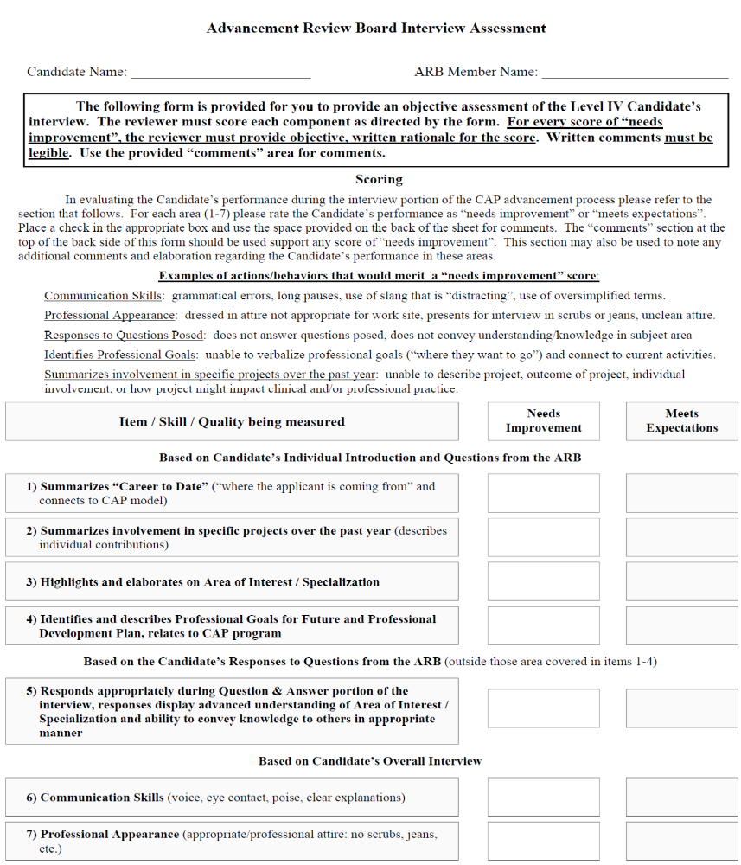

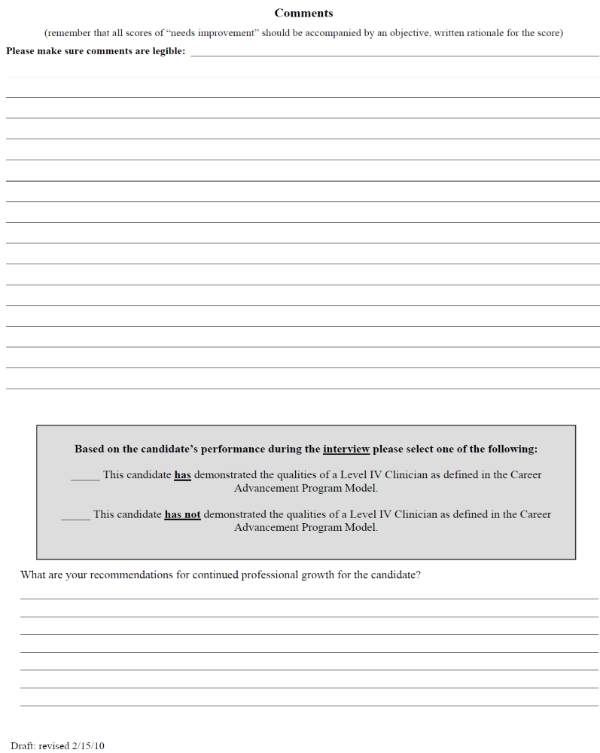

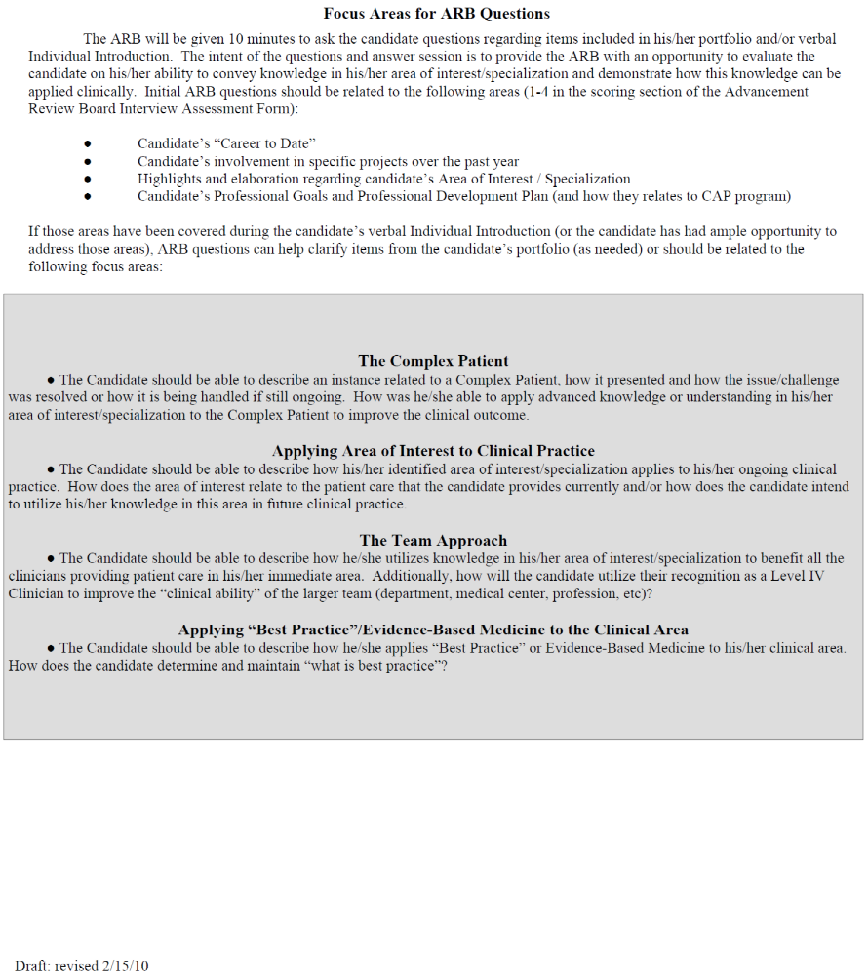

APPENDIX 4: Printable Forms (including activities list instructions)
Activities List Instructions
Mark the number of activities (ex. 1, 2, 3) next to each activity you have completed. The minimal activity requirements for each category for each level are described below.

Include written examples or details in the bullets below the activity descriptions as needed (delete examples given). If something you have done is not included in the list, add it in the “Other” section.

Once you have accounted for all of your activities, delete the description/examples that do not apply to you.

Activity Requirements:

Below are the activity requirements for all disciplines. These are minimum expectations for each level and are used for attainment and maintenance of each level. There is no substitution of categories.

CATEGORY | Level I * | Level II * | Level III | Level IV
Clinical Practice/Expertise | 1 | 1 | 1 | 2
Teaching |  | 1 | 1 | 2
Advocacy | 1 | 1 | 1 | 2
Leadership/Facilitation |  |  | 1 | 2
Outcomes/EBM |  |  | 1 | 2
TOTAL |  |  | 12 | 18

*Level I and II guidelines for those that may want to participate in the Career Advancement Program.
Level III must meet 12 required activities: 1 in each of the 5 categories, and 7 additional activities that must involve AT LEAST 2 of the categories.
Level IV must meet 18 required activities: at least 2 in each category, 5 of the activities must be from those designated with a .

Circle: Level I II III IV

Circle: Discipline ATC ES OT COTA PT PTA
Clinical Practice/Expertise

_____ Clinical Equipment/Supply
  - Examples: Maintaining the inventory for your area (i.e. satellite Athletic training rooms or High School Athletic Training Rooms); Responsible for the maintenance of the equipment (i.e. coordinating the calibration of modalities, mechanical maintenance of vehicles: gators, Polaris, etc)

_____ Practice Enhancing: Applies to self –journal reading
  - Journal readings outside of the CQI project. Must give brief overview of how the article applies to your practice area.
  - 4 articles =1 activity with a maximum of 1 activity allowed
  - See attached bibliography log

_____ In-service Attendance
  - Must attend 3 in-services to receive 1 activity with a max of 2 activities allowed
  - See attached in-service log

_____Completes/Maintains Specialty Certifications/Certificates
  - Refers to extensive courses that demonstrate competencies based on evaluations through testing or portfolio
  - Maintaining refers to those certificates or certifications that require reporting CEU’s, renewal, or recertification
  - Example: Mackenzie, FMS, NDT, CSCS, OCS, CPR Instructor, CHT, ACSM Certified; NSCA Certified; Well Coach Certified

_____ Continuing Education
  - Attends CE course either on and/or off campus. 6 hours = 1 activity point
  - See attached continuing education log

_____ Audits college level course related to your profession or professional development
  - Audits for pass/fail. Must pass 1 course for 1 activity point

_____ Successfully completes college level course for credit related to your profession or professional development
  - Must obtain a “C” or better in the class. 1 activity point per credit hour;
Include course name/institution/hours

_____ Participates in program development. Not associated with CQI/focus team. Please fill out appropriate project form.
  - Actively participates in the development of the program

_____ Participates in the development or revision of guidelines/procedure/protocol for department. Not associated with CQI/focus team. Please fill out appropriate project form.

_____ Participates in the development or revision of patient education material and or handouts. Not associated with CQI/focus team. Please fill out appropriate project form.
  - Actively participates in the development
_____ Other:

_____ TOTAL Activities

Teaching

_____ Practice Adaptation: Applies to team
  - Example: enhancing or refining skills through individualized training of team members likely to be a onetime event. (I.E., Intervention protocols or techniques, training in the ICU regarding lines/ventilators, informal training of colleagues regarding advanced skill or expertise in a practice area.)

_____ In-service: Delivery to members of primary work area. at least 30 minutes and need to submit PPT/material for manager approval
  - Example: an acute care therapist providing an in-service on splinting to other acute care team members, an outpatient therapist giving an in-service to outpatient team members
  - Include date/topic/audience

_____ In-service: Delivery to another Vanderbilt service area outside of primary work area (up to 3 times for same in-service)
  - Example: acute care therapist presents to outpatient colleagues regarding splinting
  - Include date/topic/audience

_____ Student Education must be an assigned CI
  - Example: Serving as primary clinical instructor/supervisor to physical, occupational, exercise specialist, and athletic training students
  - Shared students- each clinician gets credit
  - Part time student is 60-240 hours = 1; full time student is greater than 240 hours = 2

_____Mentoring
  - Example: Formal mentor for colleagues/new employees includes experienced clinician serving as mentor to a new graduate, a less experienced therapist, or being a CAP mentor
  - See attached mentor log

_____Professional presentation at national/regional/state/local meeting/conference (different than CQI project) Must be unpaid, however, can receive registration waiver or travel reimbursement.
- Example: Presents at ACSM, AACVPR, NSCA, AOTA, APTA , or NATA conference, including poster presentations
  - Local presentations are as follows: Less than 4 hours for each presentation = 1; 4-8 hours for each presentation = 2; 8 or more hours for each presentation = 3
  - National/regional/state presentations are as follows Less than 4 hours for each presentation = 2; 4-8 hours for each presentation = 3; 8 or more hours for each presentation = 4

_____Submits article for publication or has article published (different than CQI or Evidence Based Medicine project)
  - Example: Author in a publication outside of Vanderbilt (AJOT, Journal of Rehabilitation and Medicine, Physical Therapy, JOSPT, Advance, OT practice, JAP, MSSE, etc.) =2 activity points

_____Participates in academic teaching
  - Examples: lectures, lab instructor, team teaching, provides professional presentations in specialty/career interest area (i.e. in-service in other departments, guest speaking)
  - 1 activity for presenting the lecture (if it already exists)
  - 2 activity points for developing or significantly revising an existing presentation (must be approved by manager) and presenting it
_____ Other:

_____ TOTAL Activities

Advocacy

_____ Marketing/shadowing: Making others aware of who you are and/or what you do
  - Meets with physician for purpose of education on services department provides
  - Participates in press releases, TV spots, etc for marketing of area
  - Presents to community organization for marketing purposes

_____ Community Service Activity: Representing Vanderbilt and/or profession at events
  - Examples: Health fairs, large Vanderbilt sponsored events, Habitat for Humanity, Christmas Village (event benefits Vanderbilt), TPTA day on the Hill, AHA Heart Walk, ALA Lung Walk
  - 0-4 total hours = 1 activity; 4-8 total hours = 2 activities; 8 total hours or more = 3 activities
  - See attached community service log

_____Committee: Participates on a committee composed of members outside your primary work area. You represent your area and advocate for its needs
  - Example: CAP, FALLS, Student education

_____Committee: Facilitates a committee composed of members outside your primary work area. You represent your area and advocate for its needs.
  - Example: CAP, FALLS, student education

_____ Holds Membership of professionally related organization: Membership fees promote your profession at the State, Regional, and National Level
  - Maximum of 2
  - Example: AOTA, APTA, NATA, SEATA, TATS, ACSM, CEPA, AACVPR, NSCA
_____ Attends meetings of professional related groups: (Local, State, Regional, National level)
  - Example: Attending the business meeting portion of National organization meeting
_____ Case advocacy: Patient advocacy with management approval
  - See attached advocacy form – management signature required

_____ Professional advocacy: Advocacy for the profession with management approval
  - See attached advocacy form – management signature required

_____ Other:

_____ TOTAL Activities
Leadership/Facilitation

_____ Committee: participates on primary work area committee other than focus team/CQI project
- Example: Rewards and Recognitions, patient satisfaction
- 1-10 hours of meeting time = 1 activity; 11-20 hours of meeting time = 2 activities; 21+ hours of meeting time = 3 activities
- See committee assessment form

_____Committee: facilitates a primary work area committee other than focus team/CQI project
- Example: People First, Competencies Committee
- 1-10 hours of meeting time = 1 activity; 11-20 hours of meeting time = 2 activities; 21+ hours of meeting time = 3 activities
- See committee assessment forms

_____Participates in advisory boards/collaborative groups outside of Vanderbilt specific to clinical profession
  - Example: serving on Belmont’s School of Physical Therapy Advisory Board which meets several times a year to develop Belmont’s physical therapy program, interviews students for admission to PT or PTA school

_____ Initiates Program Development: staff comes up with a new program for their area and initiates the implementation. Not associated with CQI/focus team. Please fill out appropriate project form.
  - Example: An outpatient therapist sees his or her area could greatly be enhanced by adding a splinting program, and he or she brings the plan idea and implementation strategies to the manager.

_____ Establishes policy/procedure/protocol for department at large: Not associated with CQI/focus team. Please fill out appropriate project form.
  - Example: creating a policy on management of theraband tubing cleaning/discarding

_____ Initiates the development and/or revisions of clinical handouts/patient education material for department wide use. Not associated with CQI/focus team. Please fill out appropriate project form.
  - Example: no hand out exists for falls risk factor for the home, therapist develops one

_____ Coordinates work area program
  - Example: SOAR program, FMS program, BLS program, HELP
_____ Coordinates in-services for work area: plans 3 in-services to be given from outside presenters
  - Example: physician speaking on a topic, a medical representative introducing a product
  - Plans 3 in-services = 1 activity, plans 6 in-services = 2 activities

_____Professional Organization (State, Regional, National, local level): Task force/committee member/Holds office/board member
  - Example: TATS public relations committee; CE course reviewer

_____ Peer Orientation: Orients peer to direct service area
  - Example: outpatient therapist on spine team orienting peer spine team, neuro therapist orienting peer to neuro floors, include discipline/who/where/what

_____ Coordinator of Orientation: coordinates the orientation of new staff

_____ Coordinator of Student Education Program: work area

_____ Elements of Performance
  - Overall score must Exceed Expectations during the prior performance year

_____ Credo
  - On prior performance year, must Fully Meet Expectations in all Credo categories AND Exceed Expectations in 3 or more Credo categories
_____ Mediserve Superuser

_____ Other:

_____ TOTAL Activities

Outcomes/Evidence Based Medicine

_____ Participates in CQI/Focus team/committee: The committee’s purpose should be to determine CQI activities for the year and to plan and implement the activities (could include but not limited to journal reading and program development).

_____ Creates policy/procedure/protocol for CQI project. Please fill out appropriate project form.
  - Example: CQI project develops lightning policy. (The person(s) that wrote the policy get credit.)

_____ Develops and/or revises clinical handouts/patient education material for CQI project. Please fill out appropriate project form.
  - Example: CQI project develops handouts for patients on Pediatric bracing. (The person(s) that created the handout get credit.)

_____ Completes a literature review for CQI project
Please fill out bibliography log
  - 4 articles = 1 activity point

_____Leads CQI project /Focus Team (sub-group)/committee

_____ Collaborates as a co-investigator on extra-departmental interdisciplinary research project

_____Performs preliminary “pilot” project for future research

_____ Completes/Maintains web based required instruction prior to submitting IRB

_____Submits for approval for IRB

_____Obtains IRB approval

_____ Presents CQI at in-service

_____Submits completed project for presentation to a Professional organization at National/regional/state level

_____Publishes results of CQI in professional journal/publication

_____Presents a professional presentation at national/regional/state meeting

_____Clinical Evaluator for an approved IRB research study (funded and unfunded)

_____ Presents and leads discussion of at least 30 minutes on Evidence Based Medicine article at journal club

_____ Attends journal club regarding EBM article
  - Must attend 3 journal club meetings to receive 1 activity with a max of 2 activities allowed
  - See attached journal club log
_____ Other:
_____ TOTAL Activities
CAP DECLARATION OF INTENT

COMPLETE THE FOLLOWING AND SUBMIT TO YOUR MANAGER BY DEADLINE DATE.

THANK YOU.

NAME: _________________________________

TEAM/UNIT: ____________________________

MANAGER: _____________________________

Manager’s Printed Name: _____________________________________________

INTEND TO ADVANCE TO (PLEASE CIRCLE ONE):

LEVEL III

LEVEL IV

CAP Advancing Affirmation Statement

This statement affirms that the contents of this document are true, correct and reflect professional performance. Providing false information may result in disciplinary action.

______________________________________ ________________
Candidate’s Signature Date

______________________________________ ________________
Manager’s Signature Date

Bibliography Log
Name:__________________________________ Year:_________________
Reporting of 4 articles = 1 Activity
Name of Article | Authors | Journal/Source | Clinical Application

In-Service Log
Name:____________________________________ Year:__________________
Date | Title | Presenter | Length of In-Service
 | Attending 3 in-services = 1 activity  Max activity total of 2 | Total Number of Activities:

Continuing Education Log
Name:________________________________________ Year:_________________
6 hours of Continuing Education = 1 activity
Title of Continuing Education | Date | Number of Hours
6 hours = 1  Cumulative over the reporting period |  | /6
 | Total Activities

Note: No partial Activity credit will be issued.
For example: If the applicant receives a total of 15 contact hours of Continuing Education during the year, he/she can only receive 2 activity credits in this section.
CAP College Course / Audit Log

Audited Course: 1 point per class that is audited
Must “pass” the course

Name of Course | Institution | Pass or Fail  Grade | Hours /  Class Audit
College Course: 1 point per credit hour (3 hour course = 3 points)
Must pass with a “C” or better

Audited Course: 1 point per class that is audited
Must “pass” the course

MENTORING FORM

Name of Mentee:

Name of Mentor:

Goals and/or Expected Outcomes of Mentoring Relationship:

MENTORING OBJECTIVES
(To be developed in conjunction with Mentee, written in a format that is outcome based)
1.
2.
3.
4.
5.
6.
7.
8.

PLAN OF INSTRUCTION/ STEPS TAKEN TO ACHIEVE STATED GOALS
(In addition to hands on, readings, reports, presentations for Mentee)
1.
2.
3.
4.
5.
6.
7.
8.

Future Plans/Next Steps for Mentee:

Signature of Mentor: ____________________________________________

Date: ____________________________

Signature of Mentee: ____________________________________________

Date:_____________________________

Signature of Manager: ___________________________________________

Date: ___________________________
CAP Mentor Agreement
I have agreed to mentor the CAP applicant for FY ________________. As a CAP mentor, I have agreed to complete CAP mentor training. I am aware that being a mentor will take time out of my day and may include doing work at home. I am willing to meet with my mentee a minimum of two times, but will be available to communicate and/or meet with him/her as needed. If my mentee has questions I cannot answer I will contact the CAP committee. If for any reason I cannot fulfill my commitment, I will notify the applicant and my manager as soon as possible so that a replacement mentor can be recruited.

__________________________ ____________________
Mentor Date

_____________________________ _____________________
Manager/Administrator Date

______________________________ ______________________
CAP Applicant Date
CAP MENTOR LOG

Date | Items Discussed | Plan/Follow Up | Recommendations | Signatures of mentor/mentees

Advocacy Form
NOTE: this form should be utilized to describe professional and patient care advocacy points

Name: ________________________________________________ Date: _____________________

Please describe the advocacy activity you completed for your profession or a patient in the space below:

What: _______________________________________________________________________
____________________________________________________________________________
____________________________________________________________________________

How: _________________________________________________________________________
_____________________________________________________________________________
______________________________________________________________________________

Outcome: _____________________________________________________________________
______________________________________________________________________________
______________________________________________________________________________
______________________________________________________________________________
______________________________________________________________________________
______________________________________________________________________________
______________________________________________________________________________

Manager’s Signature: __________________________________ Date: ___________________

Community Service Log
1-4 hours = 1 activity; 4-8 hours = 2 activities; 8 or more hours = 3 activities
Date of Event | Activity/Event | Hours volunteered
 | 1-4 hours = 1 activity  4-8 hours = 2 activities  8 or more hours = 3 activities | Total number of Activities:

Journal Club Log
Name:____________________________________ Year:__________________
Date | Article Title | Source and Year | Discussion Leader
 | Attending 3 journal club meetings = 1 activity  Max activity total of 2 | Total Number of Activities:

Committee Participant Assessment Form

Purpose: The committee participant assessment form was designed as an objective means to distinguish between levels of participation/contribution in their work group/committee. The original intent was to allow the participant the opportunity to perform a self-assessment and subsequently to compare/contrast with that assessment of the Committee Facilitator.
RECOMMENDATIONS/OUTCOME: The CAP Steering Committee requests that all CAP participants complete this form as a self-assessment. If no objective information is attached to the form (project descriptions etc) and the participant has demonstrated an acceptable attendance per the Committee Facilitator, the participant will receive a score of “3” for their participation. All supportive evidence/documentation will be reviewed to receive a score of 4 or 5. CAP STEERING COMMITTEE members are available for assistance.
Each participant should be mindful that accurate and objective self-assessment is part of being a professional. Exaggerating upon the depth and breadth of involvement as well as participation on a committee is not acceptable.

NEXT STEPS: As the Performance Review system is implemented, this form will be assessed to provide effective support of the mission and vision of the individual’s professional practice goals and employment at Vanderbilt Medical Center through participation in CAP.

VANDERBILT UNIVERSITY MEDICAL CENTER

COMMITTEE PARTICIPANT ASSESSMENT

NAME:____________________________COMMITTEE:_________________________________________FY:_______

COMPLETED BY:_________________ATTENDANCE:Goal – 90% ____/____#Attended/Total # of meetings = ______%

Performance: The Committee member:

- Submits assignments for facilitator/team review 1 2 3 4
- Provides insight, expanded thoughts on topics 1 2 3 4
- Provides constructive feedback to committee members 1 2 3 4
- Maintains focus, attention to agenda 1 2 3 4
- Contributes equally to project, volunteers for assignments 1 2 3 4

Additional Comments: Must include objective supporting evidence for all scores. (Use back of form as needed)

Facilitator Signature: _______________________________________________ Date: _________________________

By signing this form, the facilitator of the committee acknowledges the participant performed in accordance with the scores listed above.

VANDERBILT UNIVERSITY MEDICAL CENTER
COMMITTEE FACILITATOR ASSESSMENT

FACILITATOR NAME:__________________________________COMMITTEE:_________________________________FY:_______

COMPLETED BY:________________________________________

Facilitator:
✓ Identifies and articulates committee’s goals, responsibilities, and desired outcomes 1 2 3 4
✓ Solicits members input; facilitates participation effectively 1 2 3 4
✓ Facilitates broad thinking and problem solving to achieve committee goals 1 2 3 4
✓ Meets deadlines, produces established expectations/e.g. materials, functions, tools, guidelines, etc. 1 2 3 4
✓ Supports and promotes department/VUMC mission and vision. 1 2 3 4
✓ Appropriate amount of supervision, availability 1 2 3 4

Additional Comments: Must include objective supporting evidence for all scores. (Use back of form as needed)
Key
- DOES NOT MEET EXPECTATIONS | - PARTIALLY OR INCONSISTENTLY MEETS EXPECTATIONS | - MEETS EXPECTATIONS | - EXCEEDS EXPECTATIONS
• Working knowledge not demonstrated  • Does not perform assigned tasks correctly; does not achieve desired results  • Does not perform tasks in a timely manner; minimal contributions beyond what is required  • Requires add’l supervision to complete tasks; add’l oversight and guidance is required  • Cannot handle routinely encountered problems  • Requires add’l resources to complete tasks | • Demonstrates working knowledge on some, but not all, duties  • Partially completes tasks  • Works independently on some tasks, but needs help in others  • Inconsistently handles routine problems  • Shows potential, but is still learning the role  • May have new tasks added to role and is still learning.  • Hasn’t had time to complete a long-term task | • Demonstrates working knowledge  • Performs tasks correctly  • Performs tasks in a timely manner  • Works independently with minimal supervision  • Handles routinely encountered problems  • Demonstrates responsible use of resources | • Improves expertise of others through coaching, mentoring, and in-service presentations  • Contributes significantly to department’s efficiency by improving systems  • Anticipates time constraints and seeks opportunities to complete tasks prior to deadlines  • Leads internal projects/teams  • Anticipates and works to prevent problems  • Actively seeks ways to improve financial performance of organization

Career Advancement Program
Project Description
NOTE: this form should be utilized for projects not related to Outcomes/EBM – for Outcomes/EBM related projects, please use the CQI form

Title of Project:_____________________________________________________________________
Project Participants Role (Facilitator, Contributor, Etc)
______________________________ ___________________
______________________________ ___________________
______________________________ ___________________
Work Area / Site:
(Identify work area(s) involved in or affected by the project.)
Identify the Category under which the project is being counted in relation to CAP
Leadership Facilitation_____ Clinical Practice_____
Provide a brief justification as to why this project fits this category:

Project Description: (include project’s intended purpose and or rationale, brief methods, statement if applicable)

Project Results: (describe the findings/results of the project, specific impact eg patient care, work/site improvement, professional contribution, and provide supporting documentation as applicable):

CQI Project Proposal

Project Name:

Date:

Project Participants:
- __________________________________ (facilitator or lead)
- __________________________________
- __________________________________
- __________________________________

Describe the problem or question:

What proof, evidence or information do you have that this problem is impacting quality,
outcomes, efficiency, customer satisfaction or employee satisfaction?

How could this project impact your clinical area?

Briefly describe your plan:

__________________________________
Manager’s signature Date

CQI Project Summary

Project Name:

Date:

Project Participants:
- __________________________________ (facilitator or lead)
- __________________________________
- __________________________________
- __________________________________
- __________________________________

Describe the Problem or question:

What was the Procedure/Process/Methodology?

Summary of Results:

Assessment:

Recommendation and Plan:

__________________________________
Manager’s Signature Date
Data should be included with submission (i.e. raw data, projects such as patient education handouts, etc)
 OTHER FORM
Purpose: To provide a process for CAP participants to receive starred activity credit for a project, collaboration, consultation, coordination, or effort of such caliber/quality that is not represented by other starred activities described in the Activities Check list. This endeavor requires completion of the following information and the participant’s manager’s signature for the activity to qualify.

Category:
____ Clinical Practice/Expertise ____Leadership/Facilitation
____Teaching ____Outcomes/EBM
____Advocacy
ACTIVITY DESCRIPTION: ______ _________________________________________________________
___________________________________________________________________________________
___________________________________________________________________________________
___________________________________________________________________________________

Justification: Explain succinctly why this endeavor merits an elevated status within the CAP Activities._____________________________________________________________________________
____________________________________________________________________________________
____________________________________________________________________________________
____________________________________________________________________________________
_________________________________________________________________________________
Participant must include “evidence” of activity: brochure, photo, etc

Participant’s Signature Date

Manager’s Signature Date
CAP Maintenance Affirmation Statement

This statement affirms that the contents of this document are true, correct and reflect professional performance. Providing false information may result in disciplinary action.

Therapist’s Signature: _______________________________________________
Date: ___________________________________________

Manager’s Signature: _________________________________________________
Date: ____________________________________________
CAP Glossary
AIDET- a methodology used to insure that the patient is informed on all processes and procedures: Acknowledge, Introduce, Duration, Explanation and Thank you.
ARB - CAP’s Advancement Review Board which is the decision making body for promotion within the program
Elevate – the goal in becoming one of the top academic medical centers in the world by: setting goals and measuring performance; following a standard of professional and personal behavior (credo); and building a working environment that allows the staff to grow and act on behalf of their customers.
CAP – Career Advancement Program
Credo – Vanderbilt has 6 personal and professional behaviors that exhibit the following:
We provide excellence in healthcare, research and education
We treat others as we wish to be treated.
We continuously evaluate and improve our performance
CQI – Continuous Quality Improvement – projects/investigations that are directed toward improvement of internal processes that support patient care, service, education and research efforts at Vanderbilt.
Focus Group – a team of medical professionals that work together to research related topics that affect their clinical practice through Continuous Quality Improvement projects
HEART Service Recovery-a methodology for staff to address patient’s complaints and concerns: Hear, Empathize, Apologize, Respond, Thank
Manage up – to speak in positive terms of your colleagues, reinforcing coordination of care and teamwork and decreases patient anxiety and concern
Rewards and Recognition Program – recognizing and rewarding staff members for positive behaviors and results that display credo behaviors and VUMC goal results
Vanderbilt Rehabilitation Providers – Location Abbreviations
VOI Vanderbilt Orthopaedic Institute
VCH Vanderbilt Children’s Hospital
VUH Vanderbilt University Hospital
PBPRI Pi Beta Phi Rehabilitation Institute
VSM Vanderbilt Sports Medicine
VBWC Vanderbilt Bill Wilkerson Center
VHCS Vanderbilt Home Care Services
VCIH Vanderbilt Center for Integrated Health
VLC Vanderbilt Lymphedema Clinic

