2016
Professionalism and Professional Health and Wellness of the Scientist

Health and Wellness Portfolio

Self-care and maintaining professional health is important throughout your career. This portfolio was developed to help you reflect on and document current practices that promote self-care and professional health and wellness.

Created By:

Charlene M. Dewey, M.D., M.Ed., FACP
Assistant Dean for Educator Development
Director, Educator Development Core and Educator Development Program
Co-Director, Center for Professional Health
Chair, Faculty and Physician Wellness Committee

Associate Professor of Medical Education and Administration
Associate Professor of Medicine

Center for Professional Health - Vanderbilt University Medical Center
1107 Oxford House
Nashville, TN
615-936-0678
www.mc.vanderbilt.edu/cph

Created by:
Charlene M. Dewey, M.D., M.Ed., FACP
William H. Swiggart, M.S., LPC/MHSP
Center for Professional Health
Vanderbilt University Medical Center
Nashville, TN.
Professional Health and Wellness

Scientist Wellness Program 2016-17

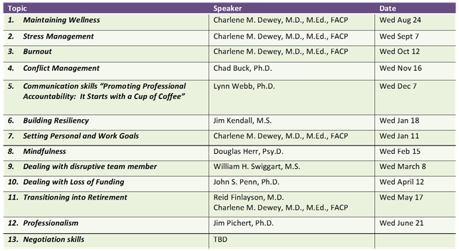

Table of Contents

Topic | Page
Maintaining Wellness | 2
Stress and Stress Management | 12
Burnout & Emotional Intelligence | 24
Conflict Management | 30
Communication Skills: Promoting Professional Accountability (Cup of Coffee)
Building Resiliency
Setting Personal and Work Goals
Mindfulness
Dealing with Disruptive Team Members
Dealing of Loss of Funding
Transitioning into Retirement
Professionalism
Negotiation Skills

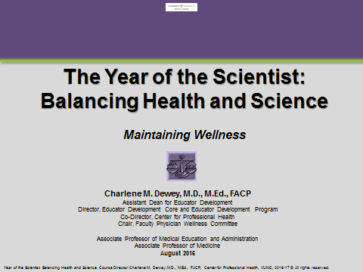

Table of Contents
Session 1: Maintaining Wellness

Topic | Page
Professional Health and Wellness Spectrum | 3
Primary Wellness Practices | 3
Self-Care | 4
Meaning/Value | 4
Relationships/Socialization | 5
Positive approach to life | 5
Spirituality | 6
Resiliency | 6
B-A-SMARTER Goals and Objectives | 7-9
Resources | 10

Professional Health and Wellness Spectrum

- Review the wellness spectrum below. Circle the letter that best represents where you feel you are at this particular time in your life. (A=optimal wellness and G=impairment with little to no wellness)

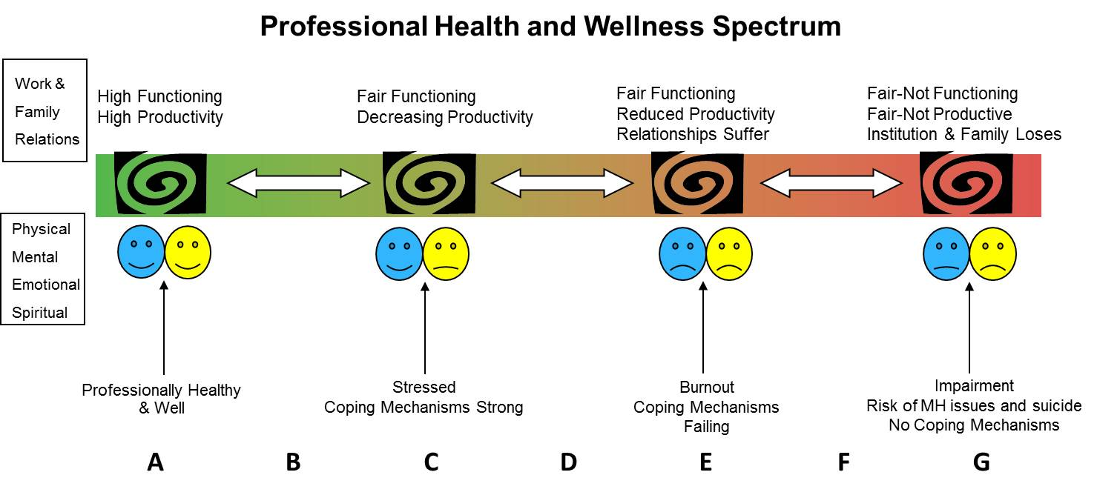

Primary Wellness Practices

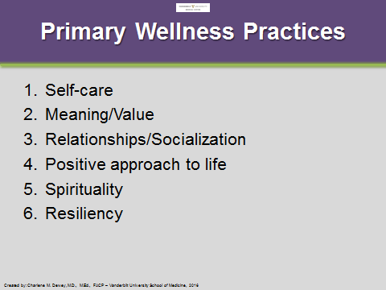
- Rank your top three primary wellness practices based on what is most important to you. (1=most important)

1.

2.

3.

I listed ___________________________________________ [fill in] first because….

Self-Care

- Circle those areas of self-care you need to improve over the next 6-12 months.

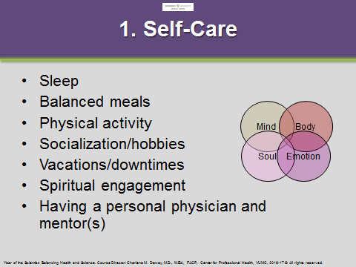

- What gives you the most meaning or sense of value in your life?

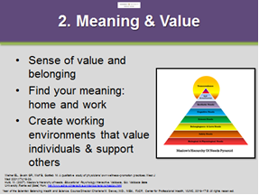

“When our work is devoid of meaning, then even completing a long list of tasks cannot yield a genuine sense of accomplishment.”
~Amabile & Kramer, “The Progress Principle,” 2011, pg. 98

- What relationships or social situations provide you with the greatest sense of wellbeing?

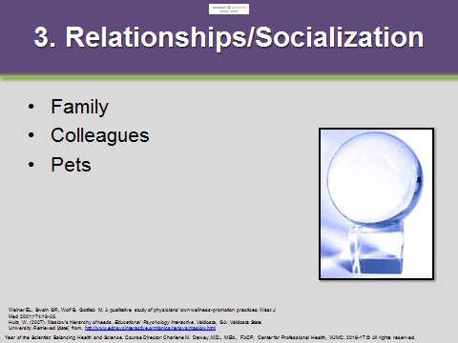

- List 1 thing you can do to be more positive at home and work.

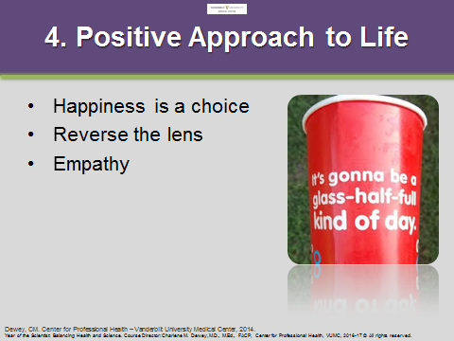

- How will you engage your spiritual wellness?

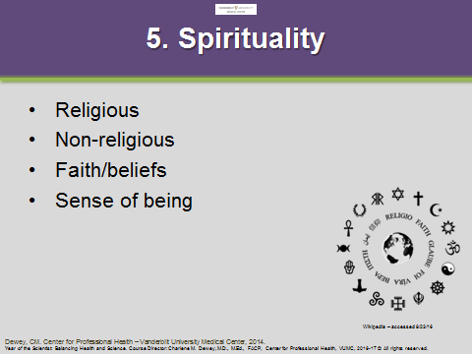

- How resilient are you? Do you need to strengthen or improve your resiliency?

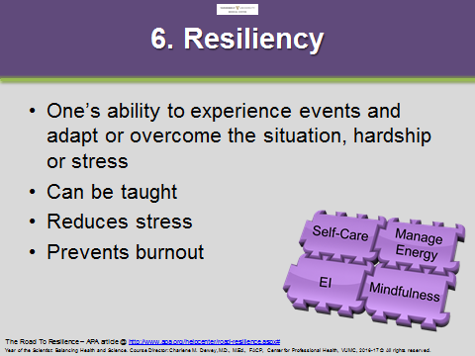

B-A-SMARTER Goal and Objective Writer

Evidence shows that writing down goals increases the likelihood of fulfilling them. Review this framework and the example below, as we will use this or similar techniques during the session.

B - Barriers | Identify major barriers or challenges to executing or maintaining your new personal goals and objectives.
A - Accountability | Select someone to serve as an advocate and hold you accountable to the tasks
S – Specific | Make sure your goal is specific.
M – Measurable | Make sure your goal has a measurable outcome to define success.
A – Appropriate | Make sure your goal is appropriate, something that is attainable – in this lifetime.
R – Relevant | Make sure your goal is relevant to you – personally. Select someone to help hold you accountable for completing your goal.
T – Timely | Make sure your goal is timely – list as either short-term (1-2 weeks), intermediate (2-4 weeks), or long-term (1-12 months).
E – Evaluate | Identify a time to evaluate your goal on a short-term, intermediate, and long-term basis.
R – Re-evaluate | At the beginning of 2017 – re-evaluate your goals from 2016 and carry over those that worked well, readjust those that need modifying, and set new goals to build on the old ones.

Example:

Check List: | Goal: I intend to improve my personal health and wellness over the next 12 months.
- B - Barriers | Objective: I will start eating three servings of fish weekly and eat one vegetarian meal a day and I will increase my physical activity (climbing all stairs I encounter and walk or work out for 20 min/ 3-4 times a week) starting January 4th. My husband will be my advocate/accountability partner.  - Barriers: work, kid’s activities, sometimes I will be tired  - Accountability: my spouse  - Specifics:  - Eat 2-3 fish servings weekly and eat vegetarian mean/day  - Exercise at least three-four times a week including:  - Flexibility (Monday - yoga and stretching)  - Strengthening (Wednesdays - upper body and Fridays - lower body)  - Cardiovascular endurance (Saturday mornings and walk stairs daily)  - Measures: Will measure by checkmarks on calendar and set phone alarm to 5:30 daily  - Appropriate: Yes – improves my health and fitness  - Relevant: Important at middle age  - Timely: Short term - Start now  - Evaluate: Self-assessments at baseline vs. 3 months vs. 6 months vs. 12 months  - Re-evaluate: January 2017 – fitness testing and overall satisfaction with weight, muscle tone, and cardiovascular stamina
- A – Accountability
- S – Specific
- M – Measurable
- A – Appropriate
- R – Relevant
- T – Timely
- E – Evaluate
- R – Re-evaluate

- Write a B-A-SMARTER goal/objective for one behavior or activity you plan to do to improve your professional health and wellness at work and at home. Share with your partner.

Home Goal

My goal is to:

Check List: | Objective:
- B - Barriers | - Barriers:  - Accountability:  - Specifics:  - Measures:  - Appropriate:  - Relevant:  - Timely:  - Evaluate:  - Re-evaluate:
- A – Accountability
- S – Specific
- M – Measurable
- A – Appropriate
- R – Relevant
- T – Timely
- E – Evaluate
- R – Re-evaluate

Work Goal

My goal is to:

Check List: | Objective:
- B - Barriers | - Barriers:  - Accountability:  - Specifics:  - Measures:  - Appropriate:  - Relevant:  - Timely:  - Evaluate:  - Re-evaluate:
- A – Accountability
- S – Specific
- M – Measurable
- A – Appropriate
- R – Relevant
- T – Timely
- E – Evaluate
- R – Re-evaluate

Wellness Resources

- Vanderbilt resources:
  - Faculty and Physician Wellness Program – Work/Life Connections EAP is available 24 hrs a day, seven days a week and counseling services are free for all Vanderbilt faculty and staff. Call: x6-1327 or visit their web page at: http://healthandwellness.vanderbilt.edu/work-life/eap/

  - Vanderbilt Center for Professional Health & Faculty and Physician Wellness Committee – Educational Resources at: http://www.mc.vanderbilt.edu/cph

  - Vanderbilt Center for Integrated Health at: http://www.vanderbilthealth.com/integrativehealth/

  - Vanderbilt Center for Patient & Professional Advocacy (CPPA) at: http://www.mc.vanderbilt.edu/centers/cppa

  - Vanderbilt Comprehensive Assessment Program for Professionals (VCAP) at: http://www.mc.vanderbilt.edu/root/vcap

- Institutional, State or Federation of State Physician Health Programs at: http://www.fsphp.org/
- Primary care provider
- TN Resources:
  - TN State Board of Medical Examiners: http://www.tn.gov/health/article/ME-licensure
  - TN State Physicians Health Program – TN Medical Foundation: https://www.e-tmf.org/
- Private counseling or coaching services:
  - Personal coaching services
  - Other professional coaching organizations
- Substance use services:
  - Substance Abuse and Mental Health Services Administration: http://www.samhsa.gov/
  - Alcoholics Anonymous® at: http://www.aa.org/
  - Narcotics Anonymous at: http://www.na.org/
  - Nicotine Anonymous at: http://www.nicotine-anonymous.org/
- National Suicide Prevention Hotline: 1-800-273-TALK or visit at: http://www.suicidepreventionlifeline.org/
- Other: YMCA/YWCA, Massage Envy, day salons, personal trainer, etc.
- Other: (fill in)_________________________________________________

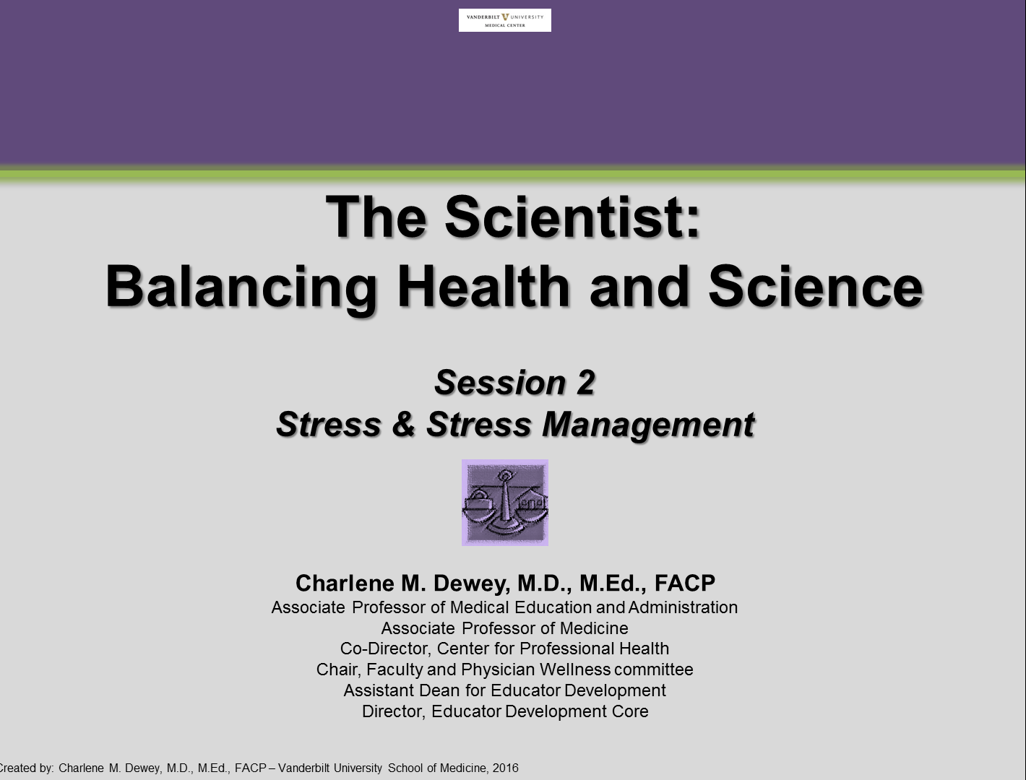

Table of Contents
Session 2: Stress and Stress Management

Topic | Page
Stress | 12
Flooding Assessment | 15
Stress Management | 17
Managing Energy | 17
Energy Crisis Assessment | 18
B-A-SMARTER Goals and Objectives | 22

Stress

Identify (by circling) your average stress level over the past 2 to 4 weeks.

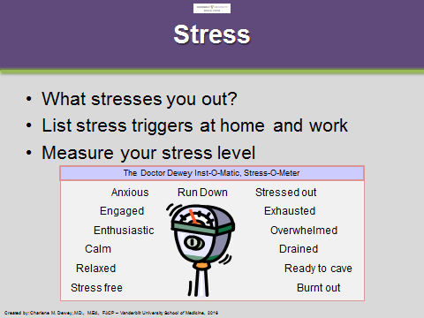

List your stress triggers at home and work.

Stress Triggers at Home | Stress Triggers at Work

Planning helps reduce stress and allows calms between the waves.

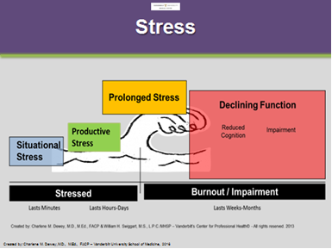

Review your calendar and identify items that will produce “waves of stress”. Write an action item(s) to address the potential wave (prevent or manage).

Source of the Wave | Action Item to Prevent/Manage the Wave
Example: Two trips in 1 month during kids volleyball and 2 workshops to develop | - Assure childcare while traveling.  - Plan workshop 1 prior to first trip.  - Plan workshop 2 on plane when returning from first trip.  - Clear meetings/hold 3 hrs next two Friday afternoons to prepare for travel and workshops.

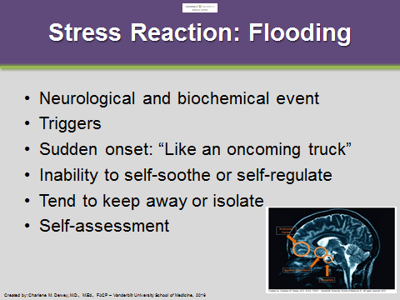

How do you feel when you are stressed?

Determine your flooding score: Take the flooding assessment below.

SELF-TEST for FLOODING©

- At times, when I get angry I feel confused. | Yes |  | No
- My discussions get far too heated. | Yes |  | No
- I have a hard time calming down when I discuss disagreements. | Yes |  | No
- I’m worried that I will say something I will regret. | Yes |  | No
- I get far more upset than is necessary. | Yes |  | No
- After a conflict I want to keep away or isolate for a while. | Yes |  | No
- There’s no need to raise my voice the way I do in a discussion. | Yes |  | No
- It really is overwhelming when a conflict gets going. | Yes |  | No
- I can’t think straight when I get so negative. | Yes |  | No
- I think, “Why can’t we talk things out logically?” | Yes |  | No
- My negative moods come out of nowhere. | Yes |  | No
- When my temper gets going there is no stopping it. | Yes |  | No
- I feel cold and empty after a conflict. | Yes |  | No
- When there is so much negativity I have difficulty focusing my thoughts. | Yes |  | No
- Small issues suddenly become big ones for no apparent reason. | Yes |  | No
- I can never seem to soothe myself after a conflict. | Yes |  | No
- Sometimes I think that my moods are just crazy. | Yes |  | No
- Things get out of hand quickly in discussions. | Yes |  | No
- My feelings are very easily hurt. | Yes |  | No
- When I get negative, stopping it is like trying to stop an oncoming truck. | Yes |  | No
- My negativity drags me down. | Yes |  | No
- I feel disorganized by all this negative emotion. | Yes |  | No
- I can never tell when a blowup is going to happen. | Yes |  | No
- When I have a conflict it takes a very long time before I feel at ease again. | Yes |  | No
Copyright © 2000-2013 by Dr. John M. Gottman. Reprinted under license by The Gottman Institute, www.gottman.com
Count your “Yes” answers. Total: __________

Scoring: If you answered “yes” to more than eight statements, this is a strong sign that you are prone to feeling flooded during conflict. Because this state can be harmful to you, it’s important to let others know how you are feeling. The antidote to flooding is to practice mindful activities/behaviors that can actually sooth and calm yourself during times of conflict.

There are four secrets of calming/soothing yourself: breathing, relaxation, heaviness, and warmth. The first secret is to get control of your breathing. When you are getting flooded, you will find yourself either holding your breath a lot or breathing shallowly. Change your breathing so it is even and you take deep regular breaths. Take your time inhaling and exhaling. The second secret is to find areas of tension in your body and first tense and then relax these muscle groups. First, examine your face, particularly your forehead and jaw, then your neck, shoulders, arms, and back. Let the tension flow out and start feeling heavy. The secret is to meditate, focusing your attention on one calming vision or idea. It can be a very specific place you go to that was once a very comforting place, like a forest or a beach. Imagine this place as vividly as you can as you calm yourself down. The fourth part is to imagine the body part becoming warm.

Copyright to John M. Gottman, All Rights Reserved (revised 11/17/03)

Stress and Behaviors

What do others notice about you when you are stressed?

How do you manage stress?

Stress Management

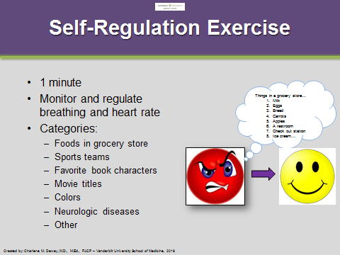
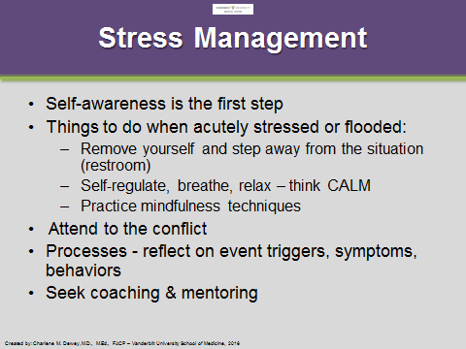

List two to four different categories you can list if you experience a stressed reaction.

1.

2.

3.

4.

Managing Energy

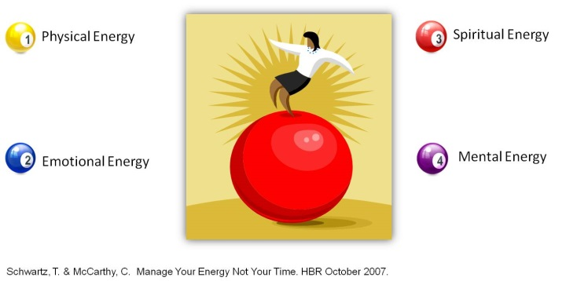
“Longer days at the office don’t work because time is a limited resource. But personal energy is renewable…By fostering deceptively simple rituals that help employees regularly replenish their energy, organizations build workers’ physical, emotional, and mental resilience.”
~Schwartz & McCarthy, 2007

Are You Headed for an Energy Crisis?
By Schwartz and McCarthy, Harvard Business Review, 2007

Complete the following self-assessment. Based on their HBR article, “Manage Your Energy, Not Your Time,” Schwartz & McCarthy provide the following self-assessment. For each item in all four categories, place a check mark () in the “True” column if you consider it to be “true” most of the time. Score yourself one point (1) for each True or by placing it in the “point” column. Total the checks for each category and then total the points for the full survey at the bottom. Find your score in the table on the back.

Items | True Most of the time | Point
Physical Energy
- I don’t regularly get consistent sleep (seven to eight hours) and I often wake up feeling tired.
- I frequently skip breakfast, or settle for something that isn’t nutritious.
- I don’t work out enough (meaning cardiovascular training at least three times a week and strength training at least once a day).
- I don’t take regular breaks during the day to truly renew and recharge, or I often eat lunch at my desk, if I eat at all.
 | Physical Total: ____
Emotional Energy
- I frequently find myself feeling irritable, impatient or anxious at work, especially when work is demanding.
- I don’t have enough time with my family or loved ones, and when I’m with them, I’m not always really with them.
- I have too little time for activities that I most deeply enjoy.
- I don’t stop frequently enough to express my appreciation to others or to savor my accomplishments and blessings.
 | Emotional Total: ___
Mental Energy
- I have difficulty focusing on one thing at a time, and I am easily distracted during the day, especially by email.
- I spend much of my day reacting to immediate crises and demands rather than focusing on activities with longer-term value and high leverage.
- I don’t take enough time for reflection, strategizing, and creative thinking.
- I work in the evenings or on weekends, and I almost never take an email-free vacation.
 | Mental Total: _____
Spiritual Energy
- I don’t spend enough time at work doing what I do best and enjoy most.
- There are significant gaps between what I say is important to me in my life and how I actually allocate my time and energy.
- My decisions at work are more often influenced by external demands than by a strong, clear sense of my own purpose.
- I don’t invest enough time and energy in making a positive difference to others or to the world.
 | Spiritual Total: ____
 | Total Point Score: ______

Are you heading for an energy crisis? Complete the assessment and review the scoring tables below by Schwartz and McCarthy, HBR, 2007. Reflect on your scores and if needed, how would you improve them?

Total Point Guide: | Guide to Category Scores:  (# of True or per category)
0-3: Excellent energy management skills  4-6: Reasonable energy management skills  7-10: Significant energy management deficits  11-16: A full-fledged energy management crisis | 0: Excellent energy management skills for that category  1: Strong energy management skills for that category  2: Significant deficits for that category  3: Poor energy management skills for that category  4: A full fledged energy crisis in that category

Where do you need more balance?
- Home
- Work
- Both
- Other:

What areas of work drain your energy? List them below.

What areas of home life drain your energy? List them below.

What am I doing well? (List a few things you do well.)

For each type of energy, write one thing you will do differently.

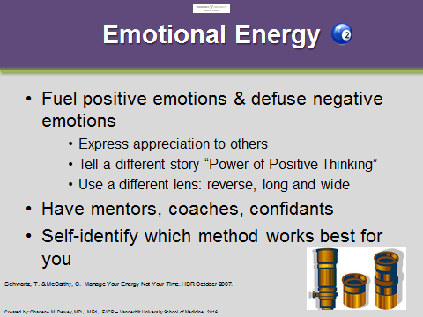
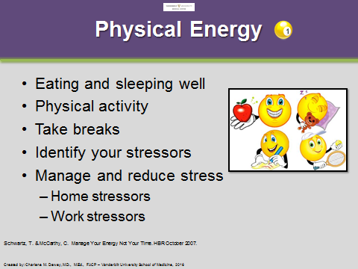

- Changes to promote my physical energy:

- Changes to promote my emotional energy:

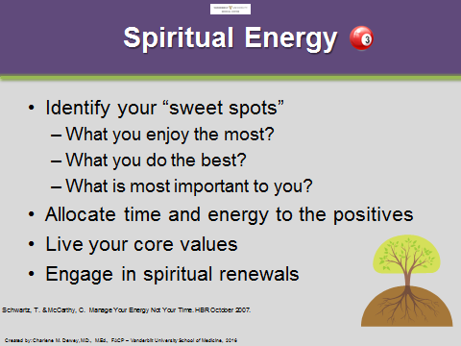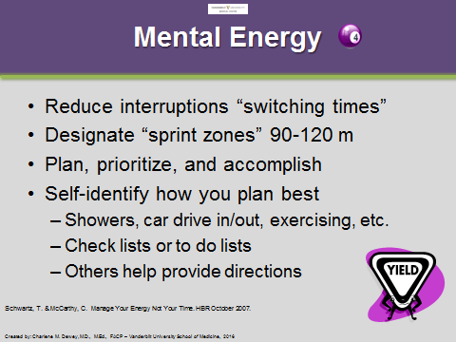

- Changes to promote my spiritual energy:

- Changes to promote my mental energy:

- Write a B-A-SMARTER goal/objective for one behavior or activity you plan to do to improve your energy and/or reduce your stress at work and at home.

Home Goal

My goal is to:

Check List: | Objective:
- B - Barriers | - Barriers:  - Accountability:  - Specifics:  - Measures:  - Appropriate:  - Relevant:  - Timely:  - Evaluate:  - Re-evaluate:
- A – Accountability
- S – Specific
- M – Measurable
- A – Appropriate
- R – Relevant
- T – Timely
- E – Evaluate
- R – Re-evaluate

Work Goal

My goal is to:

Check List: | Objective:
- B - Barriers | - Barriers:  - Accountability:  - Specifics:  - Measures:  - Appropriate:  - Relevant:  - Timely:  - Evaluate:  - Re-evaluate:
- A – Accountability
- S – Specific
- M – Measurable
- A – Appropriate
- R – Relevant
- T – Timely
- E – Evaluate
- R – Re-evaluate

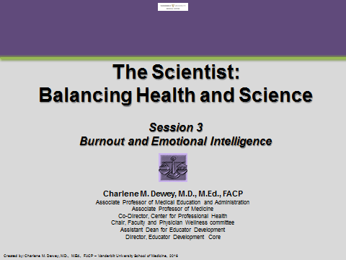

Table of Contents
Session 3: Burnout and Emotional Intelligence

Topic | Page
Burnout | 25
Preventing Burnout | 26
Emotional Intelligence | 27
B-A-SMARTER Goals and Objectives | 29-30

Burnout

“Exhaustion of physical or emotional strength or motivation usually as a result of prolonged stress or frustration.” ~Webster’s dictionary

“In the current climate, burnout thrives in the workplace. Burnout is always more likely when there is a major mismatch between the nature of the job and the nature of the person who does the job. Burnout is ‘an erosion of the soul.’ ~Christina Maslach

Maslach & Leiter . The Truth About Burnout: How Organizations cause Personal Stress and What to Do About It. 1997; pg 9.

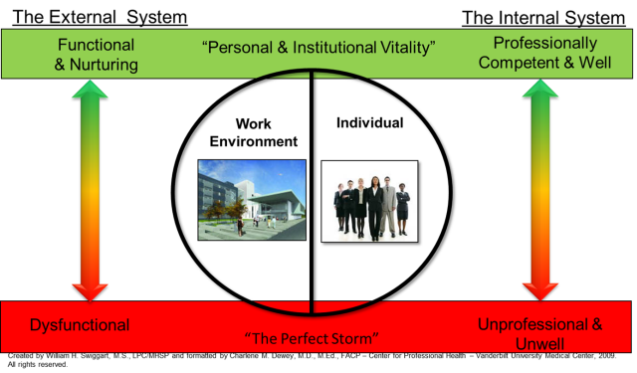
- Reflect on your current work situation…are you in the green or the red zone?

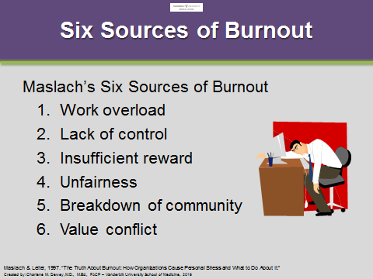

- Circle sources of burnout in your life. Determine if the sources apply to work and/or home.

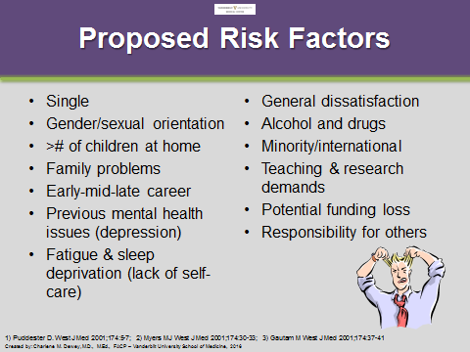
- Circle any individual risk factors for burnout.

“When our work is devoid of meaning, then even completing a long list of tasks cannot yield a genuine sense of accomplishment.”
~Amabile & Kramer, “The Progress Principle,” 2011, pg. 98.

- Circle any symptoms of burnout:
- Chronic exhaustion
- Cynical and detached
- Emotions: anger, sadness, &/or fear
- Increasingly ineffective: at work or home

If you experience any symptoms of burnout, please contact work-life connections.
Call 615-936-1327
Someone is available 24 hours a day, seven days a week.

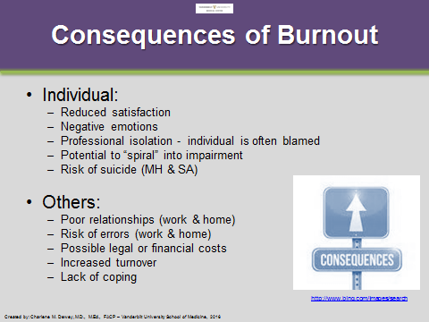
Burnout has significant consequences for both the individual and those around them. If you are not at burnout, is there someone around you who may be? Share this information with them and encourage them to seek assistance.

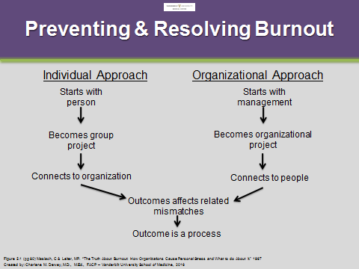
Maslach outlines two approaches to addressing the sources of burnout in the work place. How can you help?

Do you need to take an organizational approach within your section/division/department or an individual approach within your group?

Do you need approaches from both?

Emotional Intelligence

Read the article by Daniel Goleman titled: “What Makes a Leader?”

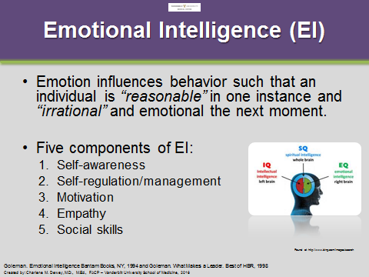
“Self-awareness means having a deep understanding of one’s emotions, strengths, weaknesses, needs, and drives. People with strong self-awareness are neither overly critical nor unrealistically hopeful. Rather, they are honest – with themselves and with others.”
~Goleman, 1998

- Mark () the five components of EI as your strength or weakness.

Components of EI | Strength | Weakness
- Self-awareness
- Self-regulation/management
- Motivation
- Empathy
- Social Skills

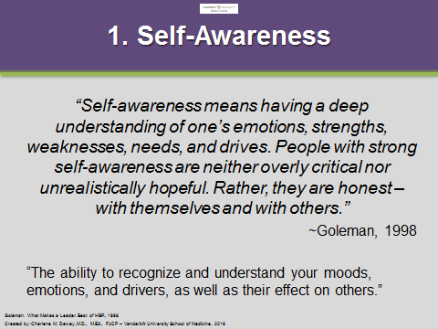
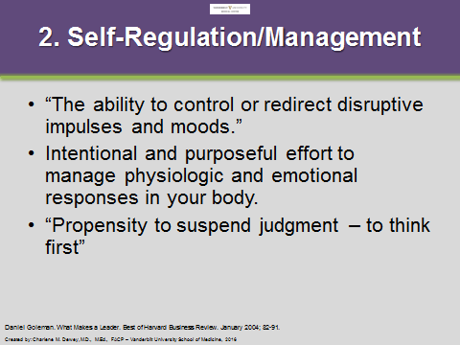

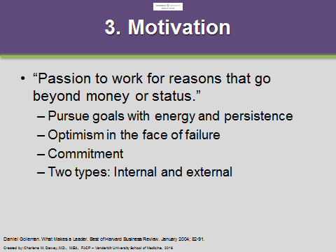
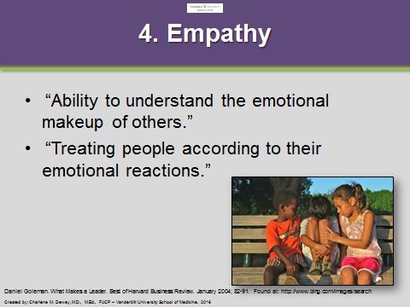

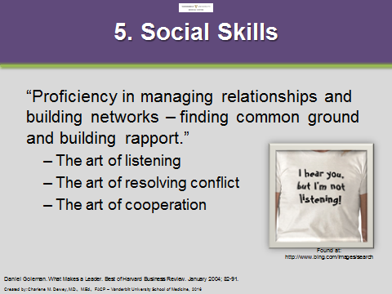

- Select one or two of your EI skills that need improvement and identify a practice plan.
EI Skill | Practice Plan

- Write a B-A-SMARTER goal/objective for one behavior or activity you plan to do to reduce your risk of burnout (at home and work) and to improve your emotional intelligence.

Home Goal to Prevent/Reduce Risk of Burnout

My goal is to:

Check List: | Objective:
- B - Barriers | - Barriers:  - Accountability:  - Specifics:  - Measures:  - Appropriate:  - Relevant:  - Timely:  - Evaluate:  - Re-evaluate:
- A – Accountability
- S – Specific
- M – Measurable
- A – Appropriate
- R – Relevant
- T – Timely
- E – Evaluate
- R – Re-evaluate

Work Goal to Prevent or Reduce Risk of Burnout

My goal is to:

Check List: | Objective:
- B - Barriers | - Barriers:  - Accountability:  - Specifics:  - Measures:  - Appropriate:  - Relevant:  - Timely:  - Evaluate:  - Re-evaluate:
- A – Accountability
- S – Specific
- M – Measurable
- A – Appropriate
- R – Relevant
- T – Timely
- E – Evaluate
- R – Re-evaluate

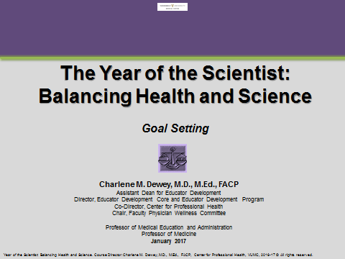

Table of Contents
Session 6: Goal Setting

Topic | Page
Definition and Goal Setting | 32
Personal Integrity Account | 32
Principle-Based Goals | 33
Barriers and Challenges | 33
B-A-SMARTER Goals and Objectives | 34

Definition and Goal Setting:
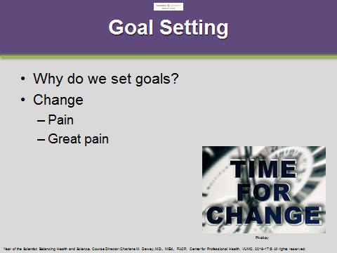
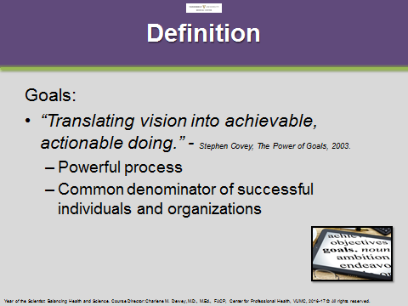

Why do you set goals? Briefly describe your beliefs and practices around goal setting.

Personal Integrity Account:

- Using the analogy of a tank of gas, how full is your personal integrity account? (Circle one option.)

- Completely full tank
- ¾ tank full
- ½ tank full
- ¼ tank full
- Almost empty
- Empty

- List one or two successes and describe why you think they were successes.

- List and describe one or two failures.

Principle-Based Goals:

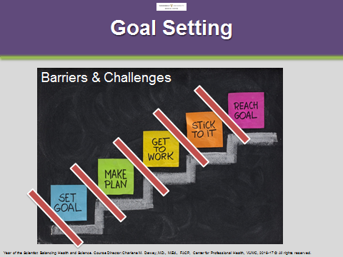
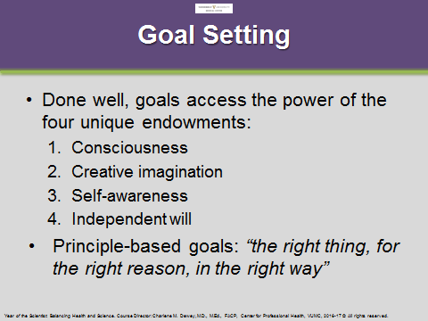

List your own challenges and barriers to setting and accomplishing goals.

Reference: Stephen R. Covey, A. Roger Merrill, and Rebecca R. Merrill. Chapter 7: The Power of Goals, in the book, First Things First. Free Press, New York, NY, 2003.

- Write a B-A-SMARTER goal/objective for one behavior or activity you plan to do to reduce your risk of burnout (at home and work) and to improve your emotional intelligence.

Home Goal to Prevent/Reduce Risk of Burnout

My goal is to:

Check List: | Objective:
- B - Barriers | - Barriers:  - Accountability:  - Specifics:  - Measures:  - Appropriate:  - Relevant:  - Timely:  - Evaluate:  - Re-evaluate:
- A – Accountability
- S – Specific
- M – Measurable
- A – Appropriate
- R – Relevant
- T – Timely
- E – Evaluate
- R – Re-evaluate

Work Goal to Prevent or Reduce Risk of Burnout

My goal is to:

Check List: | Objective:
- B - Barriers | - Barriers:  - Accountability:  - Specifics:  - Measures:  - Appropriate:  - Relevant:  - Timely:  - Evaluate:  - Re-evaluate:
- A – Accountability
- S – Specific
- M – Measurable
- A – Appropriate
- R – Relevant
- T – Timely
- E – Evaluate
- R – Re-evaluate

